According to the hierarchy of biological organization (from least complex to most complex), the tissue level of organization comes directly after __________________.
- systems
- organs
- molecules
- cells
- atoms

ANSWER: D

The _______________ feedback mechanism is crucial for maintain homeostasis around a set- point.
- positive
- negative
- negative and positive

ANSWER: B

The lungs are located in the ___________ body cavity.
- dorsal
- thoracic
- pelvic
- abdominal
- vertebral

During thermoregulation, a negative feedback mechanism will trigger sweating in response to an increase in body temperature. In this mechanism, the sweat glands would be the _______________.
- receptor
- stimulus
- effector
- control center
- setpoint

ANSWER: C

In anatomical position, the navel would be __________ to the sternum.
- superior
- inferior
- proximal
- anterior
- distal

ANSWER: B

The region located on the back of the knee is referred to as the ___________ region.
- Femoral
- Sural
- Calcaneous
- Popliteal
- Olecranal

ANSWER: D

In the diagram below, the region labeled with a star is the ______________ region.
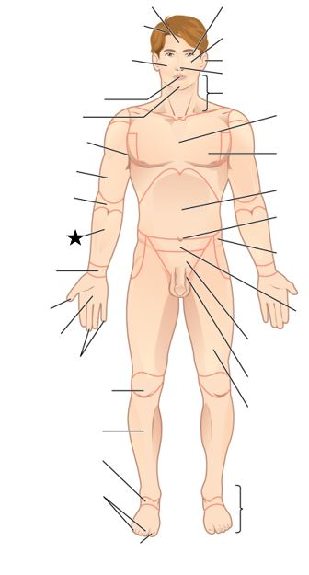
- acromial
- brachial
- antebrachial
- sternal
- carpal

ANSWER: C

The stomach is located in the ___________ body cavity.
- dorsal
- thoracic
- pelvic
- abdominal
- vertebral

ANSWER: D

When standing in anatomical position the radius would be __________ to the ulna.
A. lateral
B. medial
C. inferior
D. superior
E. proximal

ANSWER: A

The spinal cord is located in the ___________ body cavity.
- thoracic
- pelvic
- abdominal
- vertebral
- cranial

ANSWER: D

What is homeostasis? Give an example of a specific variable that must be controlled, describing the negative feedback mechanism involved in its maintenance. Include in your description the stimulus, receptor, control center, effector as well as the afferent and efferent pathways.

