Metabolism
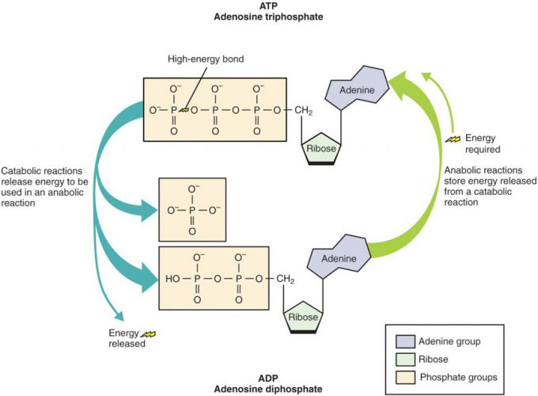

Figure 1. Structure of ATP Molecule. Adenosine triphosphate (ATP) is the energy molecule of the cell. During catabolic reactions, ATP is created and energy is stored until needed during anabolic reactions.

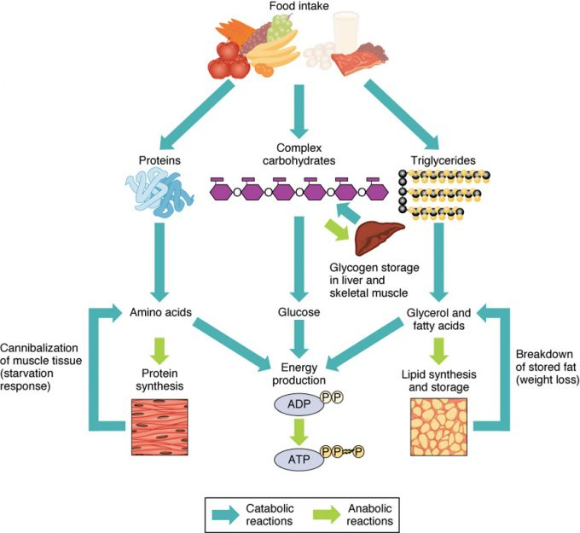

Figure 2. Sources of ATP. During catabolic reactions, proteins are broken down into amino acids, lipids are broken down into fatty acids, and polysaccharides are broken down into monosaccharides. These building blocks are then used for the synthesis of molecules in anabolic reactions.
Hormonal Regulation of Metabolism

Catabolic Hormones (Table 1)
Hormone | Function
Cortisol | Released from the adrenal gland in response to stress; its main role is to increase blood glucose levels by gluconeogenesis (breaking down fats and proteins)
Glucagon | Released from alpha cells in the pancreas either when starving or when the body needs to generate additional energy; it stimulates the breakdown of glycogen (glycogenolysis) and the production of glucose (gluconeogenesis) in the liver to increase blood glucose levels; its effect is the opposite of insulin; glucagon and insulin are a part of a negative-feedback system that stabilizes blood glucose levels
Adrenaline/epinephrine | Released in response to the activation of the sympathetic nervous system; increases heart rate and heart contractility, constricts blood vessels, is a bronchodilator that opens (dilates) the bronchi of the lungs to increase air volume in the lungs, and stimulates gluconeogenesis

Anabolic Hormones (Table 2)
Hormone | Function
Growth hormone (GH) | Synthesized and released from the pituitary gland; stimulates the growth of cells, tissues, and bones
Insulin-like growth factor (IGF) | Stimulates the growth of muscle and bone while also inhibiting cell death (apoptosis)
Insulin | Produced by the beta cells of the pancreas; plays an essential role in carbohydrate and fat metabolism, controls blood glucose levels, and promotes the uptake of glucose into body cells; causes cells in muscle, adipose tissue, and liver to take up glucose from the blood and store it in the liver and muscle as glycogen (glycogen synthesis); its effect is the opposite of glucagon; glucagon and insulin are a part of a negative-feedback system that stabilizes blood glucose levels
Testosterone | Produced by the testes in males and the ovaries in females; stimulates an increase in muscle mass and strength as well as the growth and strengthening of bone
Estrogen | Produced primarily by the ovaries, it is also produced by the liver and adrenal glands; its anabolic functions include increasing metabolism and fat deposition

Carbohydrate Metabolism

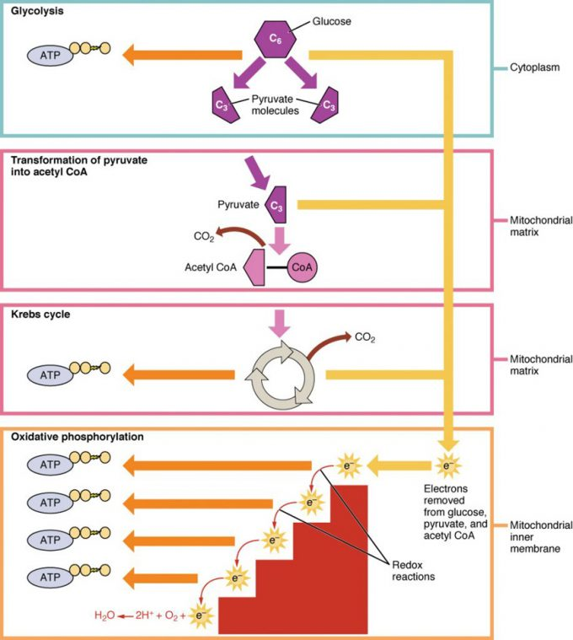
Figure 1. Cellular Respiration. Cellular respiration oxidizes glucose molecules through glycolysis, the Krebs cycle, and oxidative phosphorylation to produce ATP.
Lipid Metabolism

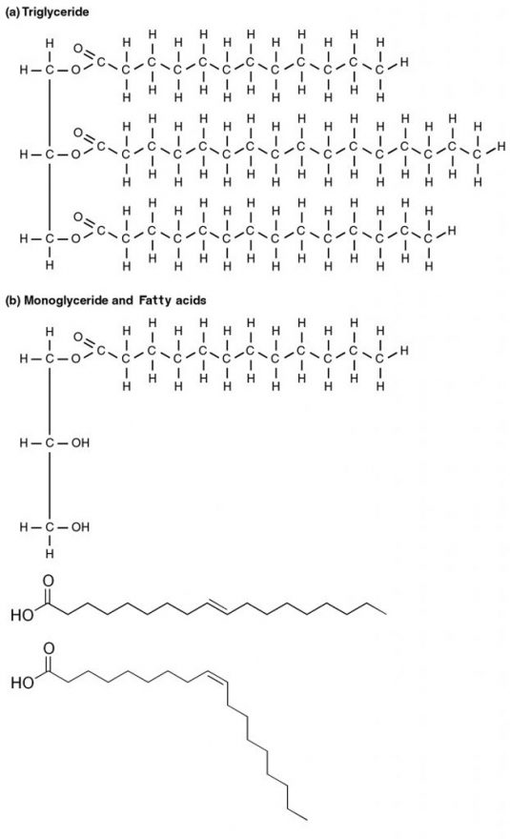
Figure 1. Triglyceride Broken Down into a Monoglyceride A triglyceride molecule (a) breaks down into a monoglyceride and two free fatty acids (b).

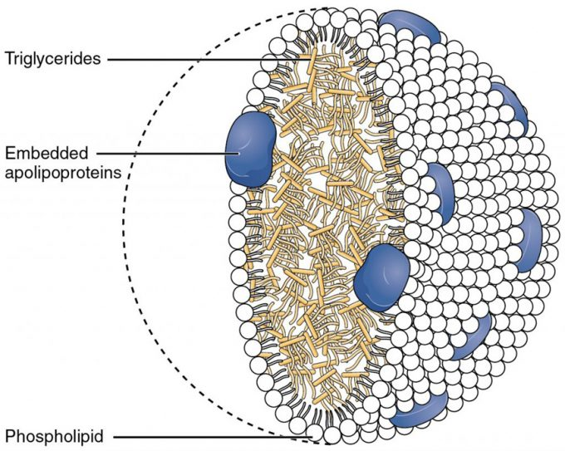

Figure 2. Chylomicrons. Chylomicrons contain triglycerides, cholesterol molecules, and other apolipoproteins (protein molecules). They function to carry these water-insoluble molecules from the intestine, through the lymphatic system, and into the bloodstream, which carries the lipids to adipose tissue for storage.

Protein Metabolism
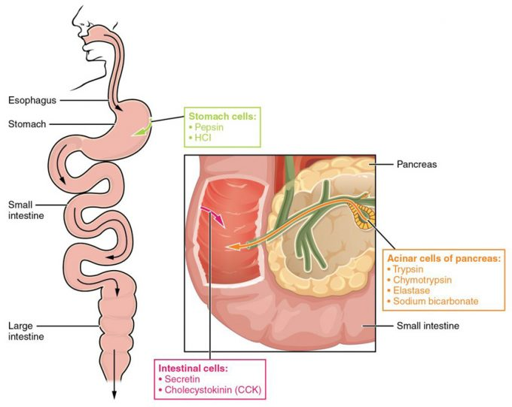

Figure 1. Digestive Enzymes and Hormones. Enzymes in the stomach and small intestine break down proteins into amino acids. HCl in the stomach aids in proteolysis by denaturing proteins, and hormones secreted by intestinal cells direct the digestive processes.
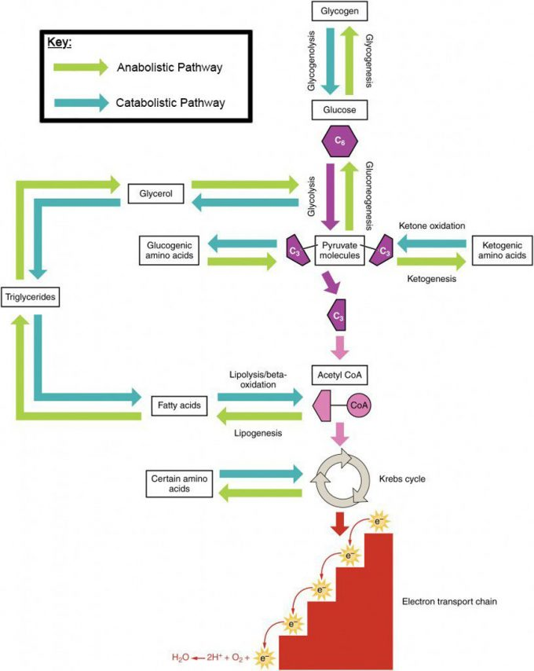
Figure 4. Catabolic and Anabolic Pathways. Nutrients follow a complex pathway from ingestion through anabolism and catabolism to energy production.

Metabolic States of the Body

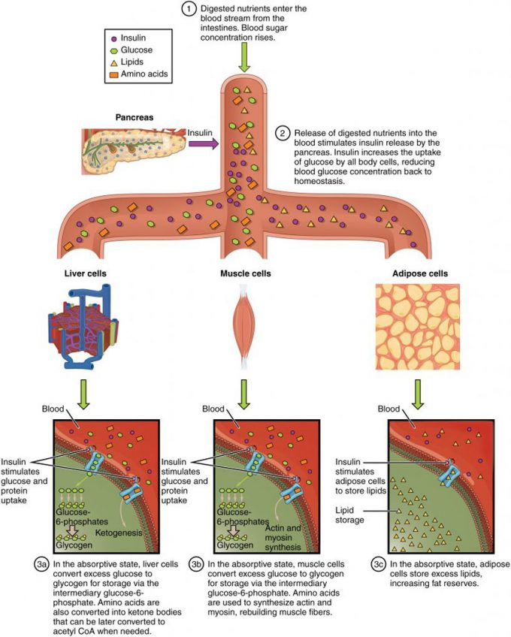
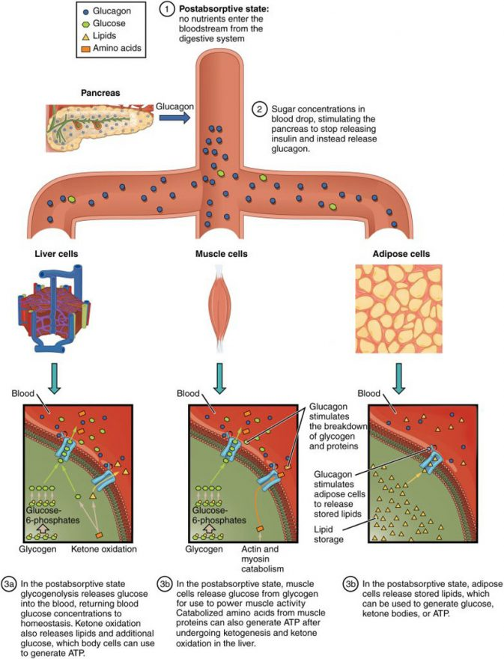

Figure 2. Postabsorptive State. During the postabsorptive state, the body must rely on stored glycogen for energy, breaking down glycogen in the cells and releasing it to cell (muscle) or the body (liver).
Energy and Heat Balance

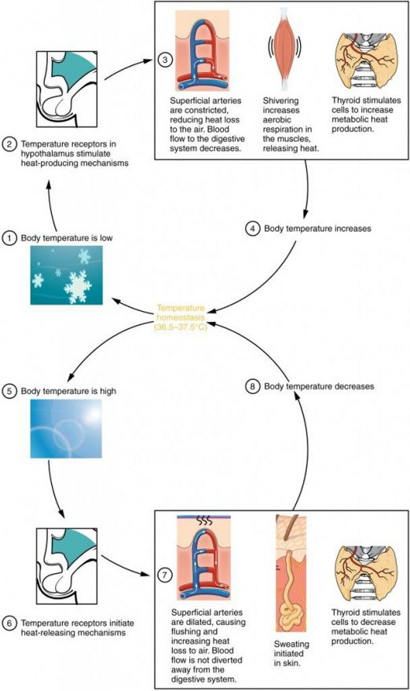
Figure 1. Hypothalamus Controls Thermoregulation. The hypothalamus controls thermoregulation.
Nutrition
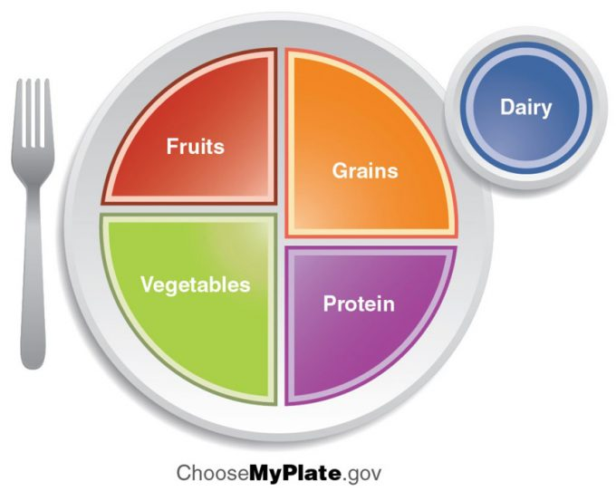
Vitamins

Fat-soluble Vitamins (Table 3)
Vitamin and alternative name | Sources | Recommended daily allowance | Function | Problems associated with deficiency
A  retinal or β-carotene | Yellow and orange fruits and vegetables, dark green leafy vegetables, eggs, milk, liver | 700–900 µg | Eye and bone development, immune function | Night blindness, epithelial changes, immune system deficiency
D  cholecalciferol | Dairy products, egg yolks; also synthesized in the skin from exposure to sunlight | 5–15 µg | Aids in calcium absorption, promoting bone growth | Rickets, bone pain, muscle weakness, increased risk of death from cardiovascular disease, cognitive impairment, asthma in children, cancer
E  tocopherols | Seeds, nuts, vegetable oils, avocados, wheat germ | 15 mg | Antioxidant | Anemia
K  phylloquinone | Dark green leafy vegetables, broccoli, Brussels sprouts, cabbage | 90–120 µg | Blood clotting, bone health | Hemorrhagic disease of newborn in infants; uncommon in adults

Water-soluble Vitamins (Table 4)
Vitamin and alternative name | Sources | Recommended daily allowance | Function | Problems associated with deficiency
B₁  thiamine | Whole grains, enriched bread and cereals, milk, meat | 1.1–1.2 mg | Carbohydrate metabolism | Beriberi, Wernicke-Korsikoff syndrome
B₂  riboflavin | Brewer’s yeast, almonds, milk, organ meats, legumes, enriched breads and cereals, broccoli, asparagus | 1.1–1.3 mg | Synthesis of FAD for metabolism, production of red blood cells | Fatigue, slowed growth, digestive problems, light sensitivity, epithelial problems like cracks in the corners of the mouth
B₃  niacin | Meat, fish, poultry, enriched breads and cereals, peanuts | 14–16 mg | Synthesis of NAD for metabolism, nerve function, cholesterol production | Cracked, scaly skin; dementia; diarrhea; also known as pellagra
B₅  pantothenic acid | Meat, poultry, potatoes, oats, enriched breads and cereals, tomatoes | 5 mg | Synthesis of coenzyme A in fatty acid metabolism | Rare: symptoms may include fatigue, insomnia, depression, irritability
B₆  pyridoxine | Potatoes, bananas, beans, seeds, nuts, meat, poultry, fish, eggs, dark green leafy vegetables, soy, organ meats | 1.3–1.5 mg | Sodium and potassium balance, red blood cell synthesis, protein metabolism | Confusion, irritability, depression, mouth and tongue sores
B₇  biotin | Liver, fruits, meats | 30 µg | Cell growth, metabolism of fatty acids, production of blood cells | Rare in developed countries; symptoms include dermatitis, hair loss, loss of muscular coordination
B₉  folic acid | Liver, legumes, dark green leafy vegetables, enriched breads and cereals, citrus fruits | 400 µg | DNA/protein synthesis | Poor growth, gingivitis, appetite loss, shortness of breath, gastrointestinal problems, mental deficits
B₁₂  cyanocobalamin | Fish, meat, poultry, dairy products, eggs | 2.4 µg | Fatty acid oxidation, nerve cell function, red blood cell production | Pernicious anemia, leading to nerve cell damage
C  ascorbic acid | Citrus fruits, red berries, peppers, tomatoes, broccoli, dark green leafy vegetables | 75–90 mg | Necessary to produce collagen for formation of connective tissue and teeth, and for wound healing | Dry hair, gingivitis, bleeding gums, dry and scaly skin, slow wound healing, easy bruising, compromised immunity; can lead to scurvy

Minerals

Major Minerals (Table 5)
Mineral | Sources | Recommended daily allowance | Function | Problems associated with deficiency
Potassium | Meats, some fish, fruits, vegetables, legumes, dairy products | 4700 mg | Nerve and muscle function; acts as an electrolyte | Hypokalemia: weakness, fatigue, muscle cramping, gastrointestinal problems, cardiac problems
Sodium | Table salt, milk, beets, celery, processed foods | 2300 mg | Blood pressure, blood volume, muscle and nerve function | Rare
Calcium | Dairy products, dark green leafy vegetables, blackstrap molasses, nuts, brewer’s yeast, some fish | 1000 mg | Bone structure and health; nerve and muscle functions, especially cardiac function; blood cloting | Slow growth, weak and brittle bones
Phosphorous | Meat, milk | 700 mg | Bone formation, metabolism, ATP production | Rare
Magnesium | Whole grains, nuts, leafy green vegetables | 310–420 mg | Enzyme activation, production of energy, regulation of other nutrients; enzyme cofactor (essential for metabolism) | Agitation, anxiety, sleep problems, nausea and vomiting, abnormal heart rhythms, low blood pressure, muscular problems
Chloride | Most foods, salt, vegetables, especially seaweed, tomatoes, lettuce, celery, olives | 2300 mg | Balance of body fluids, digestion | Loss of appetite, muscle cramps

Trace Minerals (Table 6)
Mineral | Sources | Recommended daily allowance | Function | Problems associated with deficiency
Iron | Meat, poultry, fish, shellfish, legumes, nuts, seeds, whole grains, dark leafy green vegetables | 8–18 mg | Transport of oxygen in blood, production of ATP | Anemia, weakness, fatigue
Zinc | Meat, fish, poultry, cheese, shellfish | 8–11 mg | Immunity, reproduction, growth, blood clotting, insulin and thyroid function | Loss of appetite, poor growth, weight loss, skin problems, hair loss, vision problems, lack of taste or smell
Copper | Seafood, organ meats, nuts, legumes, chocolate, enriched breads and cereals, some fruits and vegetables | 900 µg | Red blood cell production, nerve and immune system function, collagen formation, acts as an antioxidant; enzyme cofactor (essential for metabolism) | Anemia, low body temperature, bone fractures, low white blood cell concentration, irregular heartbeat, thyroid problems
Iodine | Fish, shellfish, garlic, lima beans, sesame seeds, soybeans, dark leafy green vegetables | 150 µg | Thyroid function | Hypothyroidism: fatigue, weight gain, dry skin, temperature sensitivity
Sulfur | Eggs, meat, poultry, fish, legumes | None | Component of amino acids; enzyme cofactor | Protein deficiency
Fluoride | Fluoridated water | 3–4 mg | Maintenance of bone and tooth structure | Increased cavities, weak bones and teeth
Manganese | Nuts, seeds, whole grains, legumes | 1.8–2.3 mg | Formation of connective tissue and bones, blood clotting, sex hormone development, metabolism, brain and nerve function; enzyme cofactor (essential for metabolism) | Infertility, bone malformation, weakness, seizures
Cobalt | Fish, nuts, leafy green vegetables, whole grains | None | Component of B₁₂ | None
Selenium | Brewer’s yeast, wheat germ, liver, butter, fish, shellfish, whole grains | 55 µg | Antioxidant, thyroid function, immune system function | Muscle pain
Chromium | Whole grains, lean meats, cheese, black pepper, thyme, brewer’s yeast | 25–35 µg | Insulin function | High blood sugar, triglyceride, and cholesterol levels
Molybdenum | Legumes, whole grains, nuts | 45 µg | Cofactor for enzymes | Rare

Regulation of Body Weight

