Types of Muscle Tissue

Skeletal Muscle Function

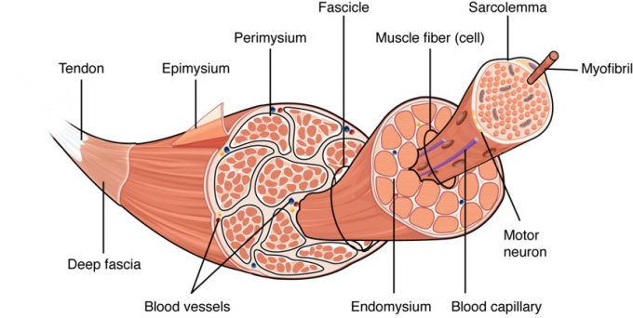

Figure 10.21 – The Three Connective Tissue Layers: Bundles of muscle fibers, called fascicles, are covered by the perimysium. Muscle fibers are covered by the endomysium.

Microscopic Anatomy

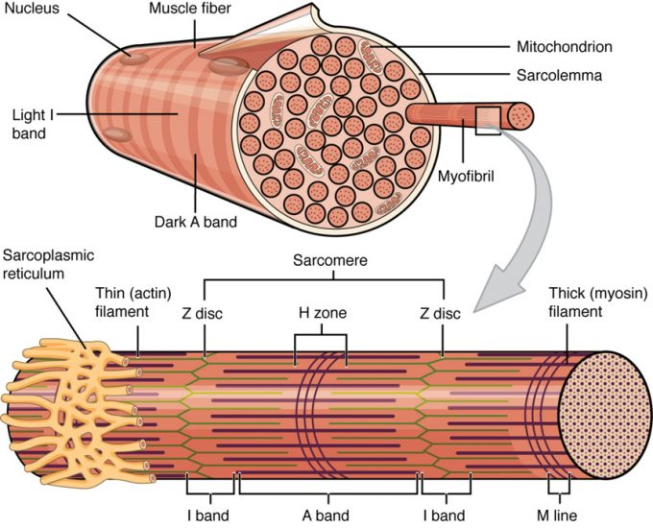

Figure 10.22 – Muscle Fiber: A skeletal muscle fiber is surrounded by a plasma membrane called the sarcolemma, which contains sarcoplasm, the cytoplasm of muscle cells. A muscle fiber is composed of many myofibrils, which contain sarcomeres with light and dark regions that give the cell its striated appearance.
Structure of a Sarcomere
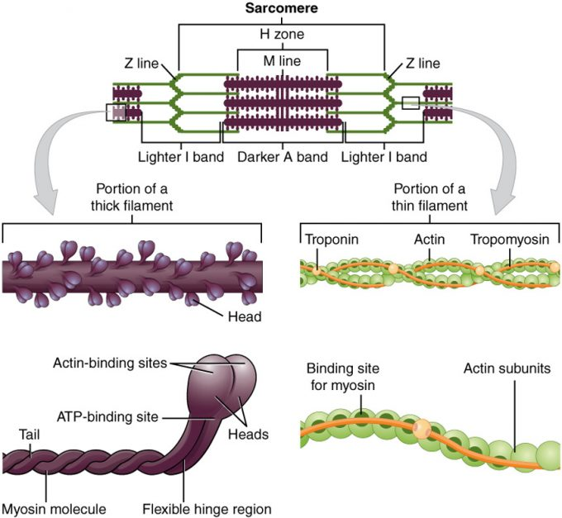

Figure 10.23 – The Sarcomere: The sarcomere, the region from one Z-line to the next Z-line, is the functional unit of a skeletal muscle fiber.

Sliding Filament Model

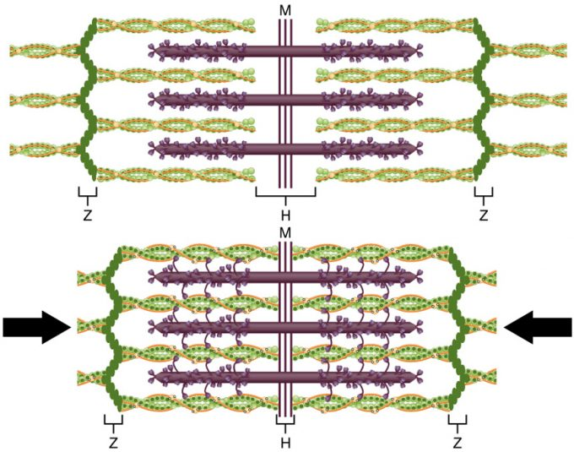

Figure 10.24 – The Sliding Filament Model of Muscle Contraction: When a sarcomere contracts, the Z lines move closer together, and the I band becomes smaller. The A band stays the same width. At full contraction, the thin and thick filaments overlap.

Control of Muscular Contraction

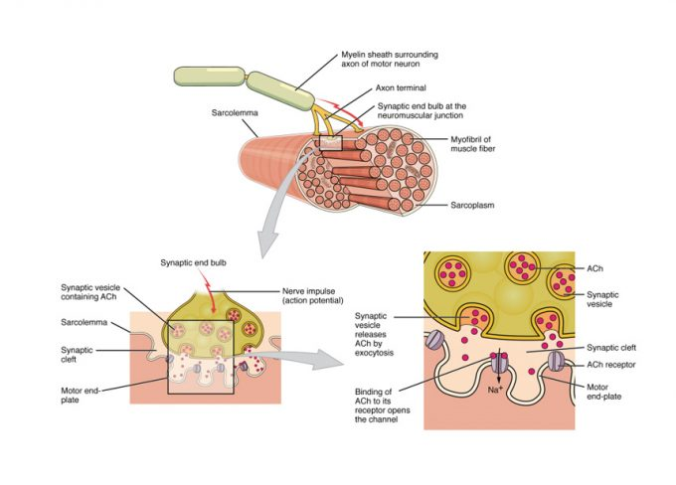
Figure 10.31 – Motor End-Plate and Innervation: At the NMJ, the axon terminal releases ACh. The motor end-plate is the location of the ACh-receptors in the muscle fiber sarcolemma. When ACh molecules are released, they diffuse across a minute space called the synaptic cleft and bind to the receptors.
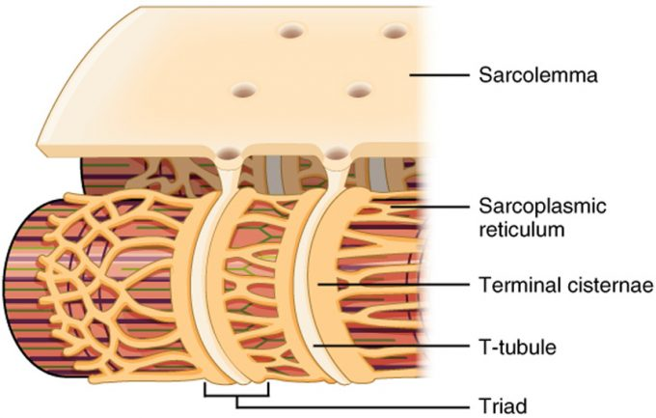

Figure 10.32 – The T-tubule: Narrow T-tubules permit the conduction of electrical impulses. The SR functions to regulate intracellular levels of calcium. Two terminal cisternae (where enlarged SR connects to the T-tubule) and one T-tubule comprise a triad—a “threesome” of membranes, with those of SR on two sides and the T-tubule sandwiched between them.
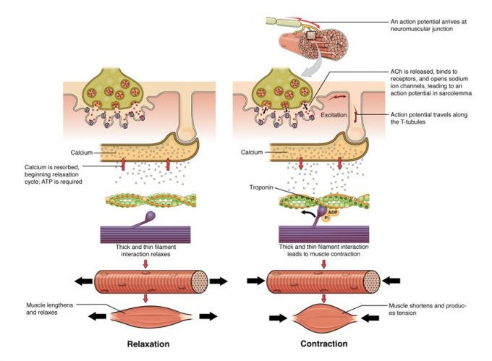
Figure 10.33 – Contraction of a Muscle Fiber: A cross-bridge forms between actin and the myosin heads triggering contraction. As long as Ca++ ions remain in the sarcoplasm to bind to troponin, and as long as ATP is available, the muscle fiber will continue to shorten. Relaxation of a Muscle Fiber: Ca++ ions are pumped back into the SR, which causes the tropomyosin to reshield the binding sites on the actin strands. A muscle may also stop contracting when it runs out of ATP and becomes fatigued.

Cross-Bridge Cycling

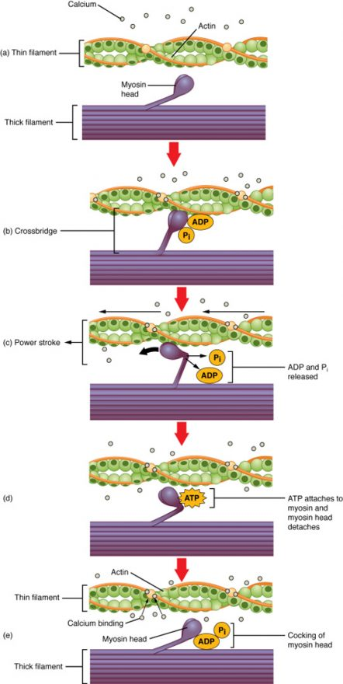

Figure 10.34 – Skeletal Muscle Contraction: (a) The active site on actin is exposed as calcium binds to troponin. (b) The myosin head is attracted to actin, and myosin binds actin at its actin-binding site, forming the cross-bridge. (c) During the power stroke, the phosphate generated in the previous contraction cycle is released. This results in the myosin head pivoting toward the center of the sarcomere, after which the attached ADP and phosphate group are released. (d) A new molecule of ATP attaches to the myosin head, causing the cross-bridge to detach. (e) The myosin head hydrolyzes ATP to ADP and phosphate, which returns the myosin to the cocked position.
Role of ATP

Sources of ATP

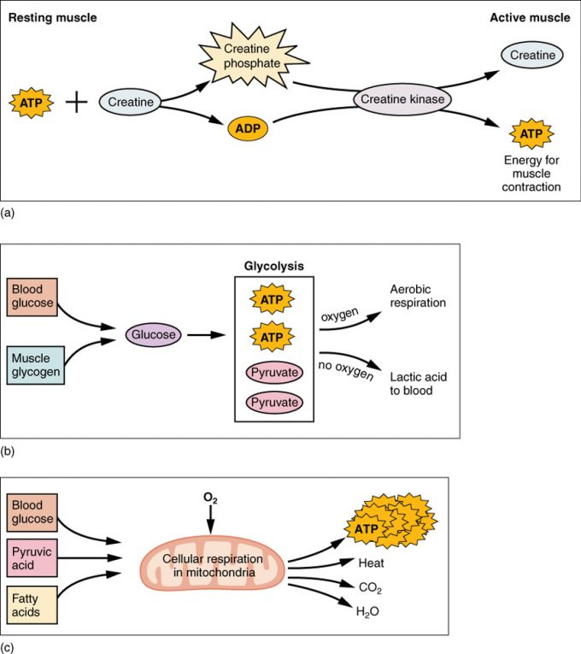

Nervous Control of Muscle Tension

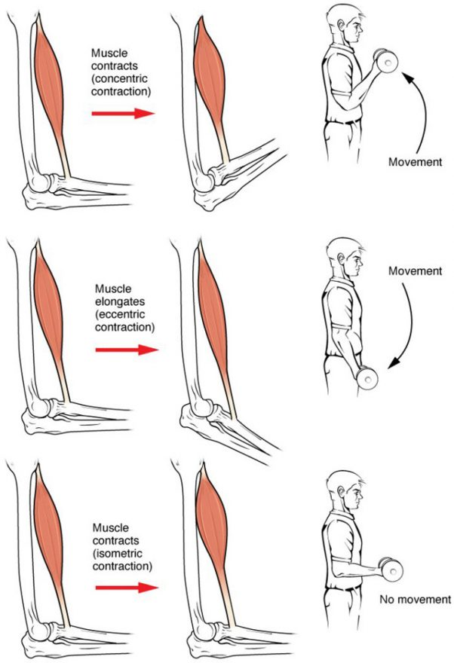
Figure 10.41 – Types of Muscle Contractions: During isotonic contractions, muscle length changes to move a load. During isometric contractions, muscle length does not change because the load exceeds the tension the muscle can generate.
Motor Units

Muscle Twitch

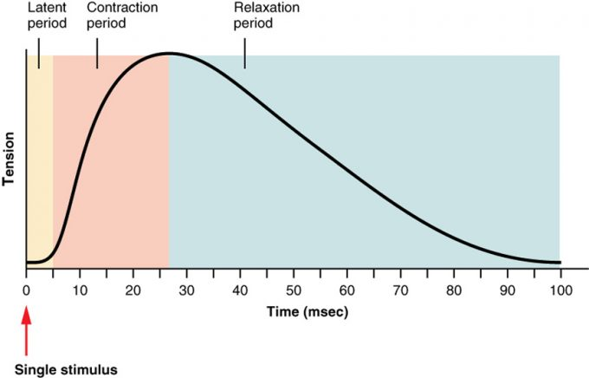

Figure 10.43 – A Myogram of a Muscle Twitch: A single muscle twitch has a latent period, a contraction phase when tension increases, and a relaxation phase when tension decreases. During the latent period, the action potential is being propagated along the sarcolemma. During the contraction phase, Ca++ ions in the sarcoplasm bind to troponin, tropomyosin moves from actin-binding sites, cross-bridges form, and sarcomeres shorten. During the relaxation phase, tension decreases as Ca++ ions are pumped out of the sarcoplasm and cross-bridge cycling stops.

Length of Sarcomere

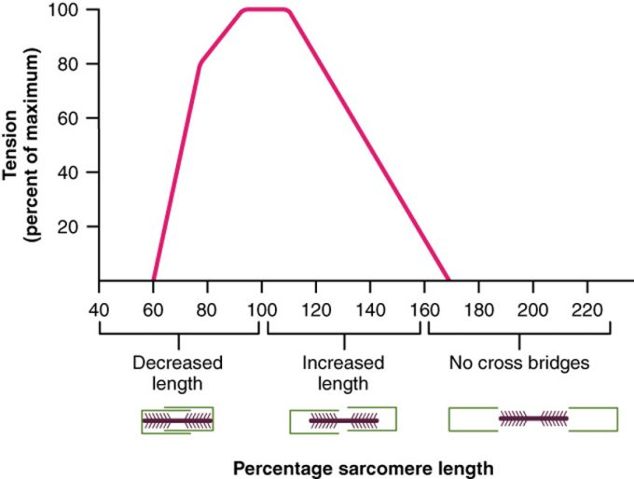
Figure 10.42 – The Ideal Length of a Sarcomere: Sarcomeres produce maximal tension when thick and thin filaments overlap between about 80 percent to 120 percent.
Stimulus Frequency

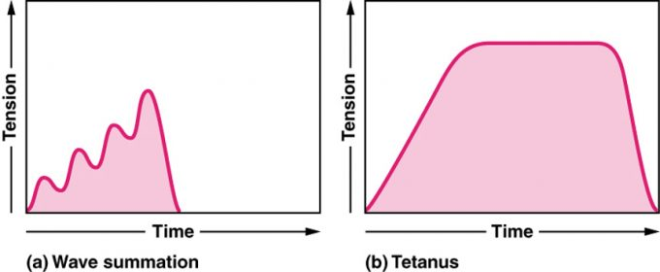

Figure 10.44 – Wave Summation and Tetanus: (a) The excitation-contraction coupling effects of successive motor neuron signaling is added together which is referred to as wave summation. The bottom of each wave, the end of the relaxation phase, represents the point of stimulus. (b) When the stimulus frequency is so high that the relaxation phase disappears completely, the contractions become continuous; this is called tetanus.
Treppe

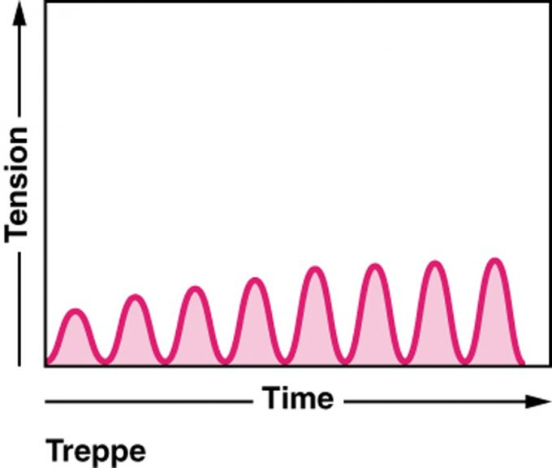

Figure 10.45 – Treppe: When muscle tension increases in a graded manner that looks like a set of stairs, it is called treppe. The bottom of each wave represents the point of stimulus.

Stimulus Intensity

Muscle Tone
Types of Muscle Fibers
Effect of Exercise

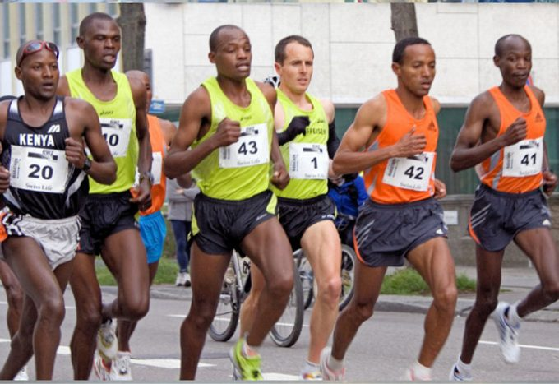

Figure 10.61 – Marathoners: Long-distance runners have a large number of SO fibers and relatively few FO and FG fibers. (credit: “Tseo2”/Wikimedia Commons)
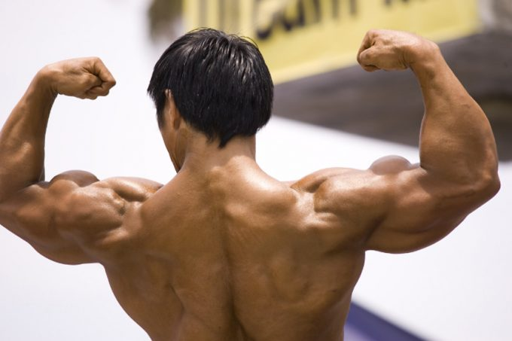
Figure 10.62 – Muscle hypertrophy: Body builders work on creasing the size of the fast glycolytic fibers through resistance training. (credit: Lin Mei/flickr)

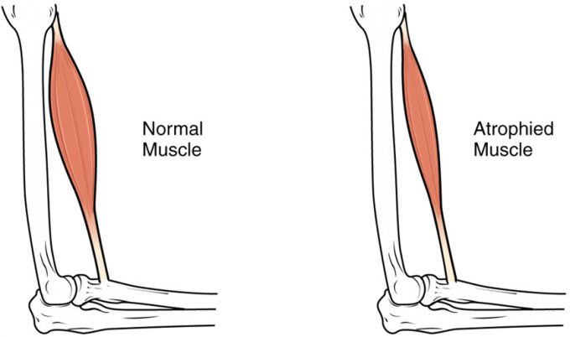

Figure 10.63 – Atrophy: Muscle mass is reduced as muscles atrophy with disuse.
Smooth Muscle Tissue

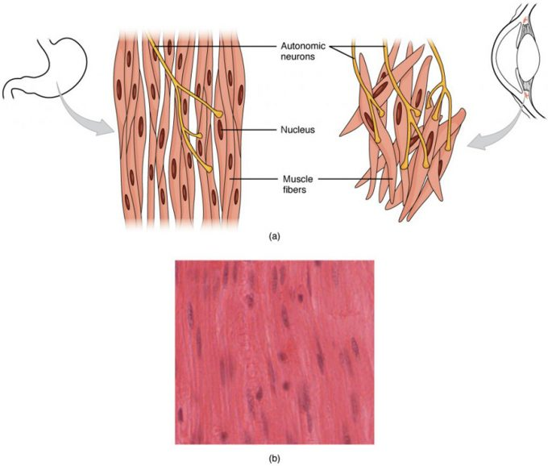
Figure 10.71 – Smooth Muscle Tissue: Smooth muscle tissue is found around organs in the digestive, respiratory, reproductive tracts and the iris of the eye. LM × 1600. (Micrograph provided by the Regents of University of Michigan Medical School © 2012)
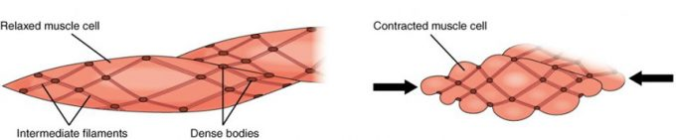

Figure 10.72 – Muscle Contraction: The dense bodies and intermediate filaments are networked through the sarcoplasm, which cause the muscle fiber to contract.
Development and Regeneration

