Joints
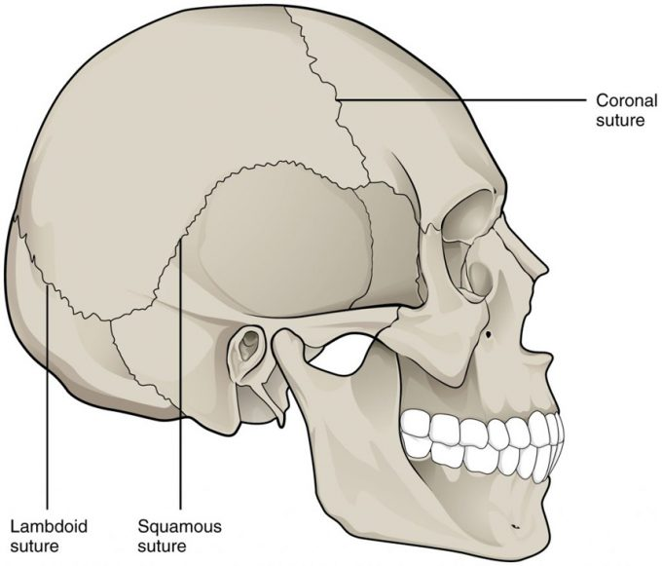

Figure 9.11 – Suture Joints of Skull: The suture joints of the skull are an example of a synarthrosis, an immobile or essentially immobile joint.
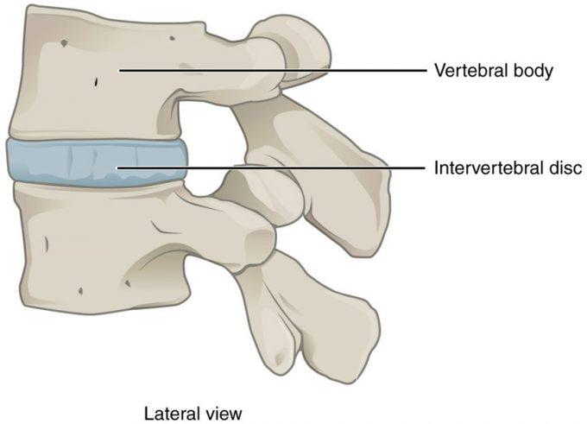Figure 9.12 – Intervertebral Disc: An intervertebral disc unites the bodies of adjacent vertebrae within the vertebral column. Each disc allows for limited movement between the vertebrae and thus functionally forms an amphiarthrosis type of joint. Intervertebral discs are made of fibrocartilage and thereby structurally form a symphysis type of cartilaginous joint.
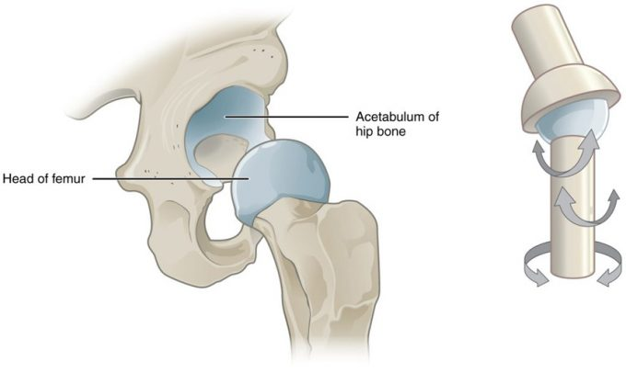Figure 9.13. Multiaxial Joint: A multiaxial joint, such as the hip joint, allows for three types of movement: anterior-posterior, medial-lateral, and rotational.

Classification of Joints Based on Structure

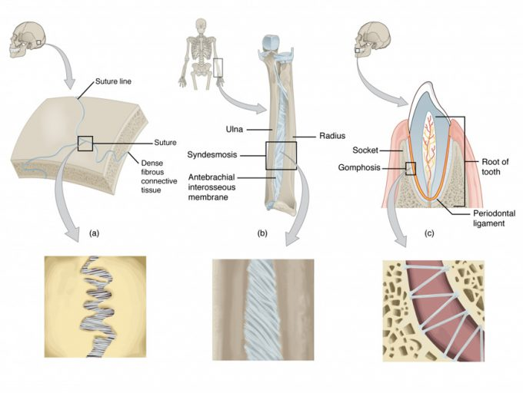Figure 9.21 – Fibrous Joints: Fibrous joints form strong connections between bones. (a) Sutures join most bones of the skull. (b) An interosseous membrane forms a syndesmosis between the radius and ulna bones of the forearm. (c) A gomphosis is a specialized fibrous joint that anchors a tooth to its socket in the jaw.

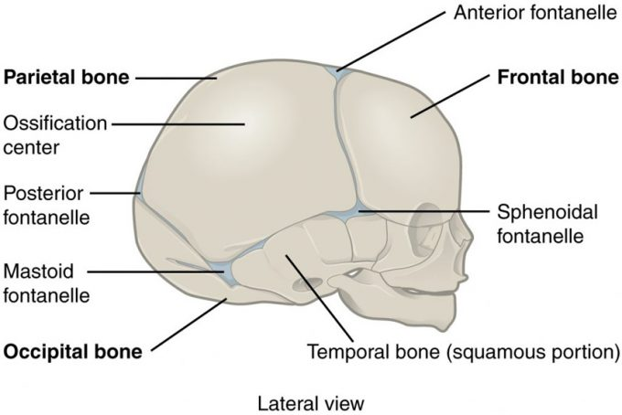

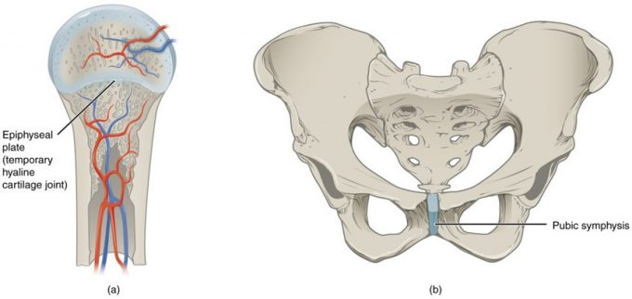

Synovial Joint

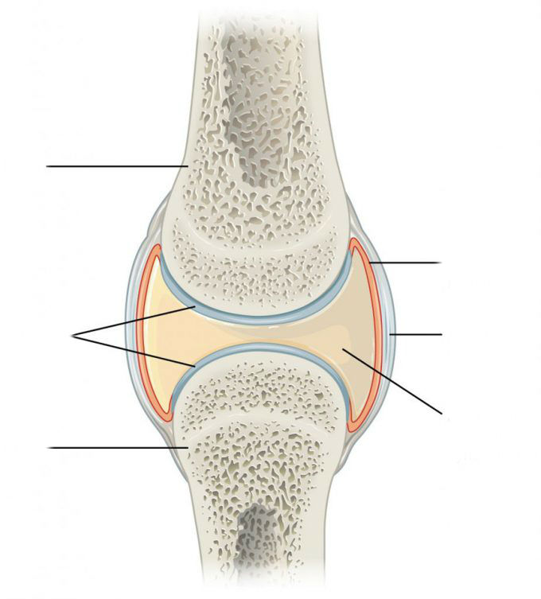
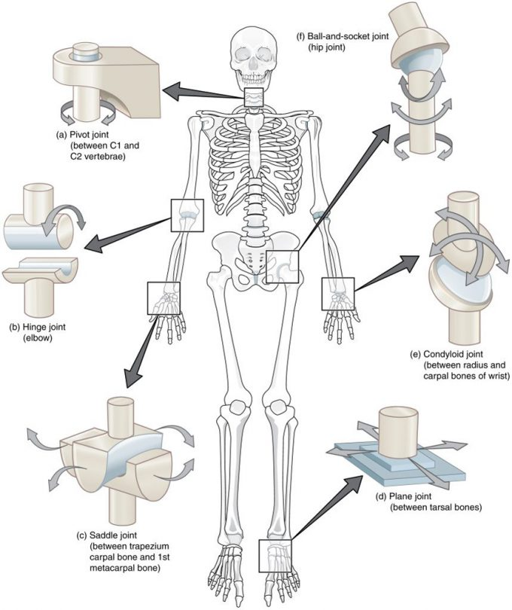

Arthritis
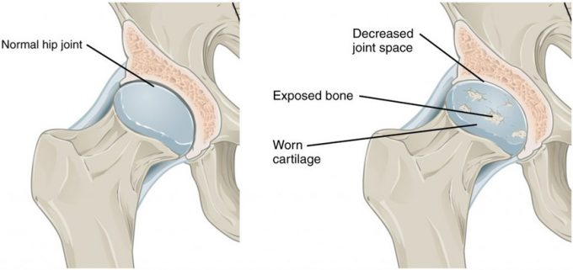

Joint Disorders

Gout

Bursae

Types of Movement

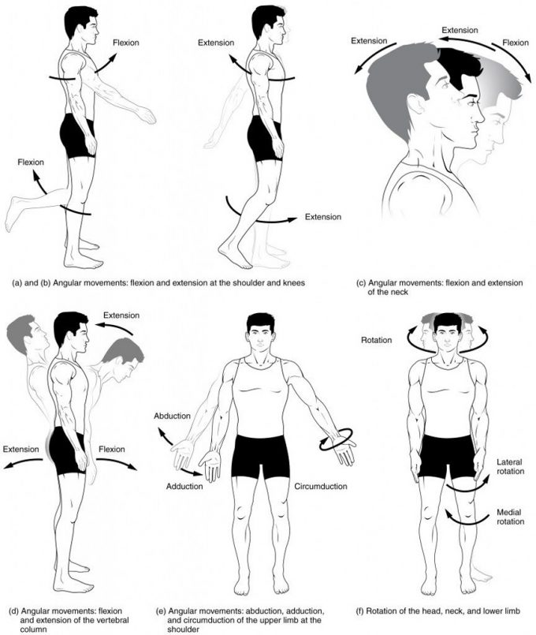
Figure 9.51 – Movements of the Body, Part 1: Synovial joints give the body many ways in which to move. (a)–(b) Flexion and extension motions are in the sagittal (anterior–posterior) plane of motion. These movements take place at the shoulder, hip, elbow, knee, wrist, metacarpophalangeal, metatarsophalangeal, and interphalangeal joints. (c)–(d) Anterior bending of the head or vertebral column is flexion, while any posterior-going movement is extension. (e) Abduction and adduction are motions of the limbs, hand, fingers, or toes in the coronal (medial–lateral) plane of movement. Moving the limb or hand laterally away from the body, or spreading the fingers or toes, is abduction. Adduction brings the limb or hand toward or across the midline of the body, or brings the fingers or toes together. Circumduction is the movement of the limb, hand, or fingers in a circular pattern, using the sequential combination of flexion, adduction, extension, and abduction motions. Adduction/abduction and circumduction take place at the shoulder, hip, wrist, metacarpophalangeal, and metatarsophalangeal joints. (f) Turning of the head side to side or twisting of the body is rotation. Medial and lateral rotation of the upper limb at the shoulder or lower limb at the hip involves turning the anterior surface of the limb toward the midline of the body (medial or internal rotation) or away from the midline (lateral or external rotation).
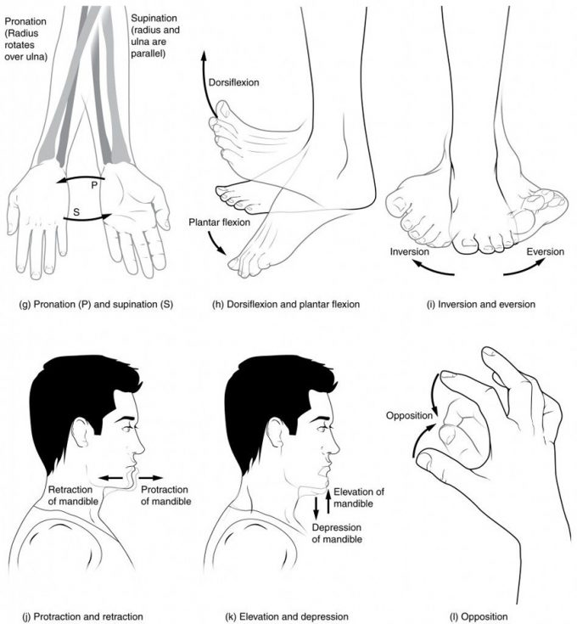
Figure 9.52 – Movements of the Body, Part 2: (g) Supination of the forearm turns the hand to the palm forward position in which the radius and ulna are parallel, while forearm pronation turns the hand to the palm backward position in which the radius crosses over the ulna to form an “X.” (h) Dorsiflexion of the foot at the ankle joint moves the top of the foot toward the leg, while plantar flexion lifts the heel and points the toes. (i) Eversion of the foot moves the bottom (sole) of the foot away from the midline of the body, while foot inversion faces the sole toward the midline. (j) Protraction of the mandible pushes the chin forward, and retraction pulls the chin back. (k) Depression of the mandible opens the mouth, while elevation closes it. (l) Opposition of the thumb brings the tip of the thumb into contact with the tip of the fingers of the same hand and reposition brings the thumb back next to the index finger.
Movements of the Joints (Table 1)
Type of Joint | Movement | Example
Pivot | Uniaxial joint; allows rotational movement | Atlantoaxial joint (C1–C2 vertebrae articulation); proximal radioulnar joint
Hinge | Uniaxial joint; allows flexion/extension movements | Knee; elbow; ankle; interphalangeal joints of fingers and toes
Condyloid | Biaxial joint; allows flexion/extension, abduction/adduction, and circumduction movements | Metacarpophalangeal (knuckle) joints of fingers; radiocarpal joint of wrist; metatarsophalangeal joints for toes
Saddle | Biaxial joint; allows flexion/extension, abduction/adduction, and circumduction movements | First carpometacarpal joint of the thumb; sternoclavicular joint
Plane | Multiaxial joint; allows inversion and eversion of foot, or flexion, extension, and lateral flexion of the vertebral column | Intertarsal joints of foot; superior-inferior articular process articulations between vertebrae
Ball-and-socket | Multiaxial joint; allows flexion/extension, abduction/adduction, circumduction, and medial/lateral rotation movements | Shoulder and hip joints

Articulations of Vertebral Column

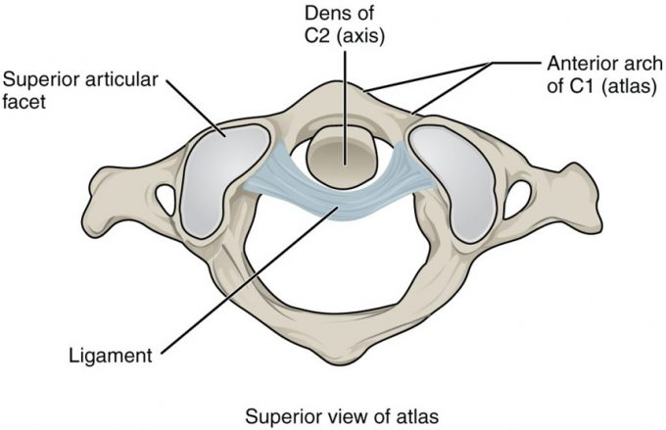
Figure 9.61 – Atlantoaxial Joint: The atlantoaxial joint is a pivot type of joint between the dens portion of the axis (C2 vertebra) and the anterior arch of the atlas (C1 vertebra), with the dens held in place by a ligament.

Temporomandibular Joint

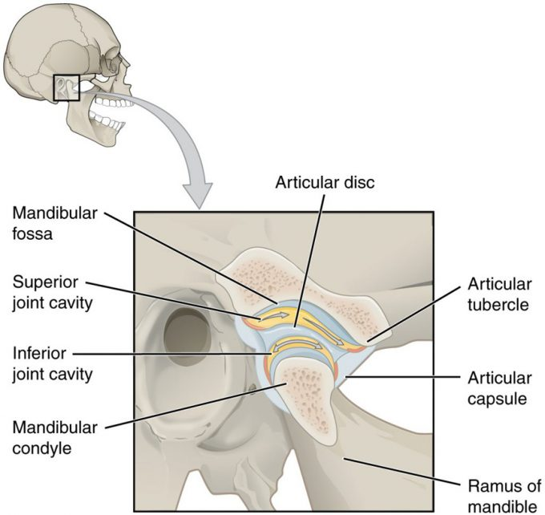

Figure 9.62 – Temporomandibular Joint: The temporomandibular joint is the articulation between the temporal bone of the skull and the condyle of the mandible, with an articular disc located between these bones. During depression of the mandible (opening of the mouth), the mandibular condyle moves both forward and hinges downward as it travels from the mandibular fossa onto the articular tubercle.
Shoulder Joint

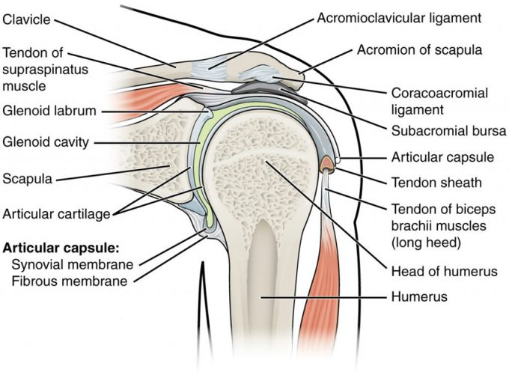
Figure 9.63 – Glenohumeral Joint: The glenohumeral (shoulder) joint is a ball-and-socket joint that provides the widest range of motions. It has a loose articular capsule and is supported by ligaments and the rotator cuff muscles.

Elbow Joint

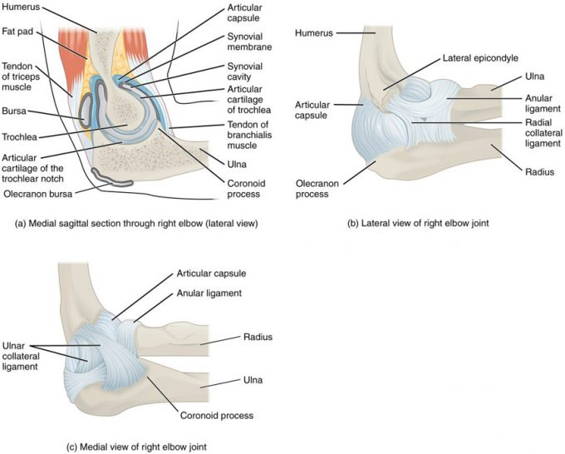

Figure 9.64 – Elbow Joint: (a) The elbow is a hinge joint that allows only for flexion and extension of the forearm. (b) It is supported by the ulnar and radial collateral ligaments. (c) The annular ligament supports the head of the radius at the proximal radioulnar joint, the pivot joint that allows for rotation of the radius

Hip Joint

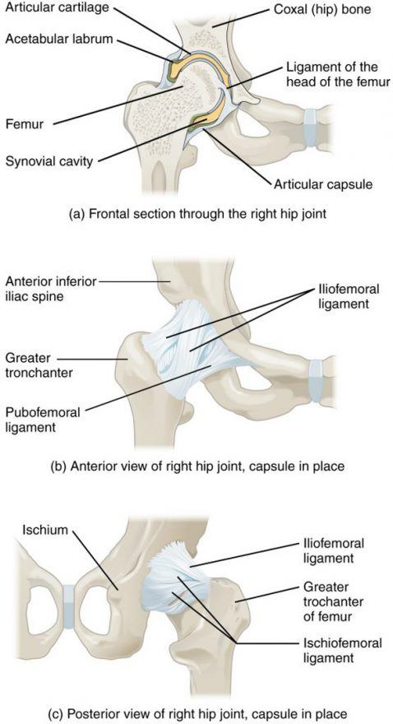
Knee Joint

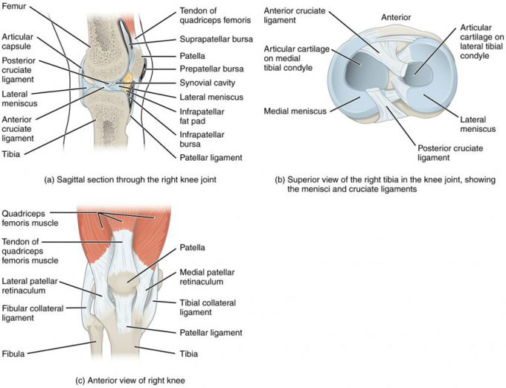

Figure 9.66 – Knee Joint: (a) The knee joint is the largest joint of the body. (b)–(c) It is supported by the tibial and fibular collateral ligaments located on the sides of the knee outside of the articular capsule, and the anterior and posterior cruciate ligaments found inside the capsule. The medial and lateral menisci provide padding and support between the femoral condyles and tibial condyles.

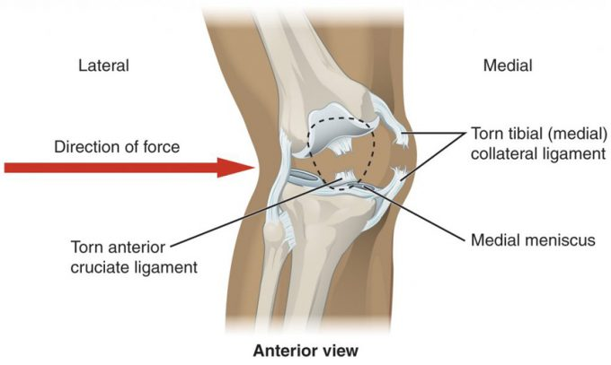
Figure 9.67 – Knee Injury: A strong blow to the lateral side of the extended knee will cause three injuries, in sequence: tearing of the tibial collateral ligament, damage to the medial meniscus, and rupture of the anterior cruciate ligament.

Ankle and Foot Joints
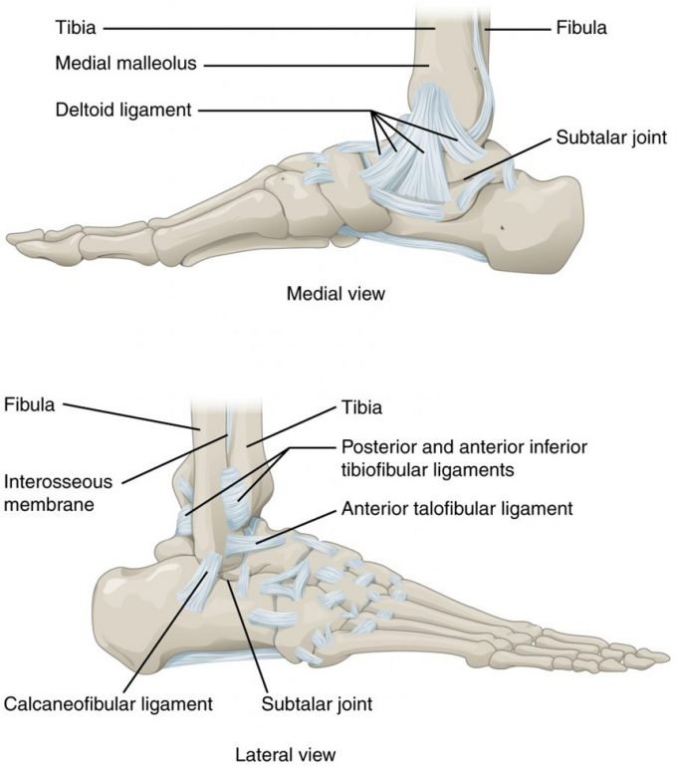
Figure 9.68 – Ankle Joint: The talocrural (ankle) joint is a uniaxial hinge joint that only allows for dorsiflexion or plantar flexion of the foot. Movements at the subtalar joint, between the talus and calcaneus bones, combined with motions at other intertarsal joints, enables eversion/inversion movements of the foot. Ligaments that unite the medial or lateral malleolus with the talus and calcaneus bones serve to support the talocrural joint and to resist excess eversion or inversion of the foot.

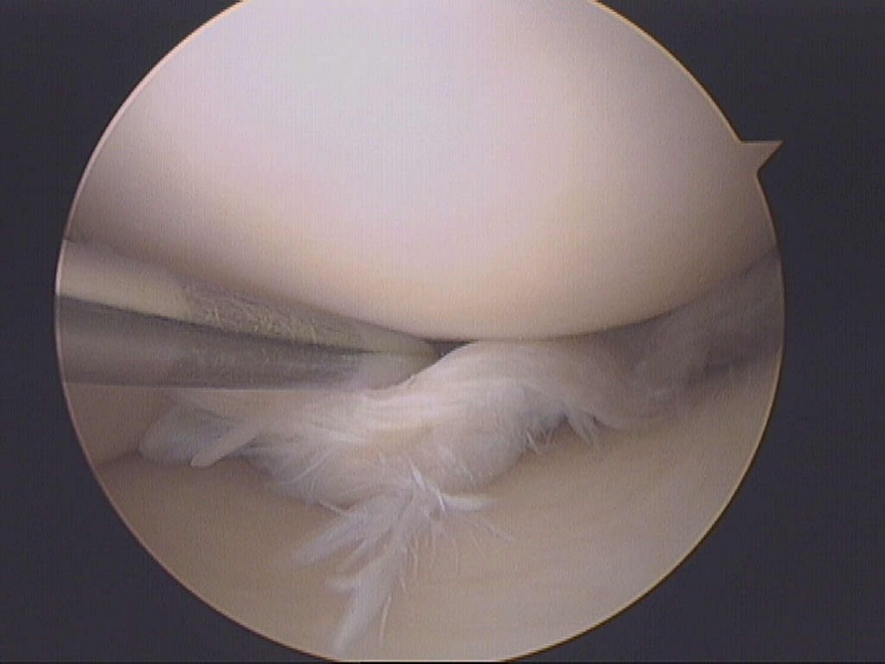
Joint Injuries

