Endocrine System

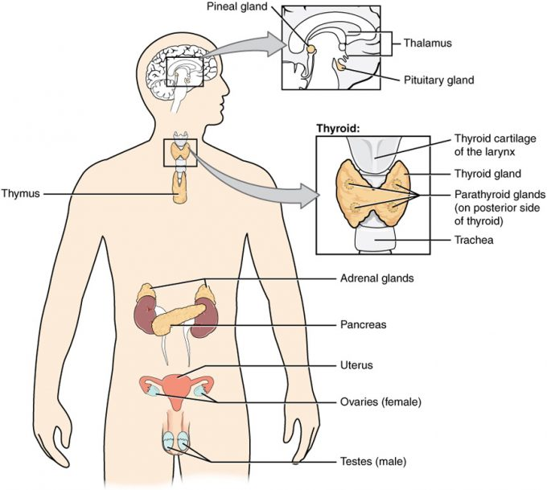

Hormones

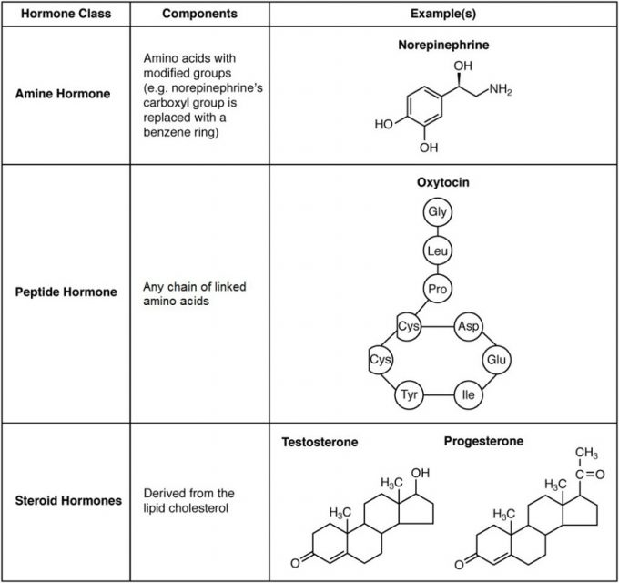
Pathways of Hormone Action

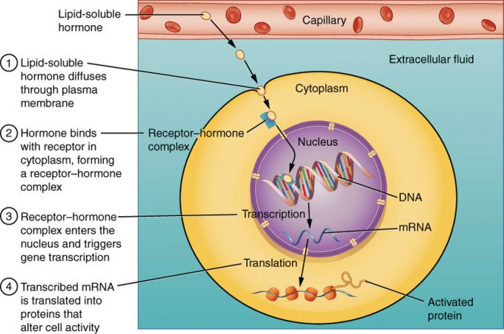

Figure 17.22 – Binding of Lipid-Soluble Hormones: A steroid hormone directly initiates the production of proteins within a target cell. Steroid hormones easily diffuse through the cell membrane. The hormone binds to its receptor in the cytosol, forming a receptor–hormone complex. The receptor–hormone complex then enters the nucleus and binds to the target gene on the DNA. Transcription of the gene creates a messenger RNA that is translated into the desired protein within the cytoplasm.

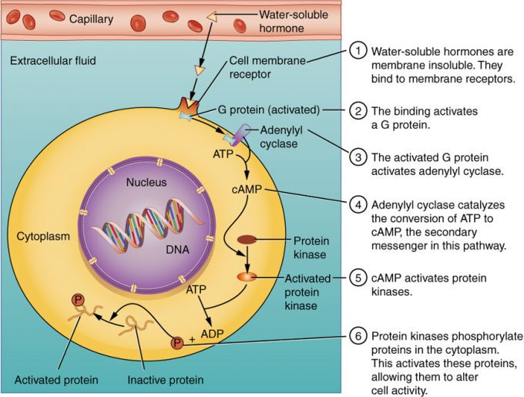

Figure 17.23 – Binding of Water-Soluble Hormones: Water-soluble hormones cannot diffuse through the cell membrane. These hormones must bind to a surface cell-membrane receptor. The receptor then initiates a cell-signaling pathway within the cell involving G proteins, adenylyl cyclase, the secondary messenger cyclic AMP (cAMP), and protein kinases. In the final step, these protein kinases phosphorylate proteins in the cytoplasm. This activates proteins in the cell that carry out the changes specified by the hormone.
Target Cell Response
Hormone Interaction

Control of Hormone Release

Homeostasis

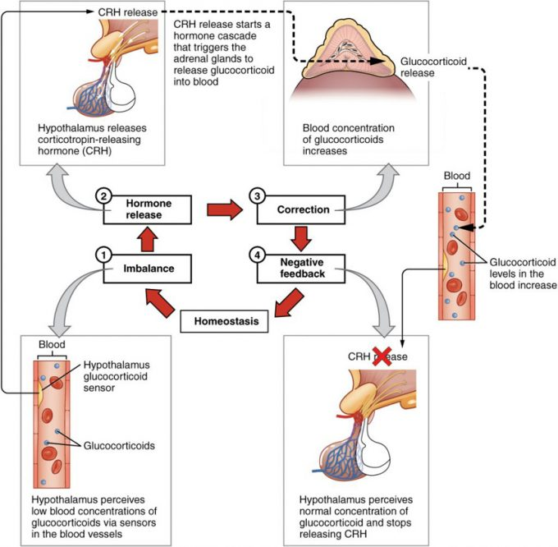

Figure 17.24 – Negative Feedback Loop: The release of adrenal glucocorticoids is stimulated by the release of hormones from the hypothalamus and pituitary gland. This signaling is inhibited when glucocorticoid levels become elevated by causing negative signals to the pituitary gland and hypothalamus.
Role of Hypothalamus

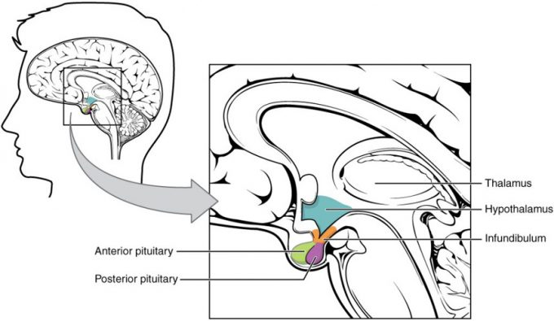

Figure 17.31 – Hypothalamus–Pituitary Complex: The hypothalamus region lies inferior and anterior to the thalamus. It connects to the pituitary gland by the stalk-like infundibulum. The pituitary gland consists of an anterior and posterior lobe, with each lobe secreting different hormones in response to signals from the hypothalamus.

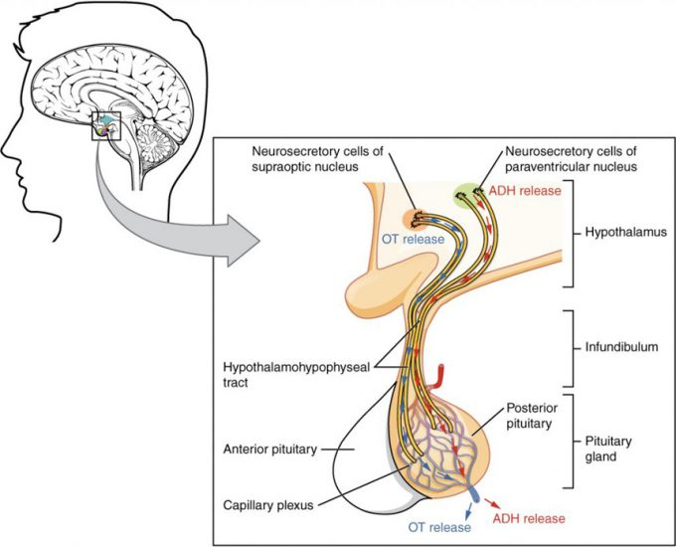

Pituitary Gland

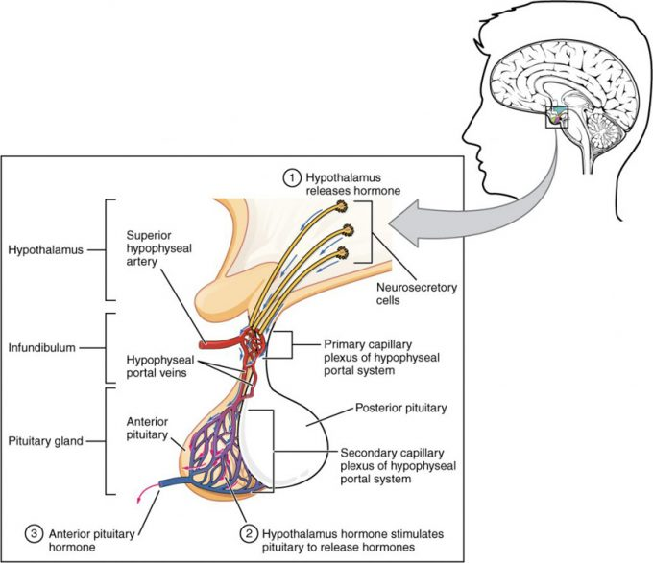

Figure 17.33 – Anterior Pituitary: The anterior pituitary manufactures seven hormones. The hypothalamus produces separate hormones that stimulate or inhibit hormone production in the anterior pituitary. Hormones from the hypothalamus reach the anterior pituitary via the hypophyseal portal system.
Growth Hormone

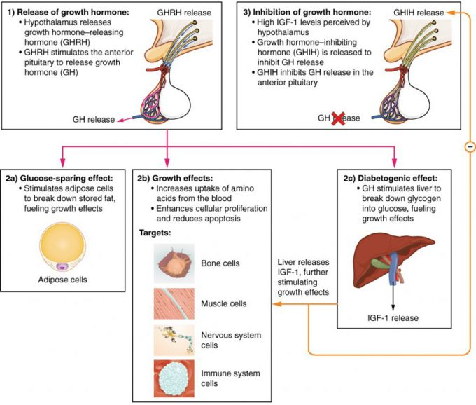

Figure 17.34 – Hormonal Regulation of Growth: Growth hormone (GH) directly accelerates the rate of protein synthesis in skeletal muscle and bones. Insulin-like growth factor 1 (IGF-1) is activated by growth hormone and indirectly supports the formation of new proteins in muscle cells and bone.
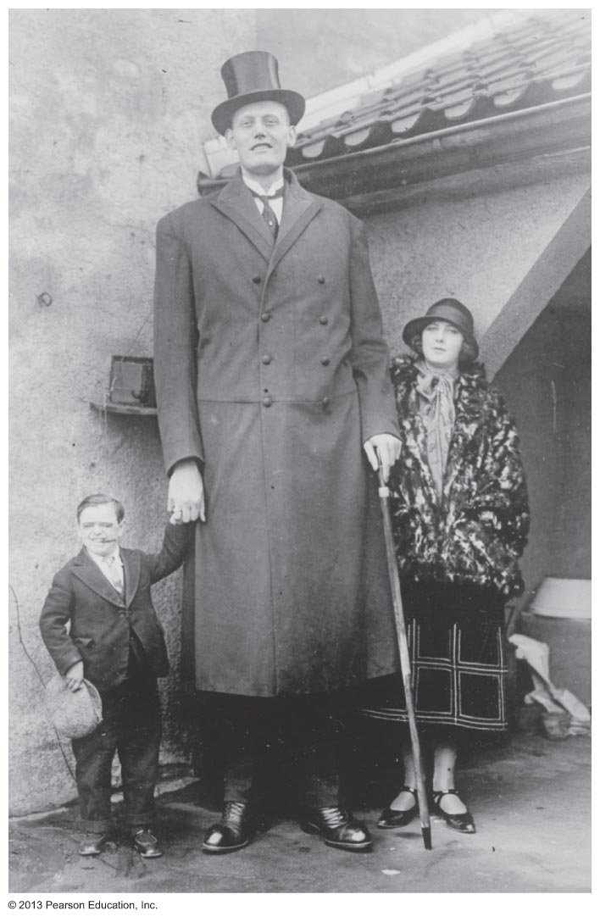
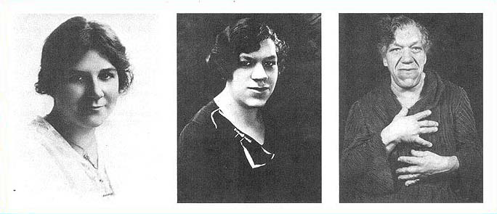
Thyroid Gland

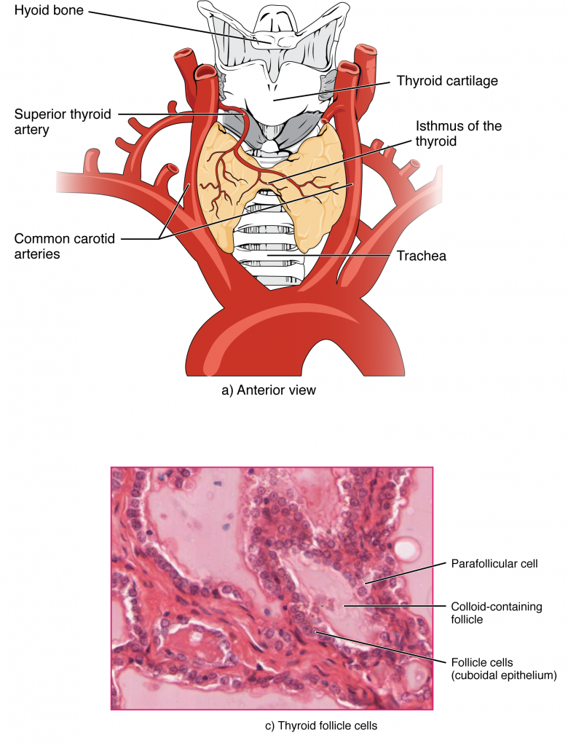
Figure 17.41 – Thyroid Gland: The thyroid gland is located in the neck where it wraps around the trachea. (a) Anterior view of the thyroid gland. (b) Posterior view of the thyroid gland. (c) The glandular tissue is composed primarily of thyroid follicles. The larger parafollicular cells often appear within the matrix of follicle cells. LM × 1332. (Micrograph provided by the Regents of University of Michigan Medical School © 2012)
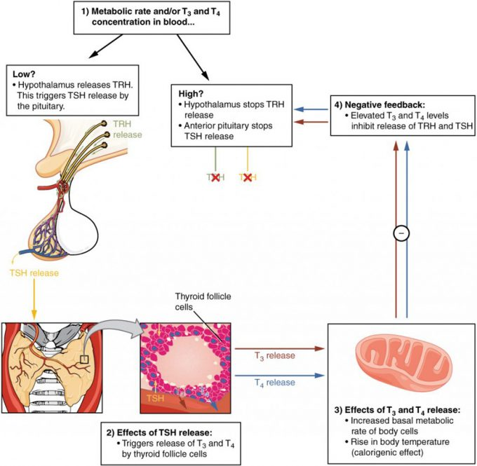

Figure 17.42 – Classic Negative Feedback Loop: A classic negative feedback loop controls the regulation of thyroid hormone levels.
Thyroid Hormones

Disorders

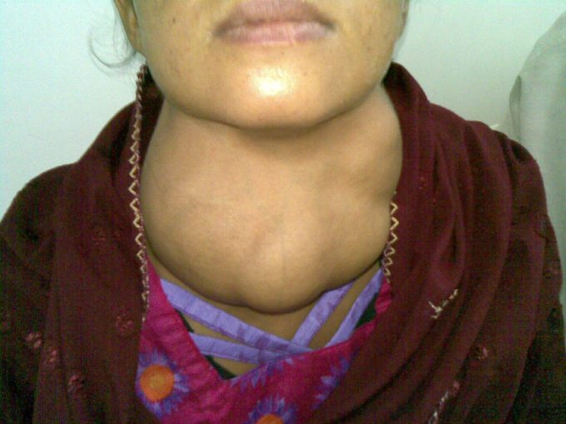
Regulation of Blood Calcium

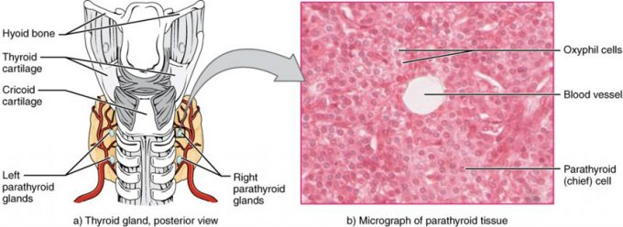

Figure 17.51 – Parathyroid Glands: The small parathyroid glands are embedded in the posterior surface of the thyroid gland. LM × 760. (Micrograph provided by the Regents of University of Michigan Medical School © 2012)

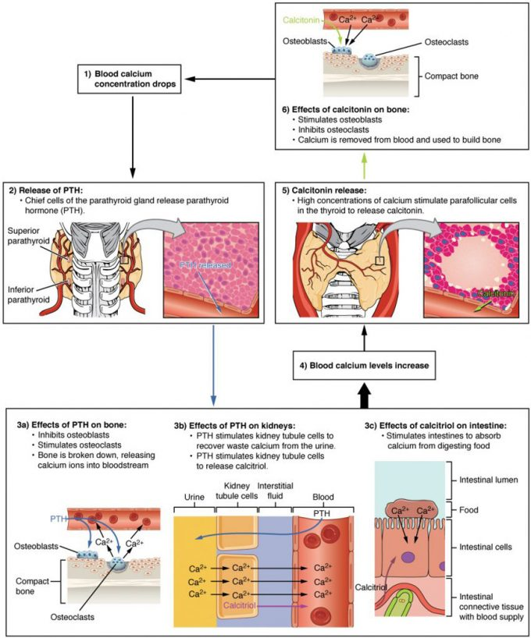
Figure 17.52 – Parathyroid Hormone in Maintaining Blood Calcium Homeostasis: Parathyroid hormone increases blood calcium levels when they drop too low. Conversely, calcitonin, which is released from the thyroid gland, decreases blood calcium levels when they become too high. These two mechanisms constantly maintain blood calcium concentration at homeostasis.
Adrenal Glands

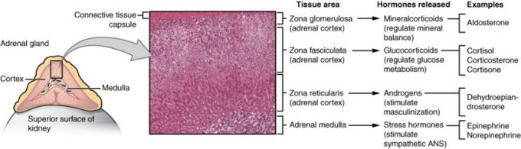

Figure 17.61 – Adrenal Glands: Both adrenal glands sit atop the kidneys and are composed of an outer cortex and an inner medulla, all surrounded by a connective tissue capsule. The cortex can be subdivided into additional zones, all of which produce different types of hormones. LM × 204. (Micrograph provided by the Regents of University of Michigan Medical School © 2012)

Mineralcorticoids
Glucocorticoids

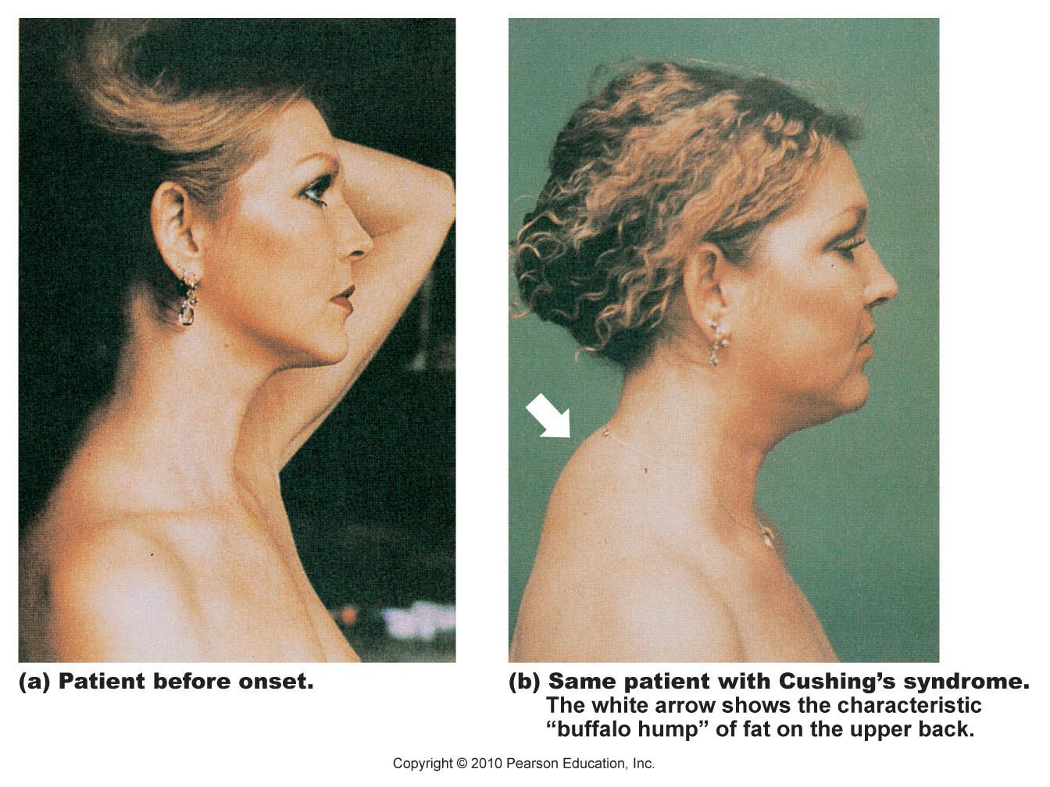

Gonadocorticoids

Pineal Gland

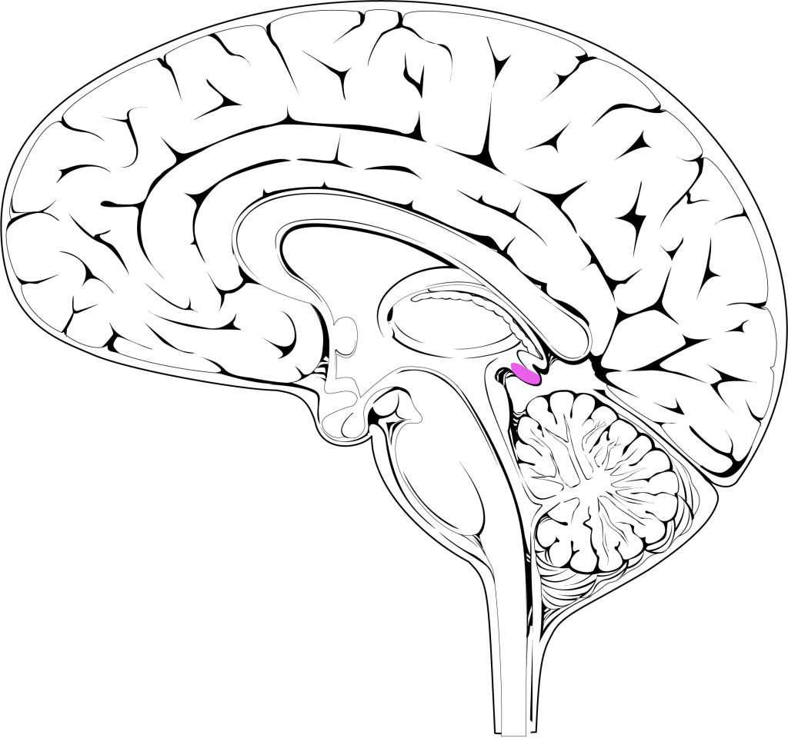
Gonadal and Placental Hormones
Pancreas

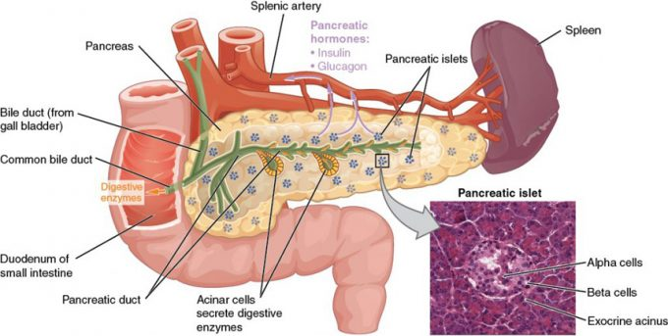

Figure 17.91: Pancreas endocrine function involves the secretion of insulin (produced by beta cells) and glucagon (produced by alpha cells) within the pancreatic islets. These two hormones regulate the rate of glucose metabolism in the body. The micrograph reveals pancreatic islets. LM × 760. Also shown are the exocrine acinar cells. (Micrograph provided by the Regents of University of Michigan Medical School © 2012)

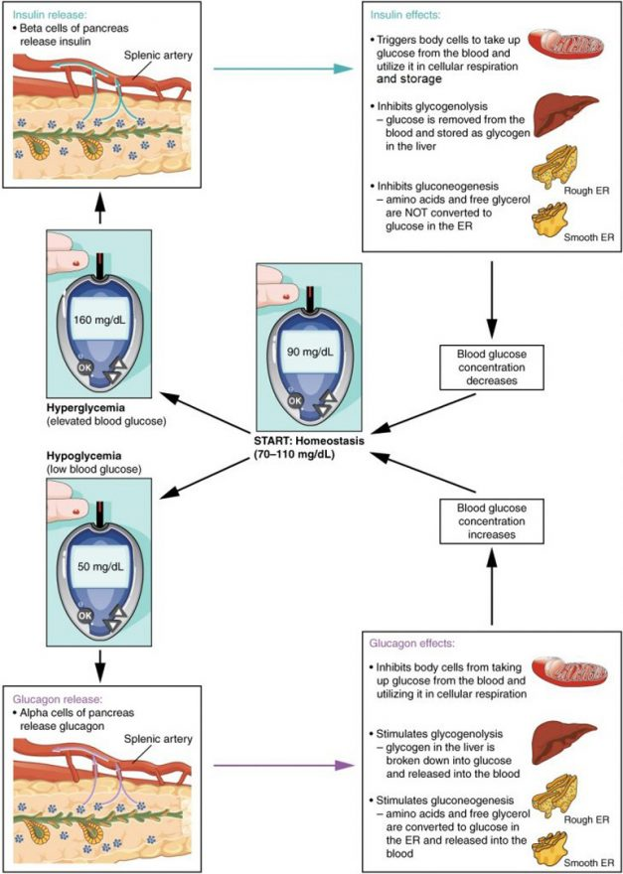

Diabetes Mellitis

Other Organs

Organs with Secondary Endocrine Functions and Their Major Hormones (Table 8)
Organ | Major hormones | Effects
Heart | Atrial natriuretic peptide (ANP) | Reduces blood volume, blood pressure, and Na⁺ concentration
Gastrointestinal tract | Gastrin, secretin, and cholecystokinin | Aid digestion of food and buffering of stomach acids
Gastrointestinal tract | Glucose-dependent insulinotropic peptide (GIP) and glucagon-like peptide 1 (GLP-1) | Stimulate beta cells of the pancreas to release insulin
Kidneys | Renin | Stimulates release of aldosterone
Kidneys | Calcitriol | Aids in the absorption of Ca²⁺
Kidneys | Erythropoietin | Triggers the formation of red blood cells in the bone marrow
Skeleton | FGF23 | Inhibits production of calcitriol and increases phosphate excretion
Skeleton | Osteocalcin | Increases insulin production
Adipose tissue | Leptin | Promotes satiety signals in the brain
Adipose tissue | Adiponectin | Reduces insulin resistance
Skin | Cholecalciferol | Modified to form vitamin D
Thymus (and other organs) | Thymosins | Among other things, aids in the development of T lymphocytes of the immune system
Liver | Insulin-like growth factor-1 | Stimulates bodily growth
Liver | Angiotensinogen | Raises blood pressure
Liver | Thrombopoetin | Causes increase in platelets
Liver | Hepcidin | Blocks release of iron into body fluids

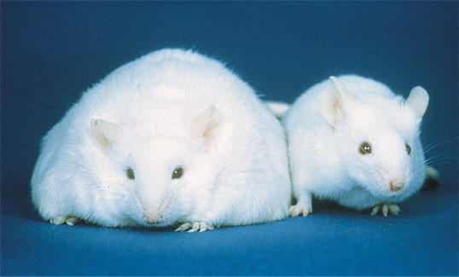

Endocrine Disrupting Chemicals

