ANS

ANS Anatomy

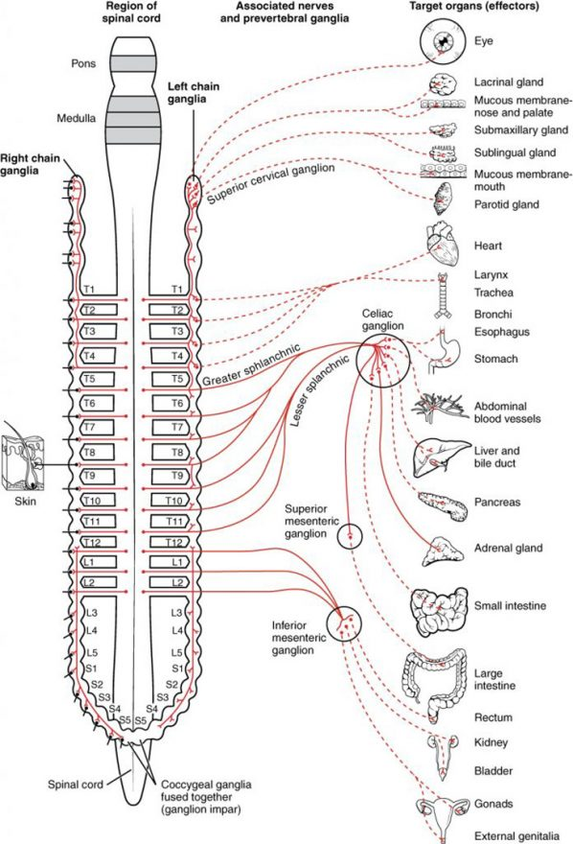
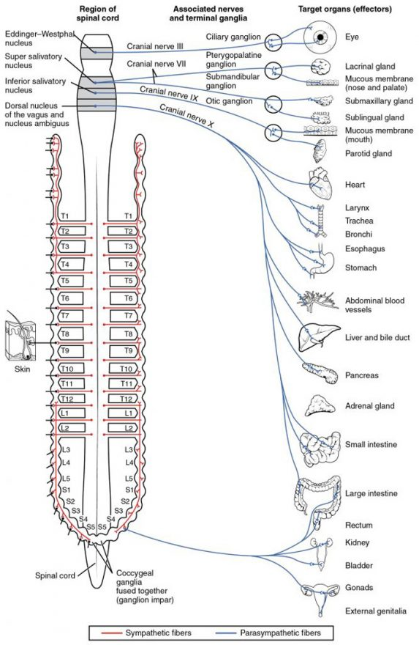
Parasympathetic

Sympathetic

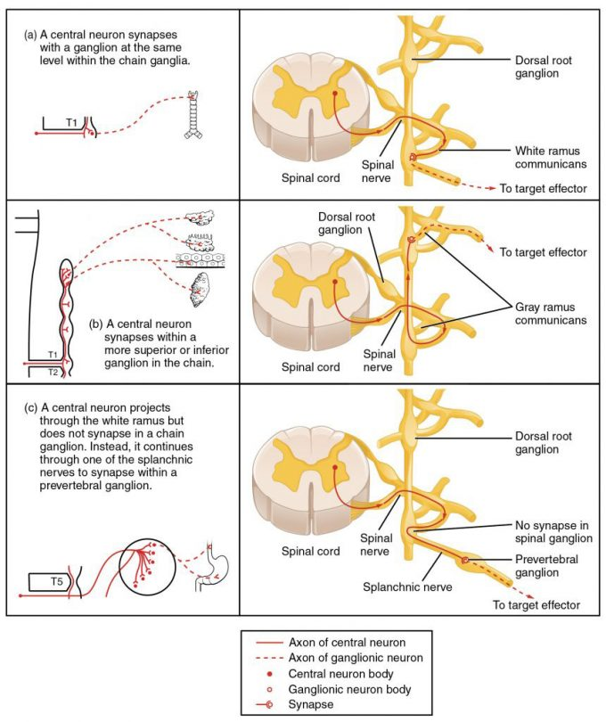
Unique Sympathetic Innervation

Autonomic Varicosities

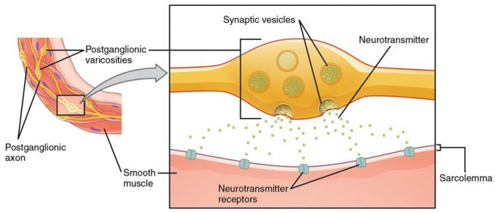
Figure 16.14 – Autonomic Varicosities: The connection between autonomic fibers and target effectors is not the same as the typical synapse, such as the neuromuscular junction. Instead of a synaptic end bulb, a neurotransmitter is released from swellings along the length of a fiber that makes an extended network of connections in the target effector.

ANS Receptors

ANS Reflexes

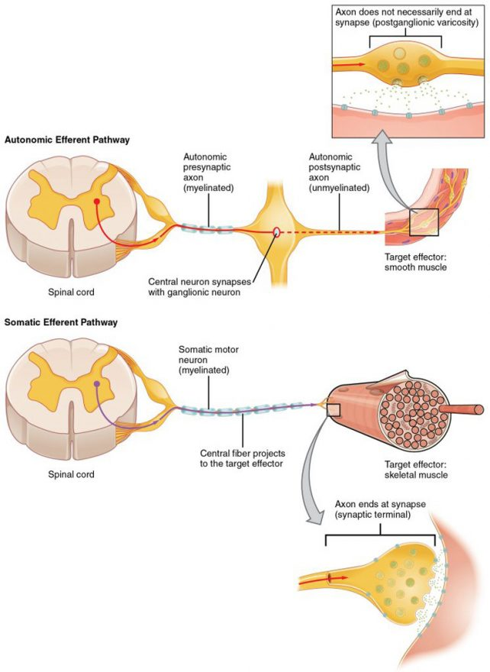
Figure 16.21 – Comparison of Somatic and Visceral Reflexes: The afferent inputs to somatic and visceral reflexes are essentially the same, whereas the efferent branches are different. Somatic reflexes, for instance, involve a direct connection from the ventral horn of the spinal cord to the skeletal muscle. Visceral reflexes involve a projection from the central neuron to a ganglion, followed by a second projection from the ganglion to the target effector.
Referred Pain

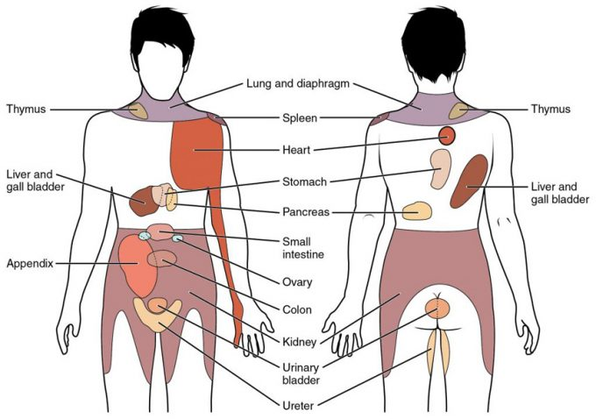
Figure 16.22 – Referred Pain Chart: Conscious perception of visceral sensations map to specific regions of the body, as shown in this chart. Some sensations are felt locally, whereas others are perceived as affecting areas that are quite distant from the involved organ.
Short and Long Reflexes
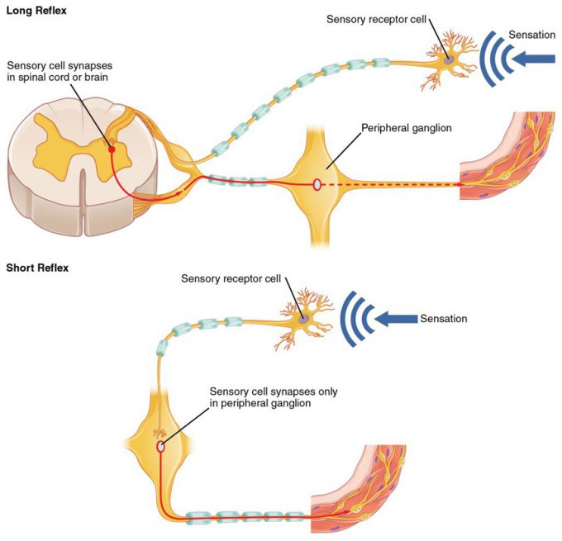
Figure 16.23 – Short and Long Reflexes: Sensory input can stimulate either a short or a long reflex. A sensory neuron can project to the CNS or to an autonomic ganglion. The short reflex involves the direct stimulation of a postganglionic fiber by the sensory neuron, whereas the long reflex involves integration in the spinal cord or brain.
Homeostatic Balance

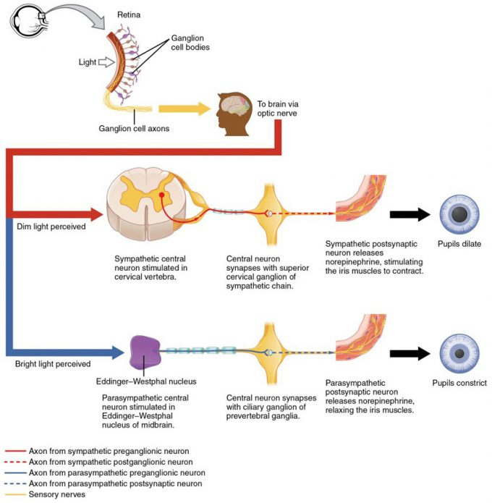
Figure 16.24 – Autonomic Control of Pupillary Size: Activation of the pupillary reflex comes from the amount of light activating the retinal ganglion cells, as sent along the optic nerve. The output of the sympathetic system projects through the superior cervical ganglion, whereas the parasympathetic system originates out of the midbrain and projects through the oculomotor nerve to the ciliary ganglion, which then projects to the iris. The postganglionic fibers of either division release neurotransmitters onto the smooth muscles of the iris to cause changes in the pupillary size. Norepinephrine results in dilation and ACh results in constriction.

ANS and CNS

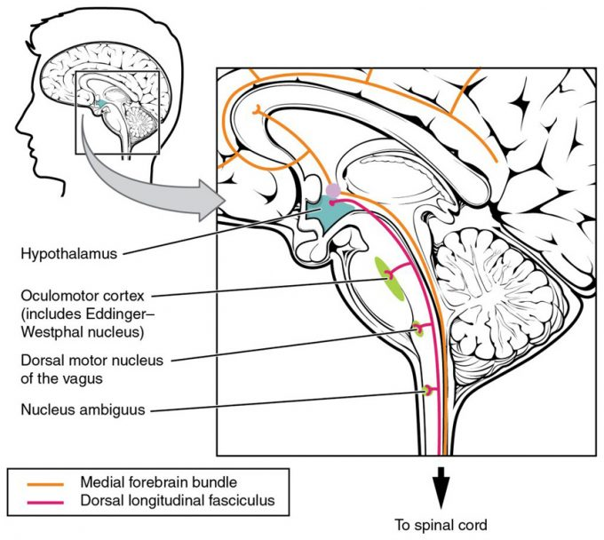
Figure 16.32 – Fiber Tracts of the Central Autonomic System: The hypothalamus is the source of most of the central control of autonomic function. It receives input from cerebral structures and projects to brain stem and spinal cord structures to regulate the balance of sympathetic and parasympathetic input to the organ systems of the body. The main pathways for this are the medial forebrain bundle and the dorsal longitudinal fasciculus.

Medulla

ANS Disorders

Drugs and the ANS

Sympathetic and Parasympathetic Effects of Different Drug Types (Table 2)
Drug type | Example(s) | Sympathetic effect | Parasympathetic effect | Overall result
Nicotinic agonists | Nicotine | Mimic ACh at preganglionic synapses, causing activation of postganglionic fibers and the release of norepinephrine onto the target organ | Mimic ACh at preganglionic synapses, causing activation of postganglionic fibers and the release of ACh onto the target organ | Most conflicting signals cancel each other out, but cardiovascular system is susceptible to hypertension and arrhythmias
Sympathomimetic drugs | Phenylephrine | Bind to adrenergic receptors or mimics sympathetic action in some other way | No effect | Increase sympathetic tone
Sympatholytic drugs | β-blockers such as propanolol or metoprolol; α-agonists such as clonidine | Block binding to adrenergic drug or decrease adrenergic signals | No effect | Increase parasympathetic tone
Parasymphatho-mimetics/muscarinic agonists | Pilocarpine | No effect, except on sweat glands | Bind to muscarinic receptor, similar to ACh | Increase parasympathetic tone
Anticholinergics/muscarinic antagonists | Atropine, scopolamine, dimenhydrinate | No effect | Block muscarinic receptors and parasympathetic function | Increase sympathetic tone

