Terminology: CNS vs. PNS
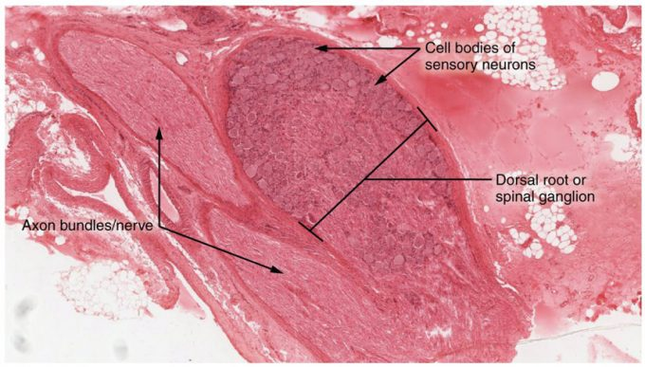
Figure 13.21 – Dorsal Root Ganglion: The cell bodies of sensory neurons, which are unipolar neurons by shape, are seen in this photomicrograph. Also, the fibrous region is composed of the axons of these neurons that are passing through the ganglion to be part of the dorsal nerve root (tissue source: canine). LM × 40. (Micrograph provided by the Regents of University of Michigan Medical School © 2012)

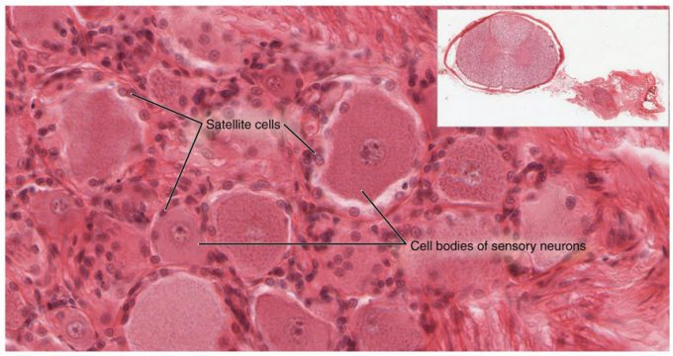
Figure 13.22 – Spinal Cord and Root Ganglion: The slide includes both a cross-section of the lumbar spinal cord and a section of the dorsal root ganglion (see also Figure 13.21) (tissue source: canine). LM × 1600. (Micrograph provided by the Regents of University of Michigan Medical School © 2012)
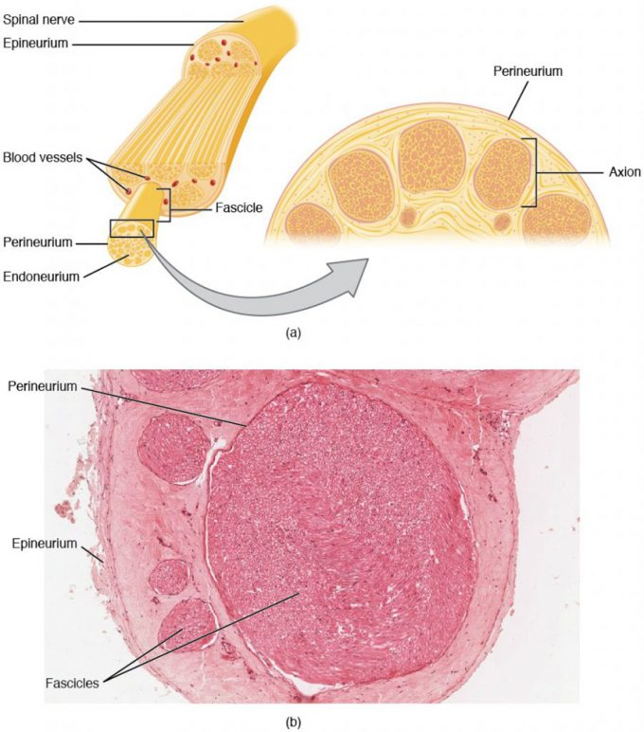
Figure 13.23 – Nerve Structure. The structure of a nerve is organized by the layers of connective tissue on the outside, around each fascicle, and surrounding the individual nerve fibers (tissue source: simian). LM × 40. (Micrograph provided by the Regents of University of Michigan Medical School © 2012)

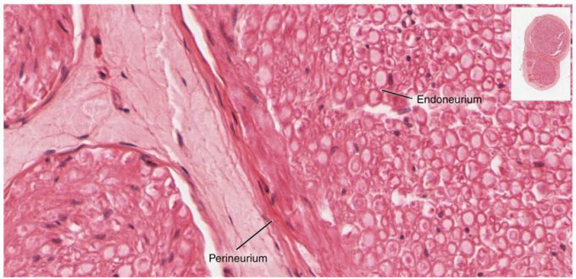
Figure 13.24 – Close-Up of Nerve Trunk: Zoom in on this slide of a nerve trunk to examine the endoneurium, perineurium, and epineurium in greater detail (tissue source: simian). LM × 1600. (Micrograph provided by the Regents of University of Michigan Medical School © 2012)
Sensory Receptors

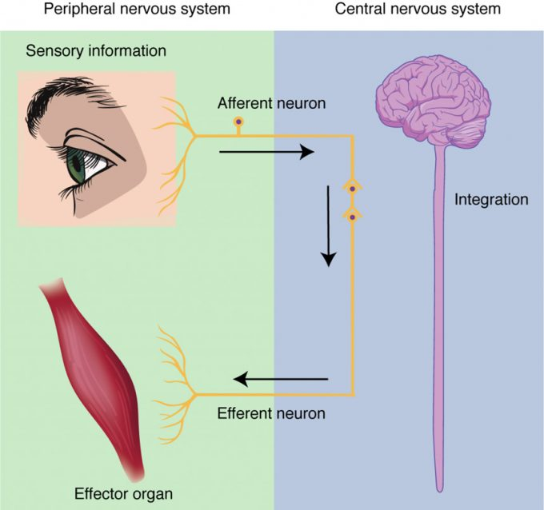

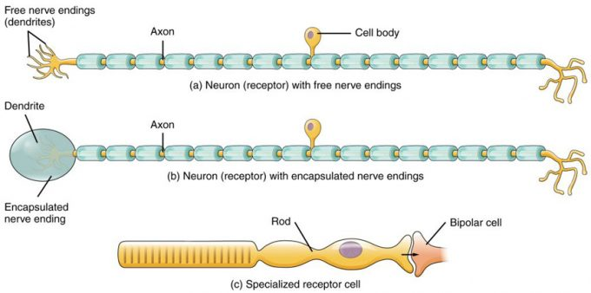

Figure 13.11 – Receptor Classification by Cell Type: Receptor cell types can be classified on the basis of their structure. Sensory neurons can have either (a) free nerve endings or (b) encapsulated endings. Photoreceptors in the eyes, such as rod cells, are examples of (c) specialized receptor cells. These cells release neurotransmitters onto a bipolar cell, which then synapses with the optic nerve neurons.

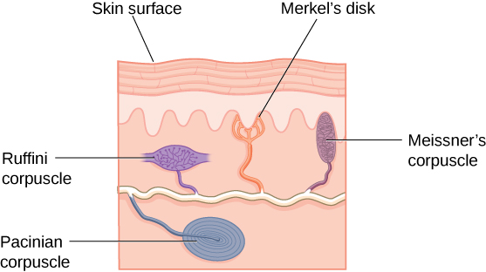

Spinal Nerves

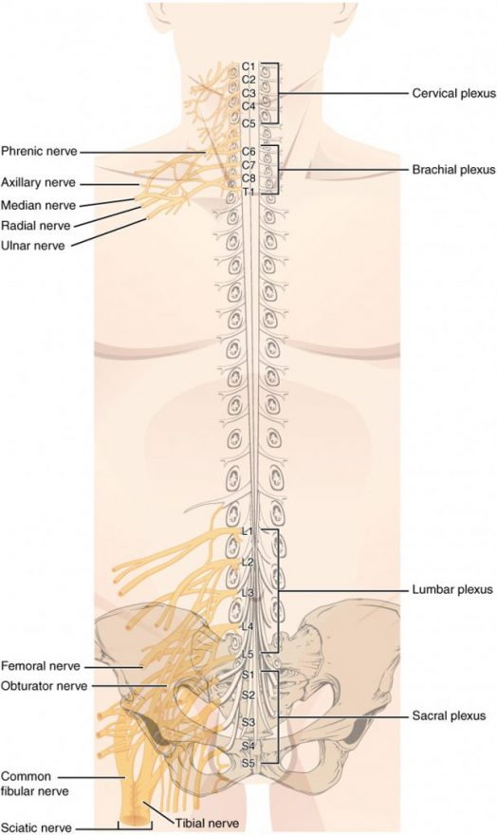
Figure 13.31 – Nerve Plexuses of the Body: There are four main nerve plexuses in the human body. The cervical plexus supplies nerves to the posterior head and neck, as well as to the diaphragm. The brachial plexus supplies nerves to the arm. The lumbar plexus supplies nerves to the anterior leg. The sacral plexus supplies nerves to the posterior leg.
Cranial Nerves

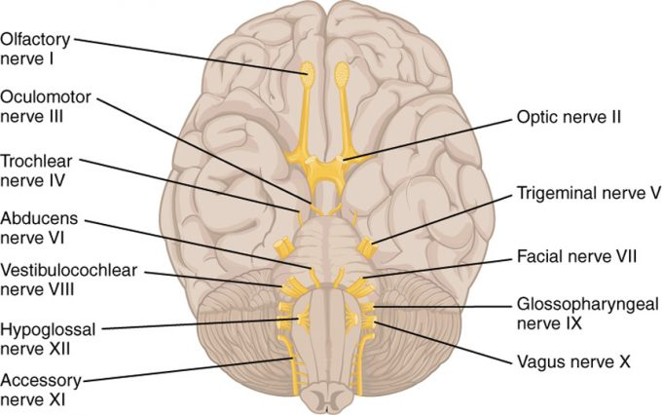

igure 13.32 – The Cranial Nerves: The anatomical arrangement of the roots of the cranial nerves observed from an inferior view of the brain.
PNS and Spinal Cord

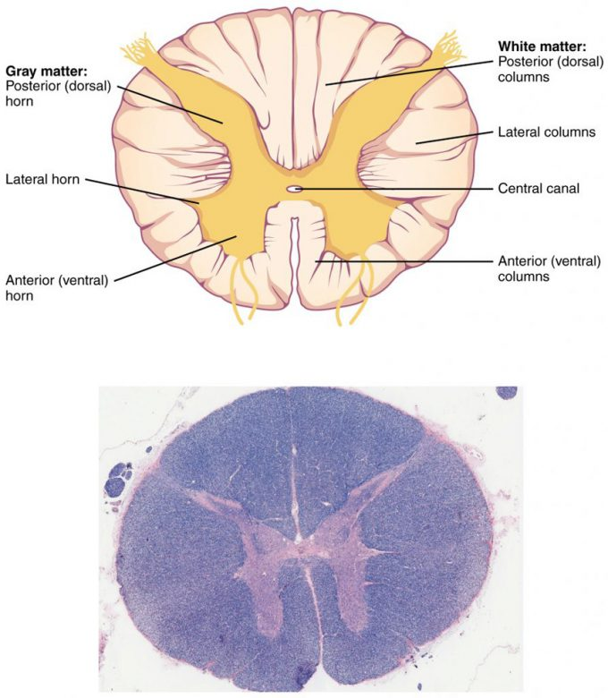 Figure 13.41 – Cross-section of Spinal Cord: The cross-section of a thoracic spinal cord segment shows the posterior, anterior, and lateral horns of gray matter, as well as the posterior, anterior, and lateral columns of white matter. LM × 40. (Micrograph provided by the Regents of University of Michigan Medical School © 2012)

Reflexes

Testing of Nerves

