Nervous System Terminology

Organization of the CNS

Figure 14.11 – Early Embryonic Development of Nervous System: The neuroectoderm begins to fold inward to form the neural groove. As the two sides of the neural groove converge, they form the neural tube, which lies beneath the ectoderm. The anterior end of the neural tube will develop into the brain, and the posterior portion will become the spinal cord. The neural crest develops into peripheral structures.

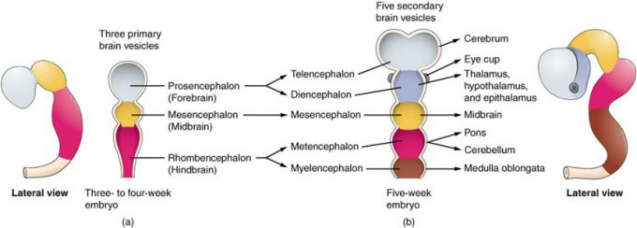

Figure 14.12 – Primary and Secondary Vesicle Stages of Development: The embryonic brain develops complexity through enlargements of the neural tube called vesicles; (a) The primary vesicle stage has three regions, and (b) the secondary vesicle stage has five regions.

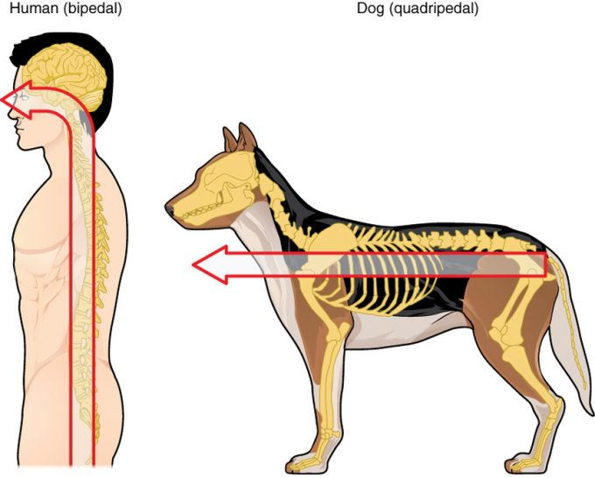

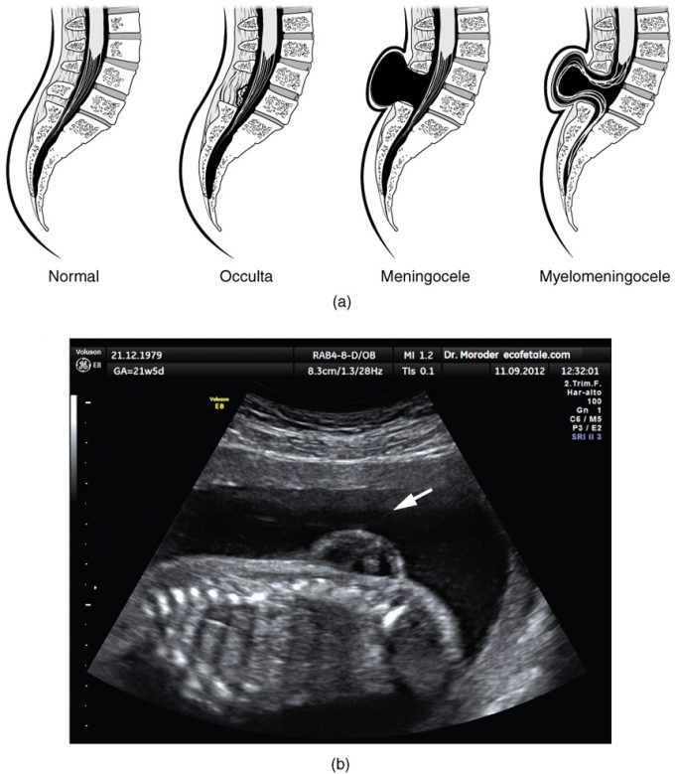
Figure 14.14 – Spinal Bifida: (a) Spina bifida is a birth defect of the spinal cord caused when the neural tube does not completely close, but the rest of development continues. The result is the emergence of meninges and neural tissue through the vertebral column. (b) Fetal myelomeningocele is evident in this ultrasound taken at 21 weeks.

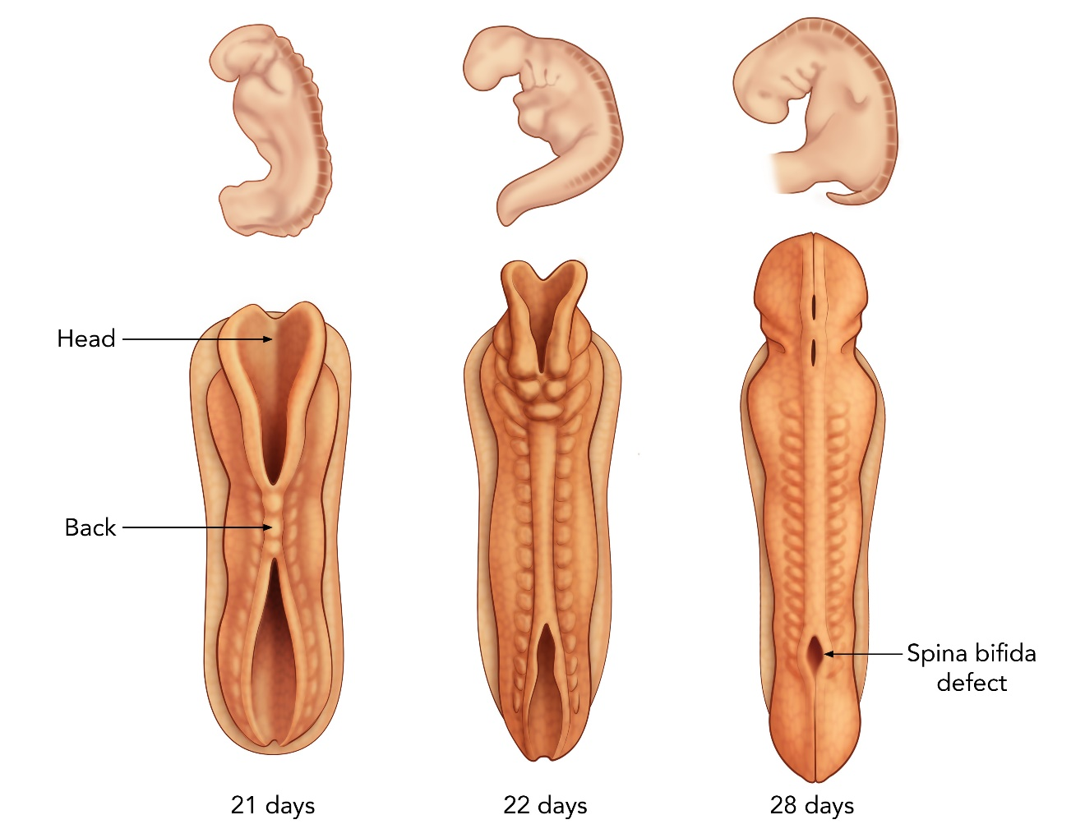

Protection of CNS

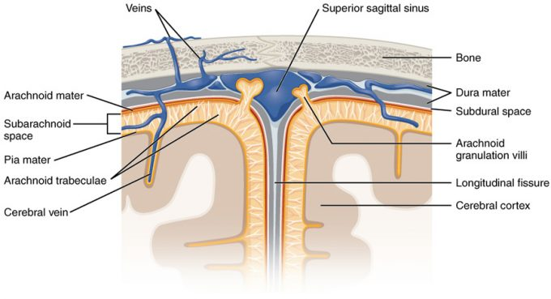
Figure 14.24 – Meningeal Layers of Superior Sagittal Sinus: The layers of the meninges in the longitudinal fissure of the superior sagittal sinus are shown, with the dura mater adjacent to the inner surface of the cranium, the pia mater adjacent to the surface of the brain, and the arachnoid and subarachnoid space between them. An arachnoid villus is shown emerging into the dural sinus to allow CSF to filter back into the blood for drainage.

Blood Flow To and From Brain

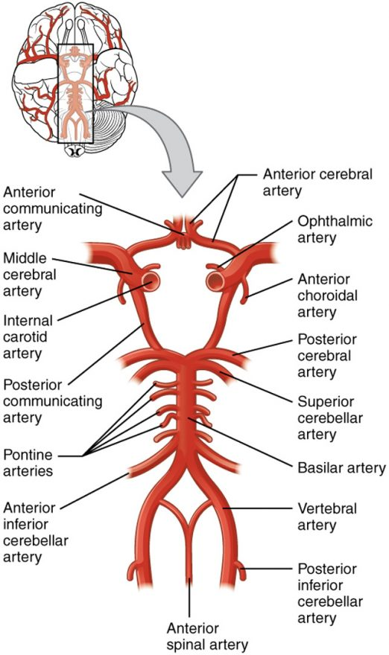
Figure 14.21 – Circle of Willis: The blood supply to the brain enters through the internal carotid arteries and the vertebral arteries, eventually giving rise to the circle of Willis.
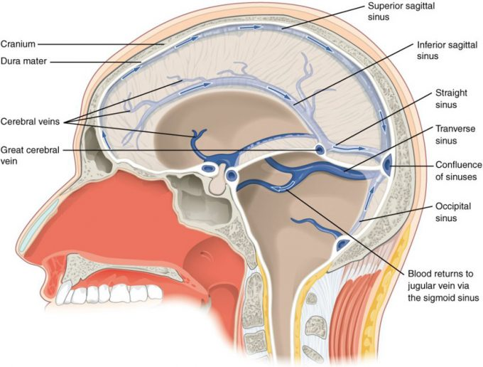
Figure 14.22 – Dural Sinuses and Veins: Blood drains from the brain through a series of sinuses that connect to the jugular veins
Blood-Brain Barrier
CSF Production and Circulation
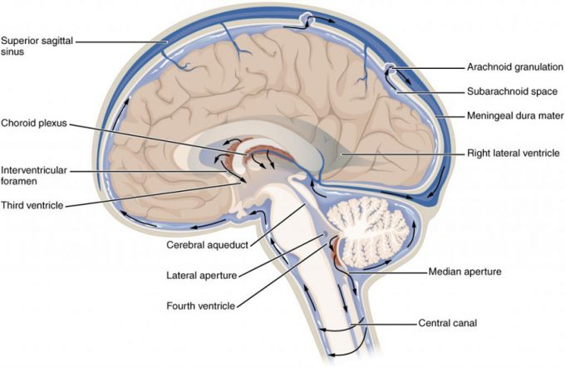
Figure 14.25 – Cerebrospinal Fluid Circulation: The choroid plexus in the four ventricles produce CSF, which is circulated through the ventricular system and then enters the subarachnoid space through the median and lateral apertures. The CSF is then reabsorbed into the blood at the arachnoid granulations, where the arachnoid membrane emerges into the dural sinuses.

Hydrocephalus

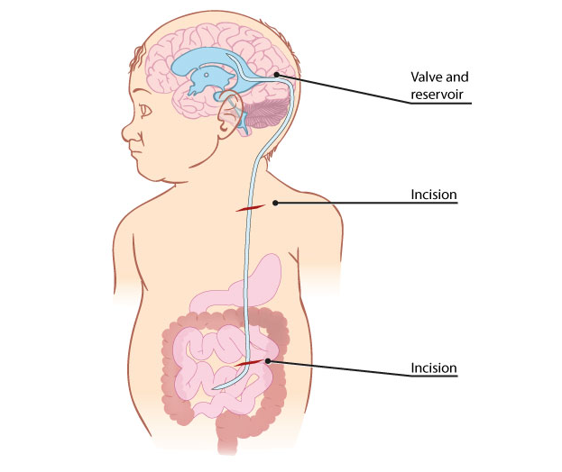

Cerebral Hemispheres

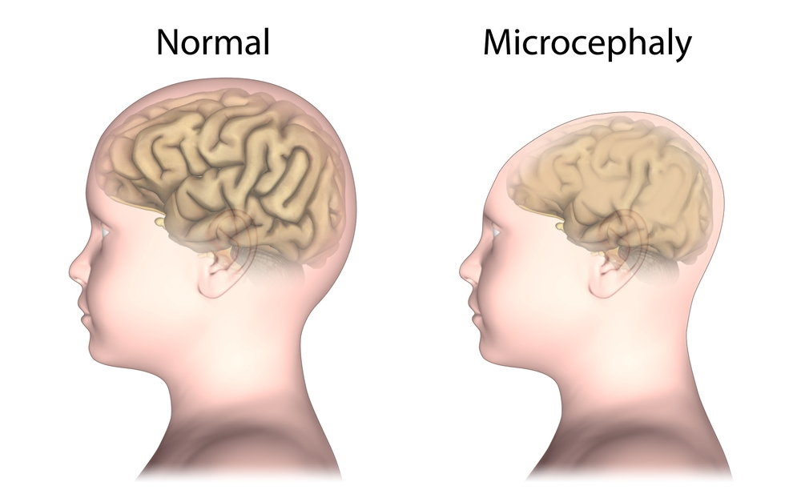
Cerebrum

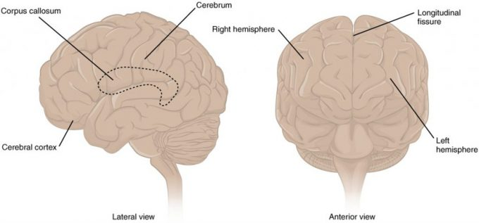
Figure 14.31 – The Cerebrum: The cerebrum is a large component of the CNS in humans, and the most obvious aspect of it is the folded surface called the cerebral cortex.

Cerebral Cortex

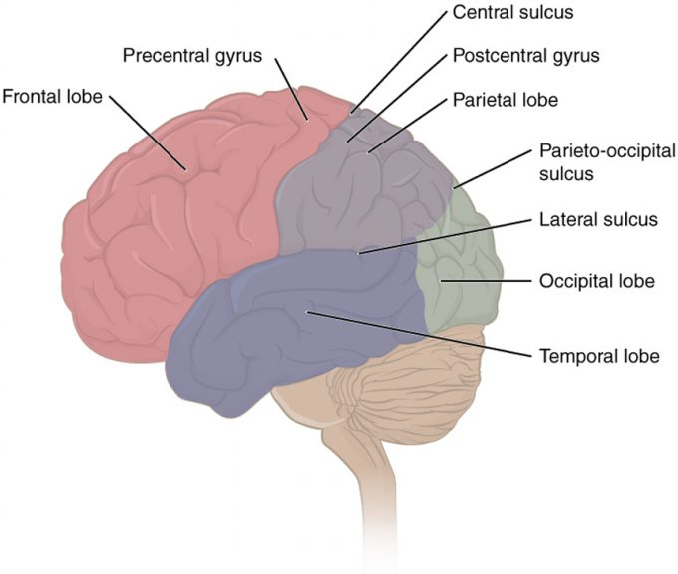

Figure 14.32 – Lobes of the Cerebral Cortex: The cerebral cortex is divided into four lobes. Extensive folding increases the surface area available for cerebral functions.
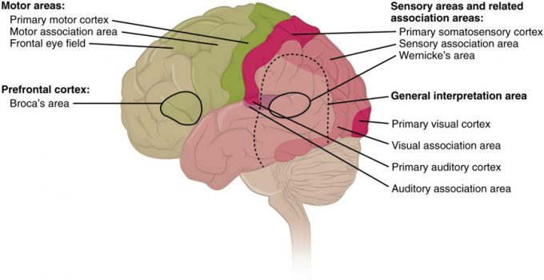
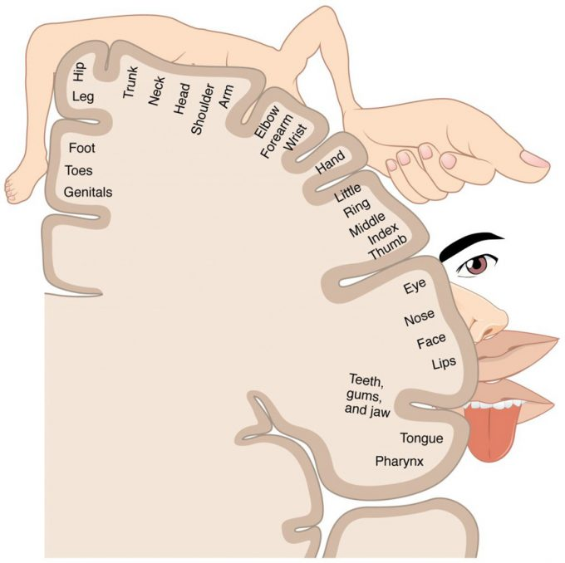

Figure 14.52 – The Sensory Homunculus: A cartoon representation of the sensory homunculus arranged adjacent to the cortical region in which the processing takes place.
Cerebral White Area
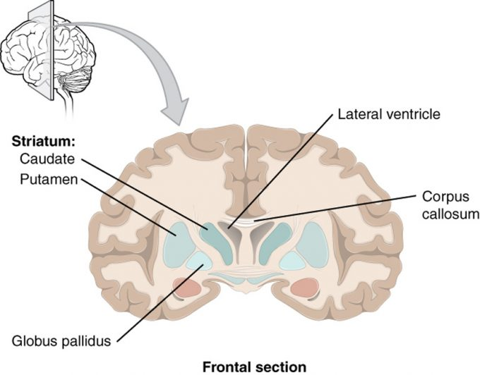

Figure 14.36 – Frontal Section of Cerebral Cortex and Basal Nuclei: The major components of the basal nuclei, shown in a frontal section of the brain, are the caudate (just lateral to the lateral ventricle), the putamen (inferior to the caudate and separated by the large white-matter structure called the internal capsule), and the globus pallidus (medial to the putamen).
Basal Nuclei

Diencephalon

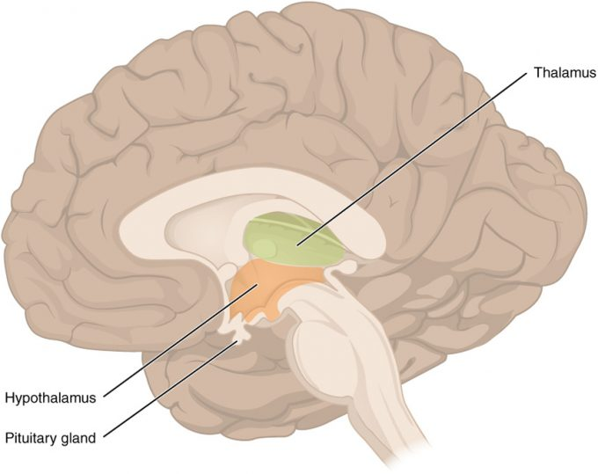
Figure 14.38 – The Diencephalon: The diencephalon is composed primarily of the thalamus and hypothalamus, which together define the walls of the third ventricle. The thalami are two elongated, ovoid structures on either side of the midline that make contact in the middle. The hypothalamus is inferior and anterior to the thalamus, culminating in a sharp angle to which the pituitary gland is attached.
Midbrain
Brain Stem
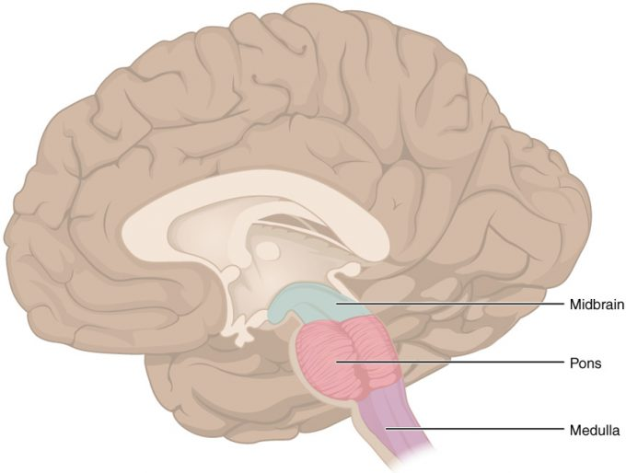
Figure 14.39 – The Brain Stem: The brain stem comprises three regions: the midbrain, the pons, and the medulla.
Cerebellum

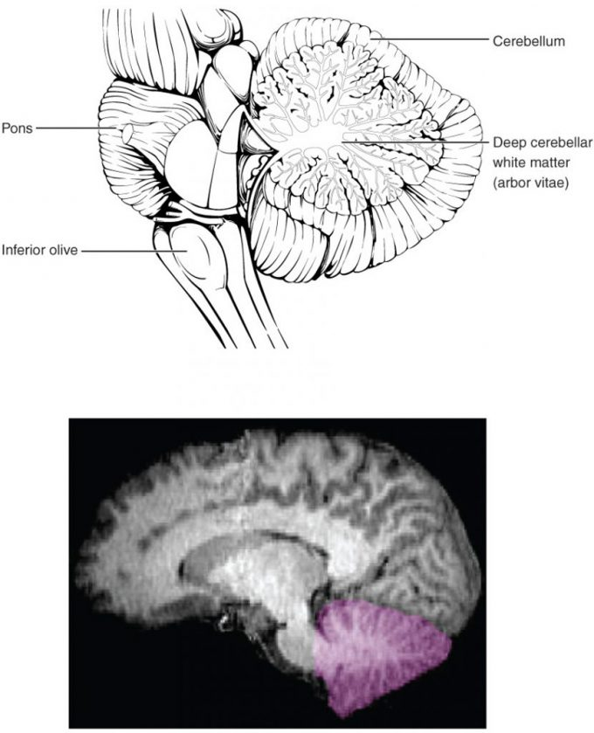
Figure 14.310 – The Cerebellum: The cerebellum is situated on the posterior surface of the brain stem. Descending input from the cerebellum enters through the large white matter structure of the pons. Ascending input from the periphery and spinal cord enters through the fibers of the inferior olive. Output goes to the midbrain, which sends a descending signal to the spinal cord.
Limbic System

Reticular Formation

Brain Injuries and Disorders

Spinal Cord Anatomy

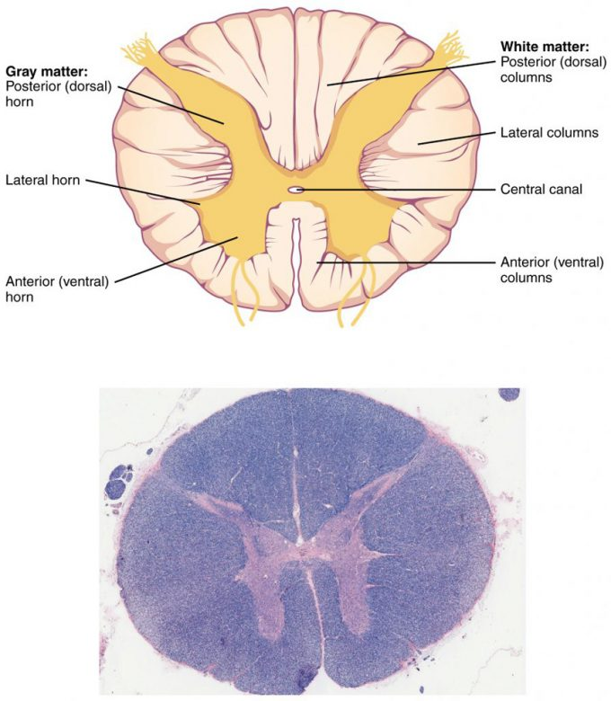
Figure 14.41 – Cross-section of Spinal Cord: The cross-section of a thoracic spinal cord segment shows the posterior, anterior, and lateral horns of gray matter, as well as the posterior, anterior, and lateral columns of white matter. LM × 40. (Micrograph provided by the Regents of University of Michigan Medical School © 2012)

Sensory and Motor Pathways

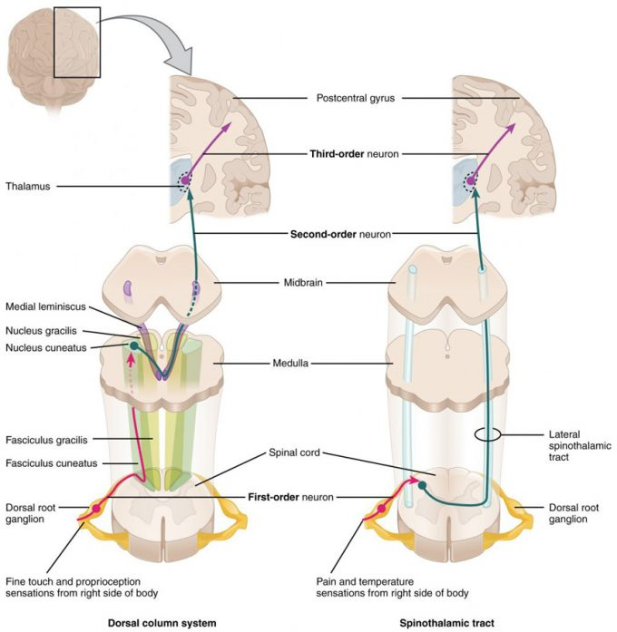

Figure 14.51 – Ascending Sensory Pathways of the Spinal Cord: The dorsal column system and spinothalamic tract are the major ascending pathways that connect the periphery with the brain.

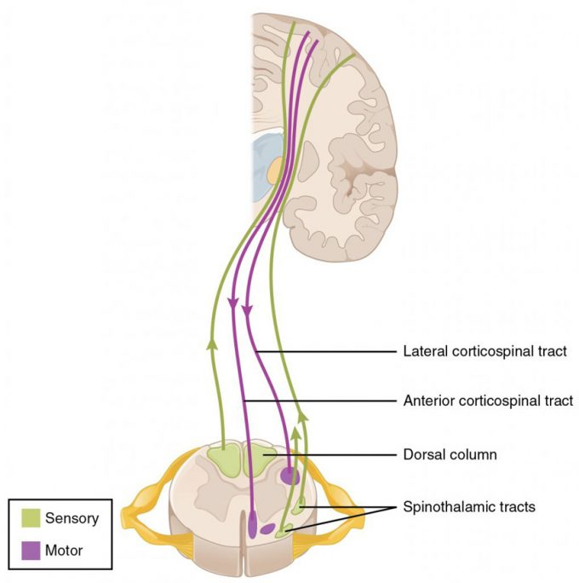

Figure 14.55 – Locations of Spinal Fiber Tracts

Dermatomes

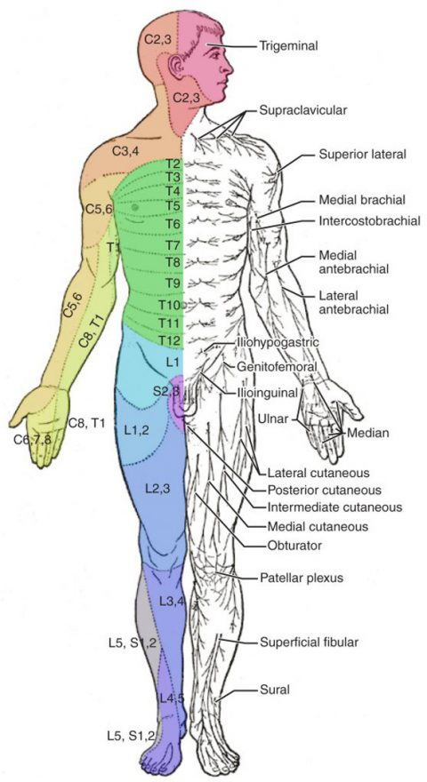
Figure 14.56 – Dermatomes: The surface of the skin can be divided into topographic regions that relate to the location of sensory endings in the skin based on the spinal nerve that contains those fibers. (credit: modification of work by Mikael Häggström)

