Special Senses

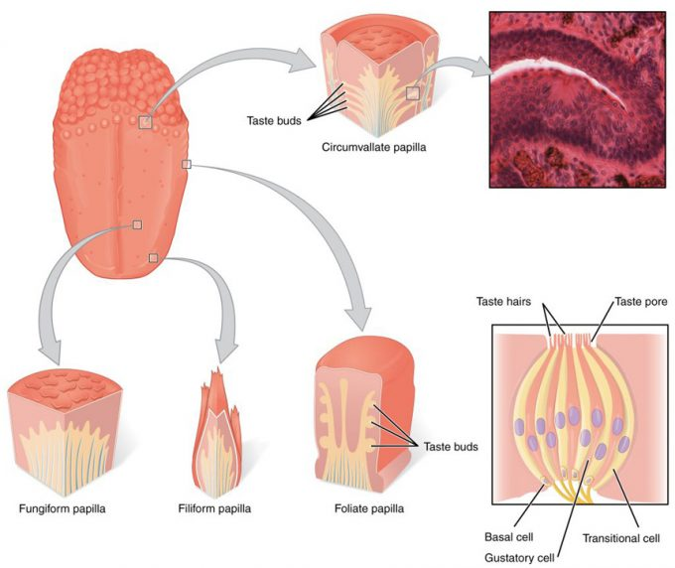
Figure 15.11 – The Tongue: The tongue is covered with small bumps, called papillae, which contain taste buds that are sensitive to chemicals in ingested food or drink. Different types of papillae are found in different regions of the tongue. The taste buds contain specialized gustatory receptor cells that respond to chemical stimuli dissolved in the saliva. These receptor cells activate sensory neurons that are part of the facial and glossopharyngeal nerves. LM × 1600. (Micrograph provided by the Regents of University of Michigan Medical School © 2012)

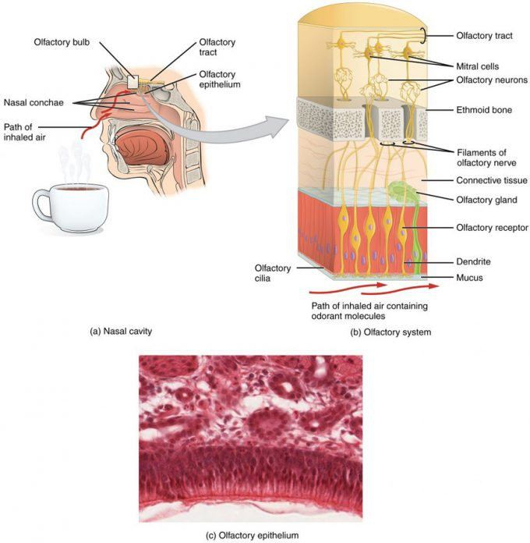
Figure 15.21 – The Olfactory System: (a) The olfactory system begins in the peripheral structures of the nasal cavity. (b) The olfactory receptor neurons are within the olfactory epithelium. (c) Axons of the olfactory receptor neurons project through the cribriform plate of the ethmoid bone and synapse with the neurons of the olfactory bulb (tissue source: simian). LM × 812. (Micrograph provided by the Regents of University of Michigan Medical School © 2012)

Hearing

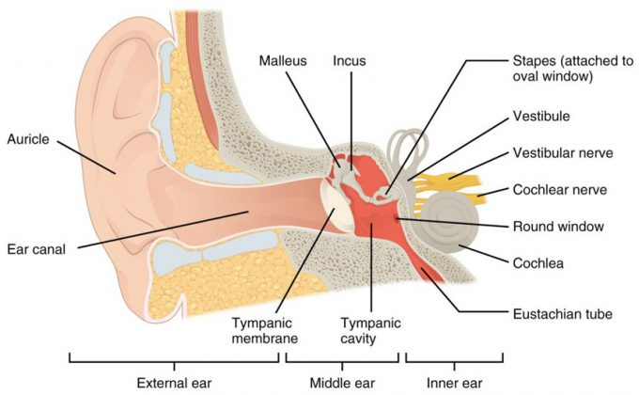
Figure 15.31 – Structures of the Ear: The external ear contains the auricle, ear canal, and tympanic membrane. The middle ear contains the ossicles and is connected to the pharynx by the Eustachian tube. The inner ear contains the cochlea and vestibule, which are responsible for audition and equilibrium, respectively.

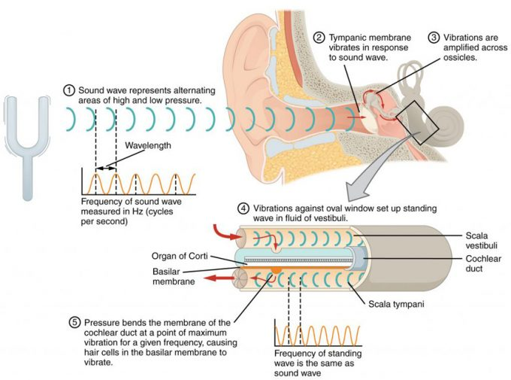
Figure 15.32 – Transmission of Sound Waves to Cochlea: A sound wave causes the tympanic membrane to vibrate. This vibration is amplified as it moves across the malleus, incus, and stapes. The amplified vibration is picked up by the oval window causing pressure waves in the fluid of the scala vestibuli and scala tympani. The complexity of the pressure waves is determined by the changes in amplitude and frequency of the sound waves entering the ear.

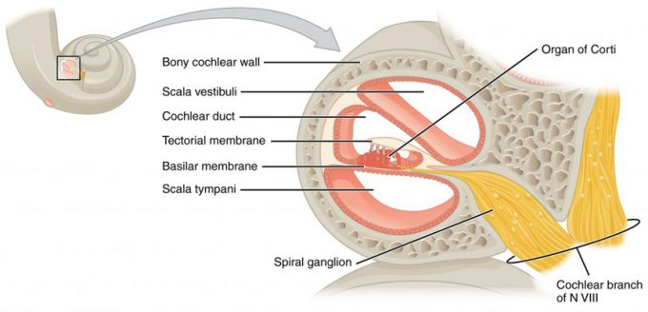

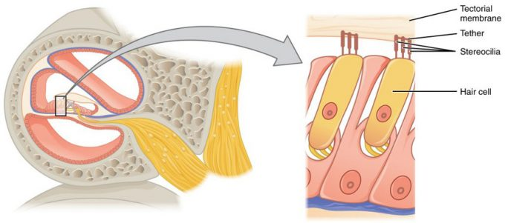
Figure 15.34 – Hair Cell: The hair cell is a mechanoreceptor with an array of stereocilia emerging from its apical surface. The stereocilia are tethered together by proteins that open ion channels when the array is bent toward the tallest member of their array, and closed when the array is bent toward the shortest member of their array.

Hearing Loss

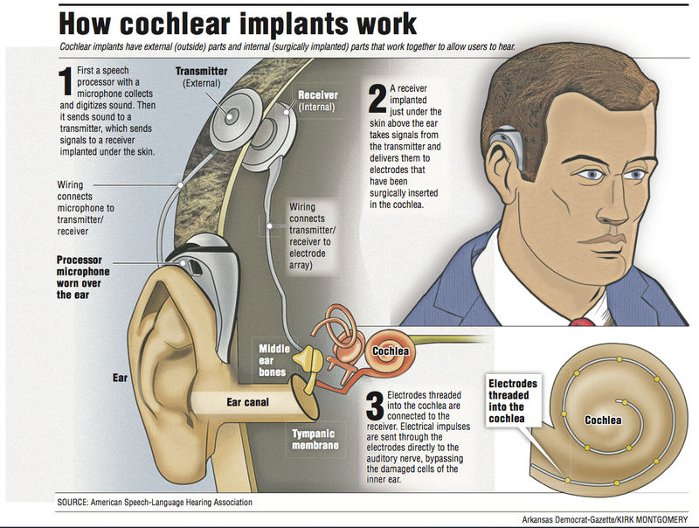

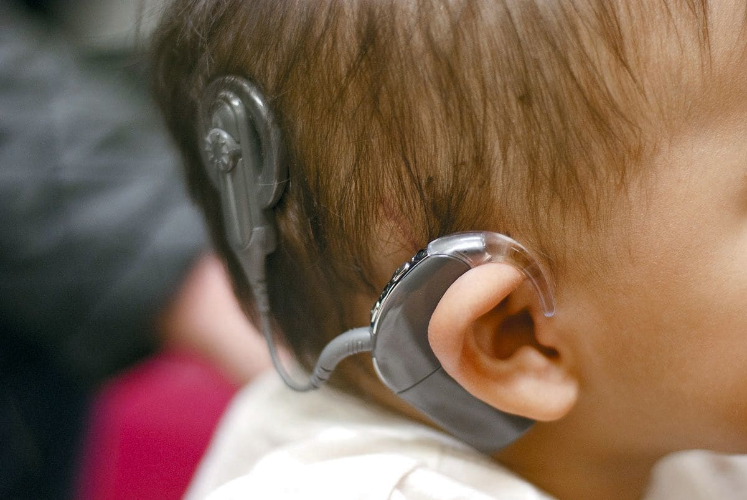
Equilibrium

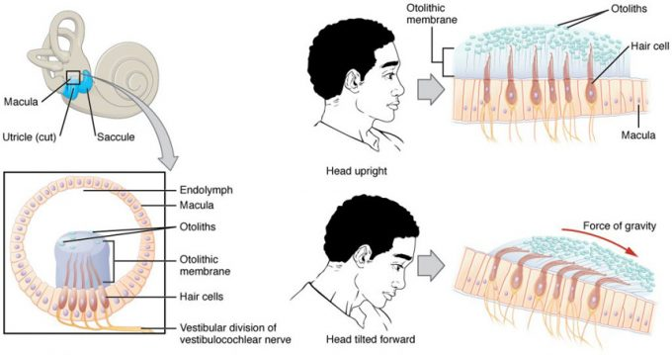
Figure 15.41 – Linear Acceleration Coding by Maculae: The maculae are specialized for sensing linear acceleration, such as when gravity acts on the tilting head, or if the head starts moving in a straight line. The difference in inertia between the hair cell stereocilia and the otolithic membrane in which they are embedded leads to a shearing force that causes the stereocilia to bend in the direction of that linear acceleration.
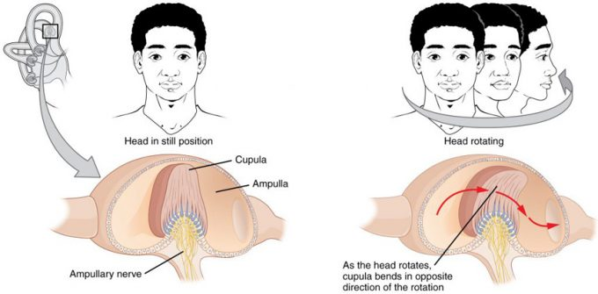
Figure 15.42 – Rotational Coding by Semicircular Canals: Rotational movement of the head is encoded by the hair cells in the base of the semicircular canals. As one of the canals moves in an arc with the head, the internal fluid moves in the opposite direction, causing the cupula and stereocilia to bend. The movement of two canals within a plane results in information about the direction in which the head is moving, and activation of all six canals can give a very precise indication of head movement in three dimensions.

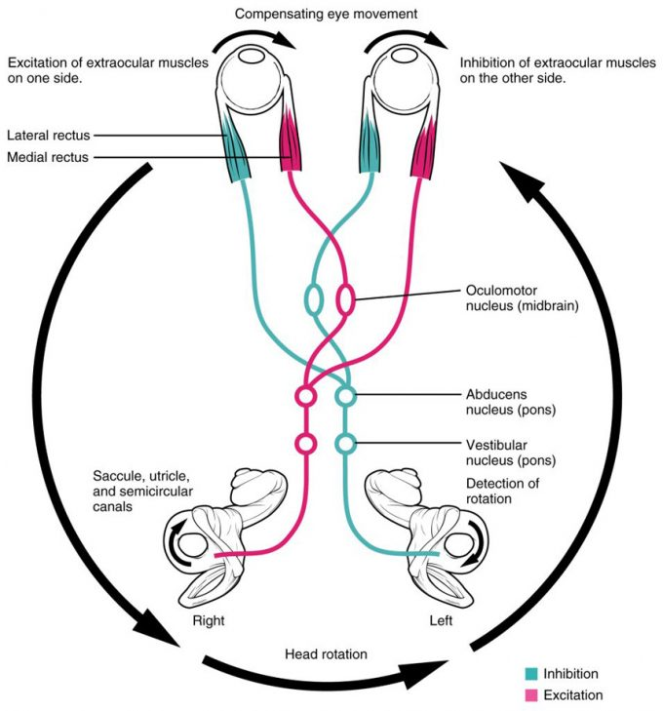
Figure 15.43 – Vestibulo-ocular Reflex: Connections between the vestibular system and the cranial nerves controlling eye movement keep the eyes centered on a visual stimulus, even though the head is moving. During head movement, the eye muscles move the eyes in the opposite direction as the head movement, keeping the visual stimulus centered in the field of view.

Vision

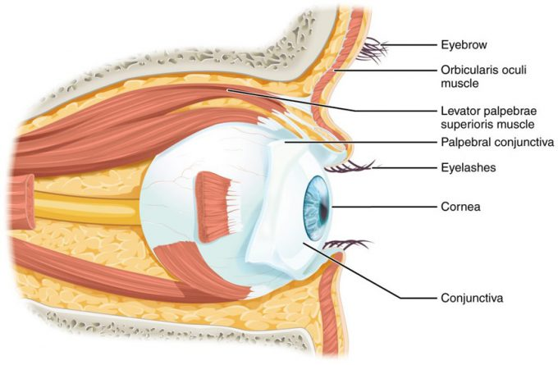
Figure 15.51 – The Eye in the Orbit: The eye is located within the orbit and surrounded by soft tissues that protect and support its function. The orbit is surrounded by cranial bones of the skull.

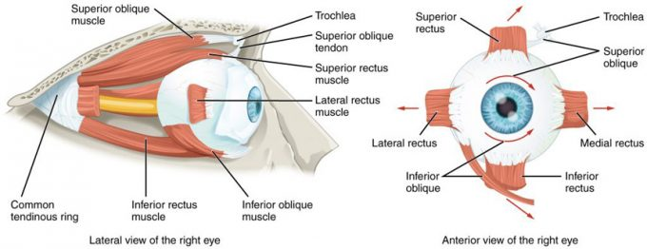
Figure 15.52 – Extraocular Muscles: The extraocular muscles move the eye within the orbit.

Structure of Eye

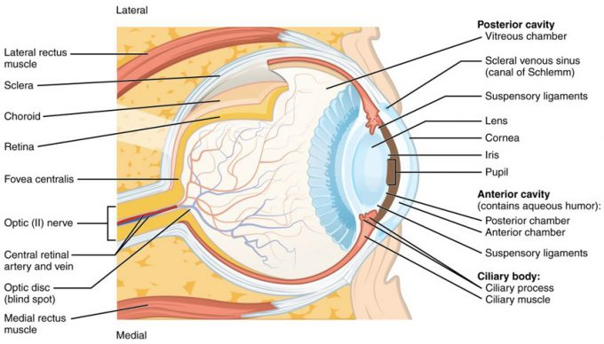
Figure 15.53 – Structure of the Eye: The sphere of the eye can be divided into anterior and posterior chambers. The wall of the eye is composed of three layers: the fibrous tunic, vascular tunic, and neural tunic. Within the neural tunic is the retina, with three layers of cells and two synaptic layers in between. The center of the retina has a small indentation known as the fovea.

Internal Fluids of Eye
Lens

Cataracts

Photoreceptors

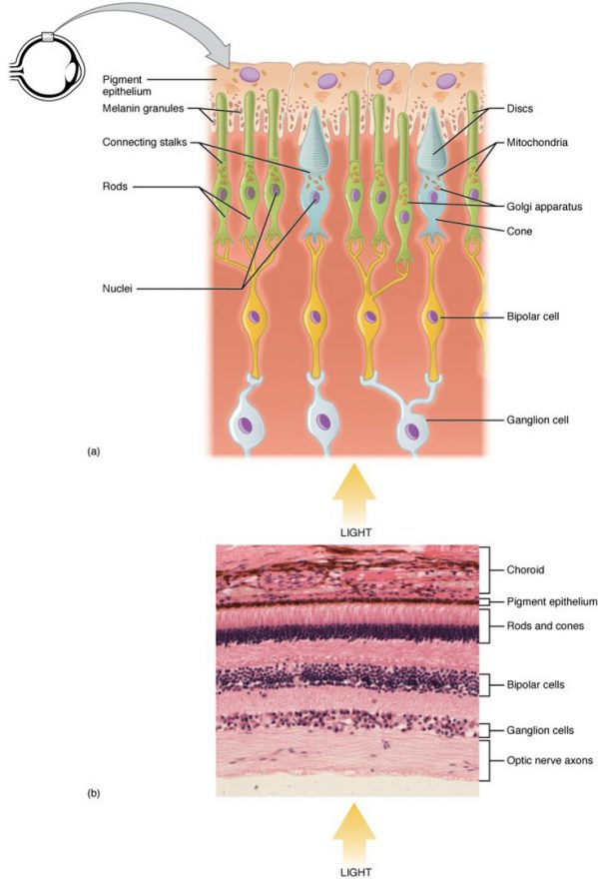
Figure 15.54 – Photoreceptor: (a) All photoreceptors have inner segments containing the nucleus and other important organelles and outer segments with membrane arrays containing the photosensitive opsin molecules. Rod outer segments are long columnar shapes with stacks of membrane-bound discs that contain the rhodopsin pigment. Cone outer segments are short, tapered shapes with folds of membrane in place of the discs in the rods. (b) Tissue of the retina shows a dense layer of nuclei of the rods and cones. LM × 800. (Micrograph provided by the Regents of University of Michigan Medical School © 2012)
Transduction in Rods

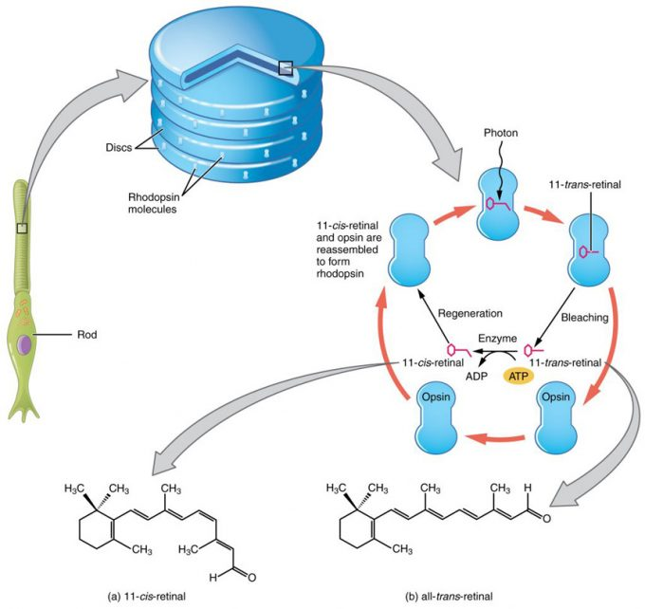
Figure 15.55 – Retinal Isomers: The retinal molecule has two isomers, (a) one before a photon interacts with it and (b) one that is altered through photoisomerization.

Cones

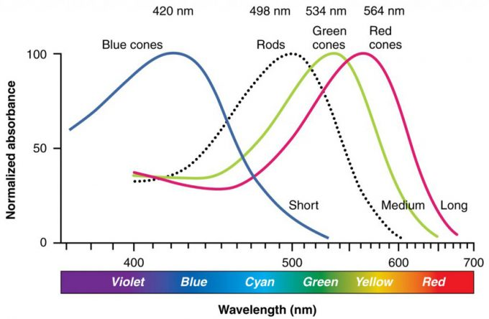

Processing

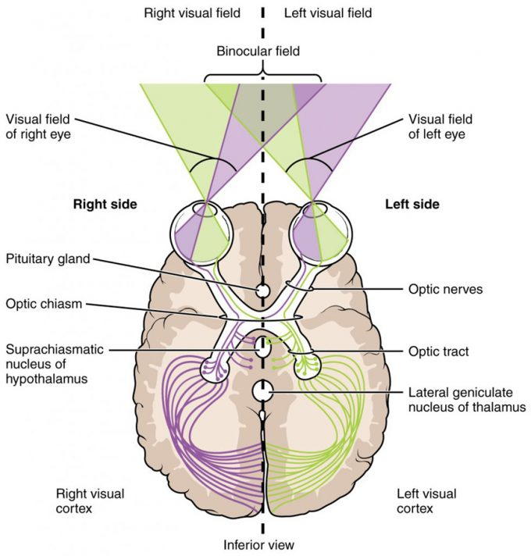

Figure 15.57 – Segregation of Visual Field Information at the Optic Chiasm: Contralateral visual field information from the lateral retina projects to the ipsilateral brain, whereas ipsilateral visual field information has to decussate at the optic chiasm to reach the opposite side of the brain.

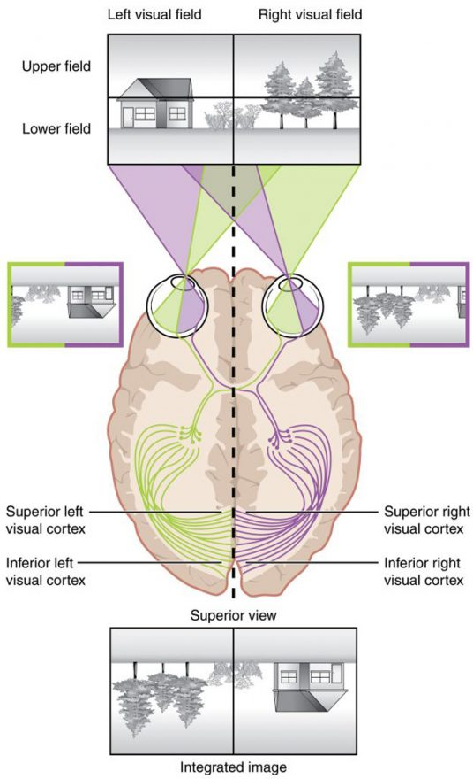
Figure 15.58 – Topographic Mapping of the Retina onto the Visual Cortex: The visual field projects onto the retina through the lenses and falls on the retinae as an inverted, reversed image. The topography of this image is maintained as the visual information travels through the visual pathway to the cortex.

