Nervous System

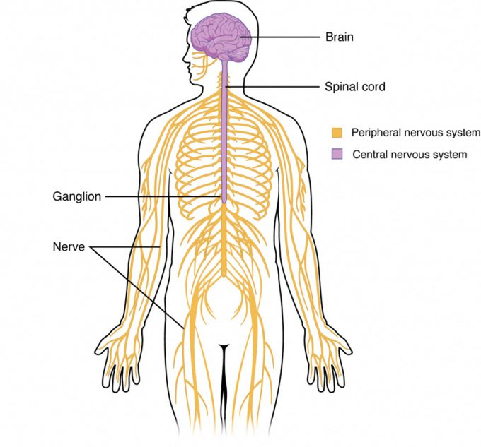
Figure 12.11 – Central and Peripheral Nervous System: The CNS contains the brain and spinal cord, the PNS includes nerves.

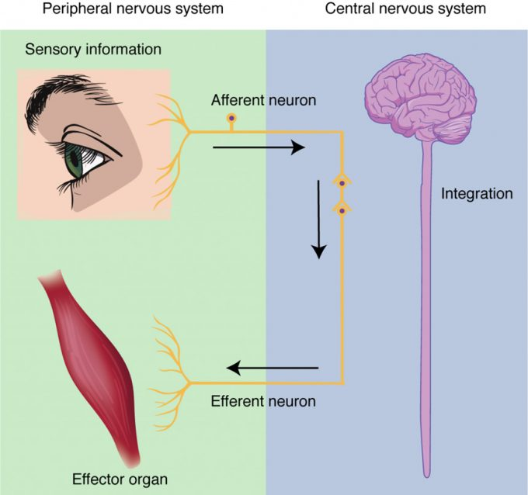
Figure 12.12: Integration occurs in the CNS where sensory information from the periphery is processed and interpreted. The CNS then creates a motor plan that is executed by the efferent branch working with effector organs.

Nervous Tissue

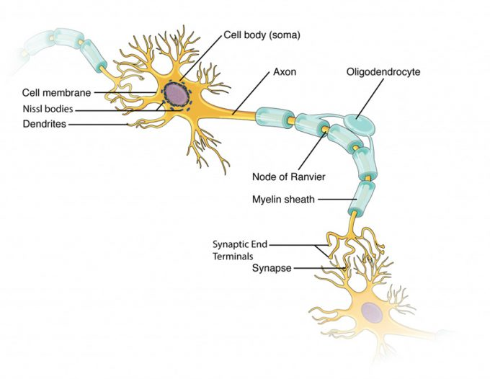
Figure 12.22 – Parts of a Multipolar Neuron: The major parts of the neuron are labeled on a multipolar neuron from the CNS.

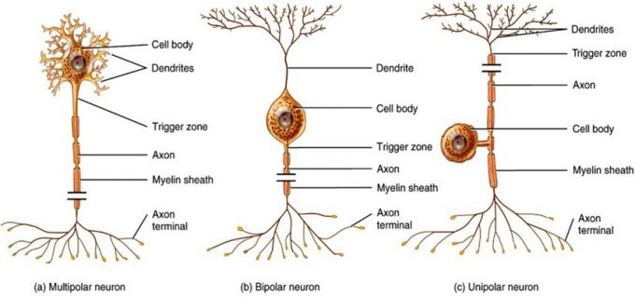
Figure 12.23 – Neuron Classification by Shape: Unipolar cells have one process that includes both the axon and dendrite. Bipolar cells have two processes, the axon and a dendrite. Multipolar cells have more than two processes, the axon and two or more dendrites.

Glial Cells

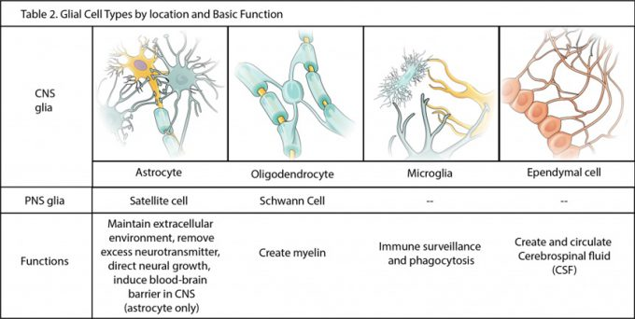

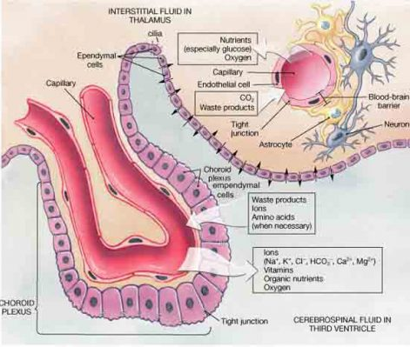
Figure 12.24 – Glial Cells of the CNS: The CNS has astrocytes, oligodendrocytes, microglia, and ependymal cells that support the neurons of the CNS in several ways.
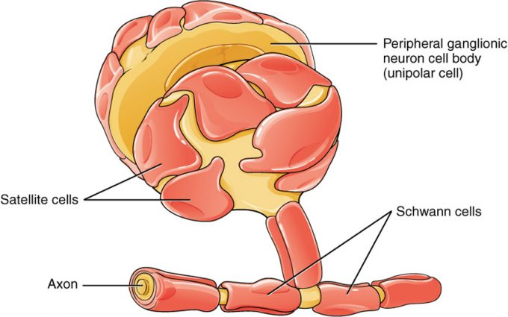
Figure 12.25 – Glial Cells of the PNS: Satellite cells associate with the cell bodies, and Schwann cells associate with the axons of neurons in the PNS.

Myelin

Figure 12.26 – The Process of Myelination: Myelinating glia wrap several layers of cell membrane around the cell membrane of an axon segment. A single Schwann cell insulates a segment of a peripheral nerve, whereas in the CNS, an oligodendrocyte may provide insulation for a few separate axon segments. EM × 1,460,000. (Micrograph provided by the Regents of University of Michigan Medical School © 2012)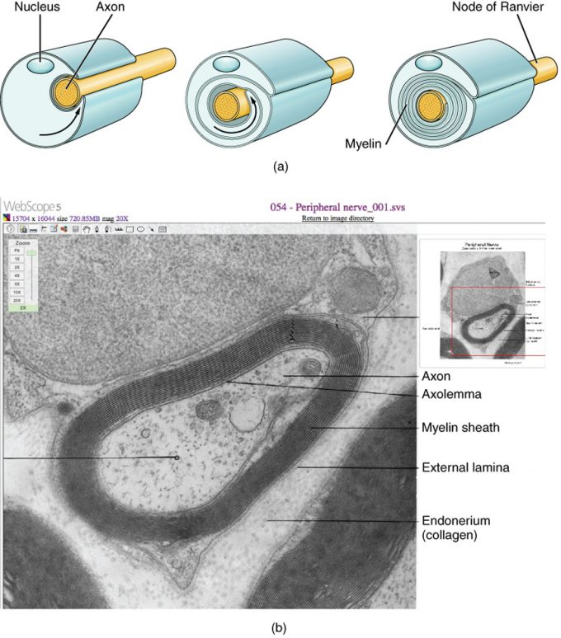

Alzheimer’s

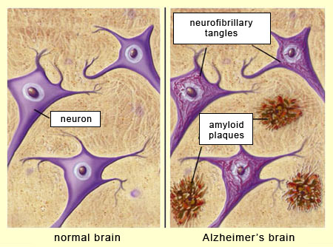

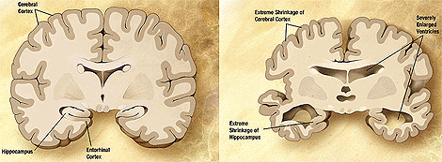

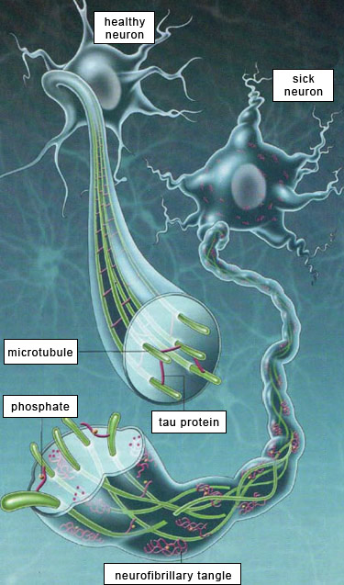

Function of Nervous Tissue

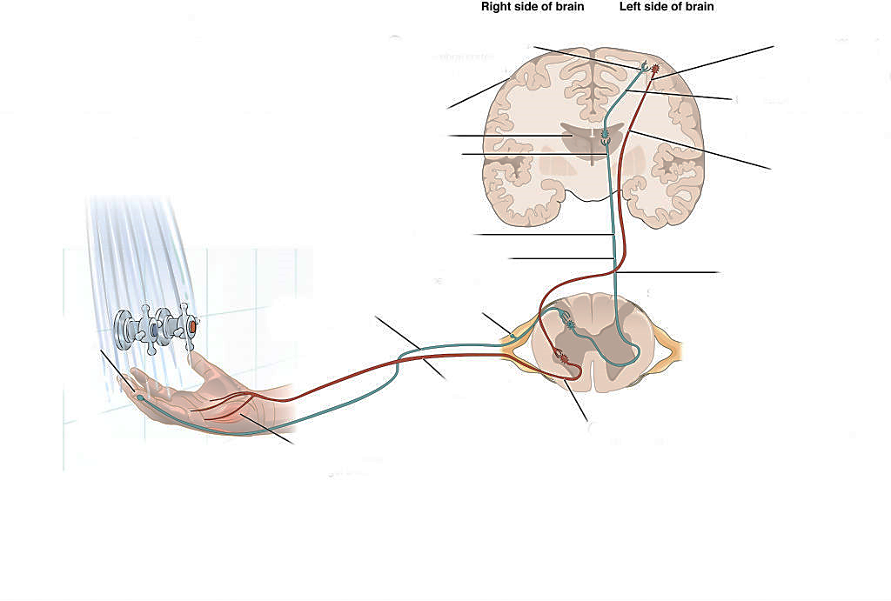

Communication

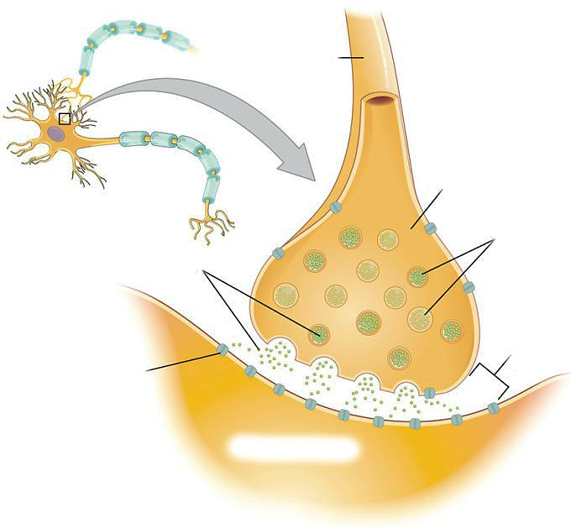Figure 12.41 – The Synapse: The synapse is a connection between a neuron and its target cell (which is not necessarily a neuron). The presynaptic element is the synaptic end bulb of the axon where Ca2+ enters the bulb to cause vesicle fusion and neurotransmitter release. The neurotransmitter diffuses across the synaptic cleft to bind to its receptor. The neurotransmitter is cleared from the synapse either by enzymatic degradation, neuronal reuptake, or glial reuptake.
Neurotransmitters & Receptors

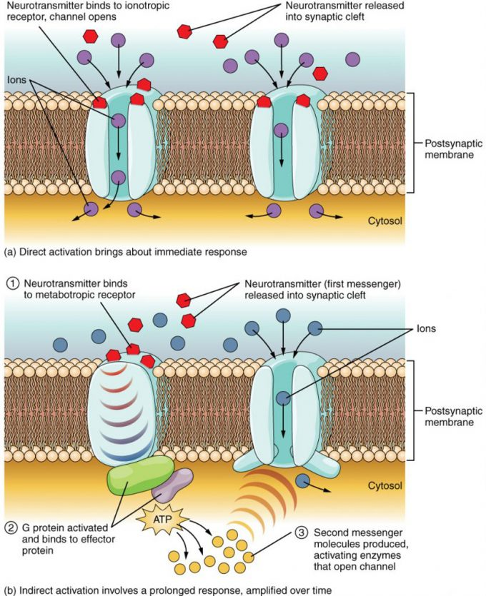

Figure 12.42 – Receptor Types: (a) An ionotropic receptor is a channel that opens when the neurotransmitter binds to it. (b) A metabotropic receptor is a complex that causes metabolic changes in the cell when the neurotransmitter binds to it (1). After binding, the G protein hydrolyzes GTP and moves to the effector protein (2). When the G protein contacts the effector protein, a second messenger is generated, such as cAMP (3). The second messenger can then go on to cause changes in the neuron, such as opening or closing ion channels, metabolic changes, and changes in gene transcription.
Characteristics of Neurotransmitter Systems (Table 3)
System | Cholinergic | Amino acids | Biogenic amines | Neuropeptides
Neurotransmitters | Acetylcholine | Glutamate, glycine, GABA | Serotonin (5-HT), dopamine, norepinephrine, (epinephrine) | Met-enkephalin, beta-endorphin, VIP, Substance P, etc.
Receptors | Nicotinic and muscarinic receptors | Glu receptors, gly receptors, GABA receptors | 5-HT receptors, D1 and D2 receptors, α-adrenergic and β-adrenergic receptors | Receptors are too numerous to list, but are specific to the peptides.
Elimination | Degradation by acetylcholinesterase | Reuptake by neurons or glia | Reuptake by neurons | Degradation by enzymes called peptidases
Postsynaptic effect | Nicotinic receptor causes depolarization. Muscarinic receptors can cause both depolarization or hyperpolarization depending on the subtype. | Glu receptors cause depolarization. Gly and GABA receptors cause hyperpolarization. | Depolarization or hyperpolarization depends on the specific receptor. For example, D1 receptors cause depolarization and D2 receptors cause hyperpolarization. | Depolarization or hyperpolarization depends on the specific receptor.

Neurophysiology

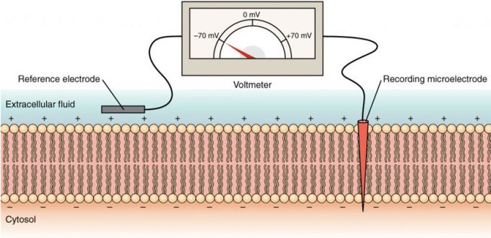
Figure 12.56 – Measuring Charge across a Membrane with a Voltmeter: A recording electrode is inserted into the cell and a reference electrode is outside the cell. By comparing the charge measured by these two electrodes, the transmembrane voltage is determined. It is conventional to express that value for the cytosol relative to the outside.

Membrane Ion Channels

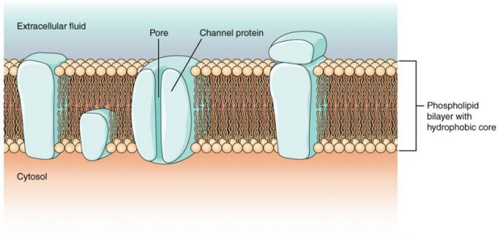
Figure 12.51 – Cell Membrane and Transmembrane Proteins: The cell membrane is composed of a phospholipid bilayer and has many transmembrane proteins, including different types of channel proteins that serve as ion channels.

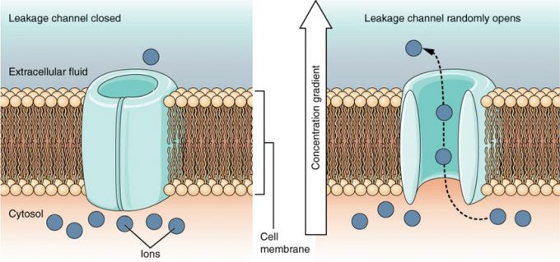
Figure 12.55 – Leak Channels: These channels open and close at random, allowing ions to pass through when they are open.
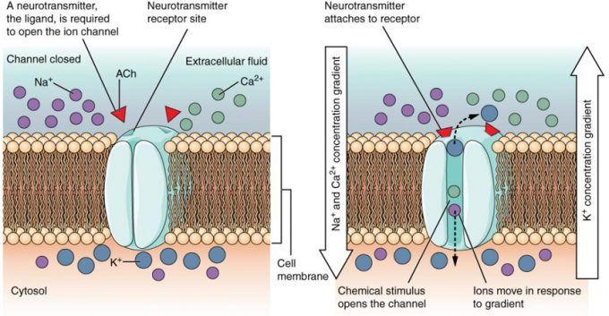
Figure 12.52 – Ligand-Gated Channels: When the ligand, in this case the neurotransmitter acetylcholine, binds to a specific location on the extracellular surface of the channel protein, the pore opens to allow select ions through. The ions, in this case, are cations of sodium, calcium, and potassium.
Figure 12.53 – Mechanically-Gated Channels: When a mechanical change occurs in the surrounding tissue (such as pressure or stretch) the channel is physically opened, and ions can move through the channel, down their concentration gradient. 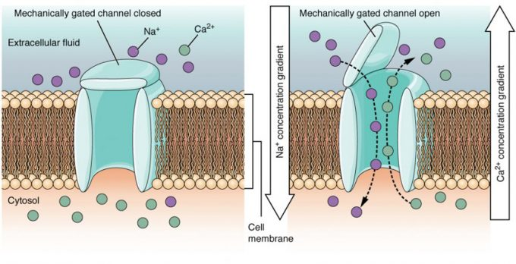Figure 12.54 – Voltage-Gated Channels: Voltage-gated channels open when the transmembrane voltage changes around them. Amino acids in the structure of the protein are sensitive to charge and cause the pore to open to the selected ion.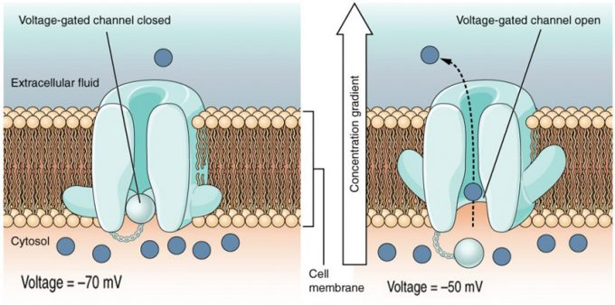

Resting Membrane Potential

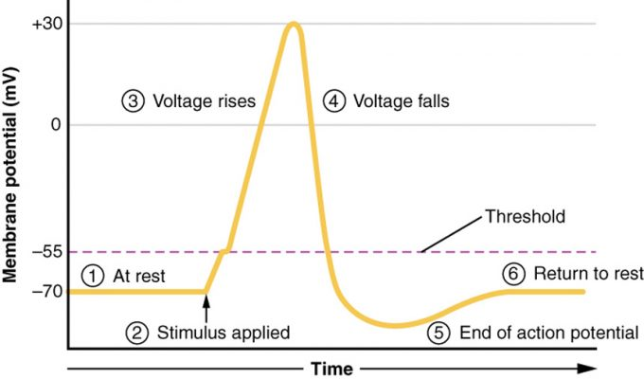
Figure 12.58 – Stages of an Action Potential: Plotting voltage measured across the cell membrane against time, the events of the action potential can be related to specific changes in the membrane voltage. (1) At rest, the membrane voltage is -70 mV. (2) The membrane begins to depolarize when an external stimulus is applied. (3) The membrane voltage begins a rapid rise toward +30 mV. (4) The membrane voltage starts to return to a negative value. (5) Repolarization continues past the resting membrane voltage, resulting in hyperpolarization. (6) The membrane voltage returns to the resting value shortly after hyperpolarization.

Action Potentials

Graded Potentials

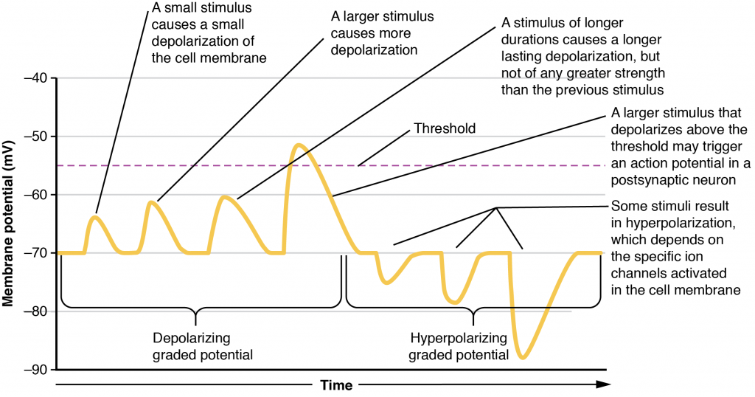

Figure 12.43 – Graded Potentials: Graded potentials are temporary changes in the membrane voltage, the characteristics of which depend on the size of the stimulus. Some types of stimuli cause depolarization of the membrane, whereas others cause hyperpolarization. It depends on the specific ion channels that are activated in the cell membrane.

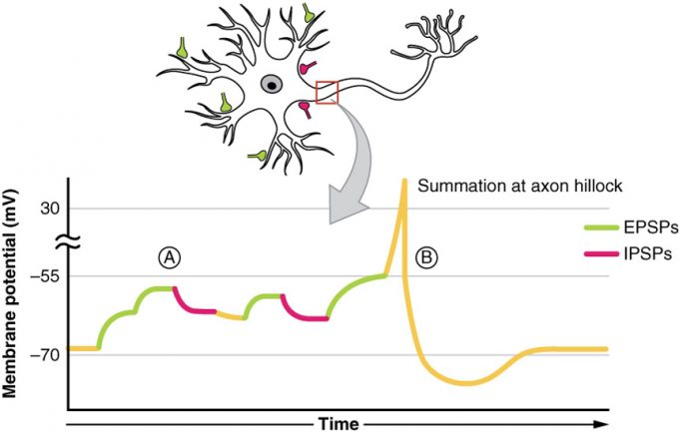

Figure 12.44 – Postsynaptic Potential Summation: The result of summation of postsynaptic potentials is the overall change in the membrane potential. At point A, several different excitatory postsynaptic potentials add up to a large depolarization. At point B, a mix of excitatory and inhibitory postsynaptic potentials result in a different end result for the membrane potential.

Propagation of AP

Conduction Velocity

