Integumentary System

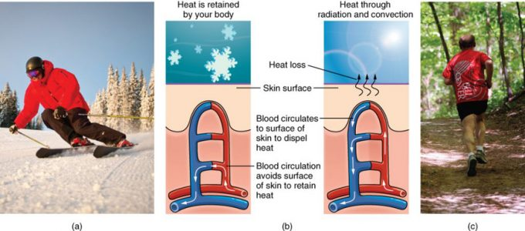

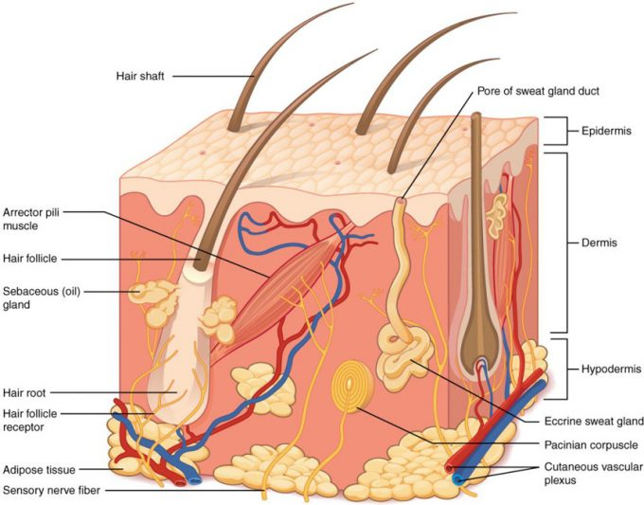

Figure 5.11: Layers of Skin. The skin is composed of two main layers: the epidermis, made of closely packed epithelial cells, and the dermis, made of dense, irregular connective tissue that houses blood vessels, hair follicles, sweat glands, and other structures. Beneath the dermis lies the hypodermis, which is composed mainly of loose connective and fatty tissues.

Epidermis

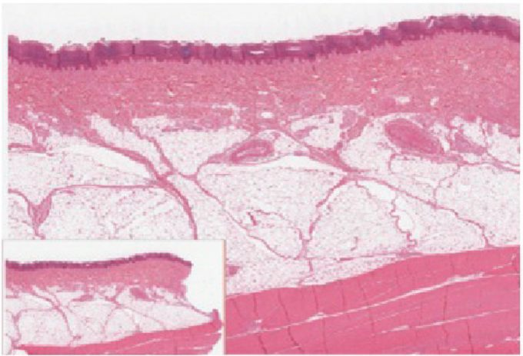

Figure 5.13: Epidermis. The epidermis is epithelium composed of multiple layers of cells. The basal layer consists of cuboidal cells, whereas the outer layers are squamous, keratinized cells, so the whole epithelium is often described as being keratinized stratified squamous epithelium. LM × 40. (Micrograph provided by the Regents of University of Michigan Medical School © 2012)
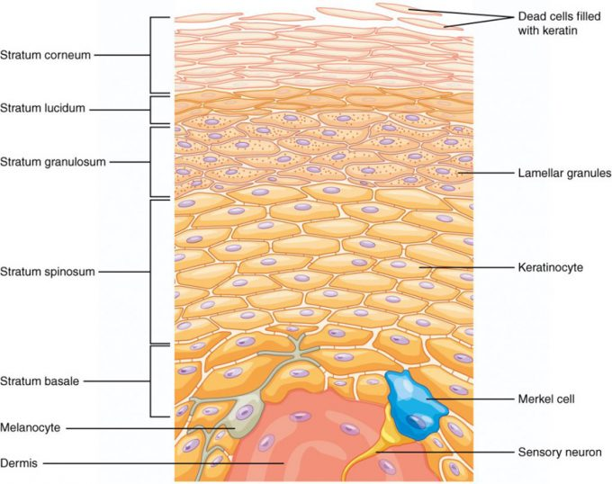

Figure 5.14: Layers of the Epidermis. The epidermis of thick skin has five layers: stratum basale, stratum spinosum, stratum granulosum, stratum lucidum, and stratum corneum.
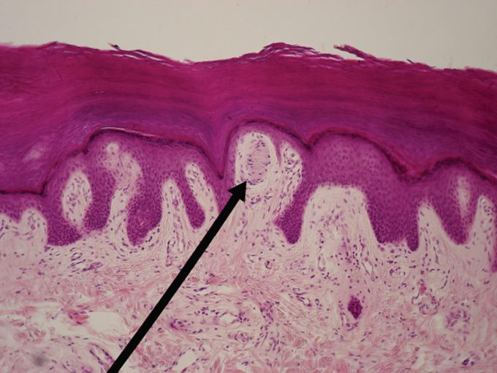
Figure 5.31: Light Micrograph of a Meissner Corpuscle. In this micrograph of a skin cross-section, you can see a Meissner corpuscle (arrow), a type of touch receptor located in a dermal papilla adjacent to the basement membrane and stratum basale of the overlying epidermis. LM × 100. (credit: “Wbensmith”/Wikimedia Commons)

Dermis

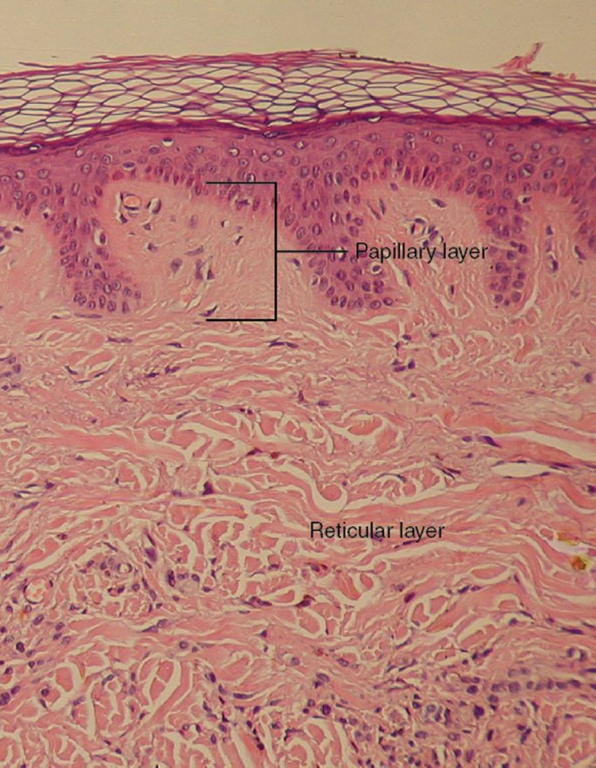

Figure 5.16: Layers of the Dermis. This stained slide shows the two components of the dermis—the papillary layer and the reticular layer. Both are made of connective tissue with fibers of collagen extending from one to the other, making the border between the two somewhat indistinct. The dermal papillae extending into the epidermis belong to the papillary layer, whereas the dense collagen fiber bundles below belong to the reticular layer. LM × 10. (credit: modification of work by “kilbad”/Wikimedia Commons)
Hypodermis

Skin Color

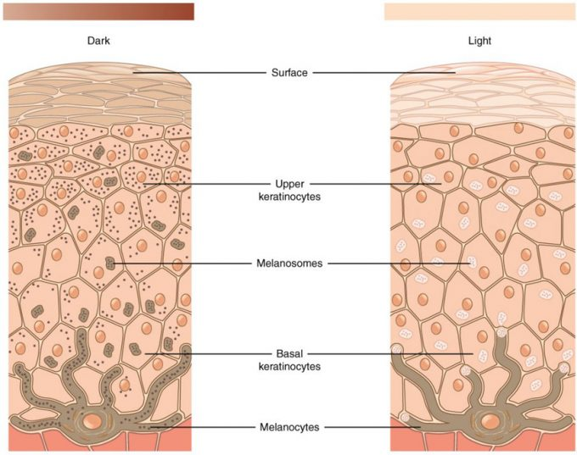

Figure 5.17: Skin Pigmentation. The relative coloration of the skin depends of the amount of melanin produced by melanocytes in the stratum basale and taken up by keratinocytes.

Skin Cancer

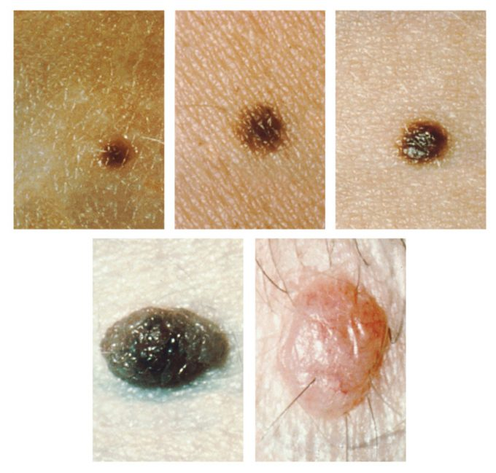

Figure 5.18: Moles. Moles range from benign accumulations of melanocytes to melanomas. These structures populate the landscape of our skin. (credit: the National Cancer Institute)

Accessory Structures of the Skin

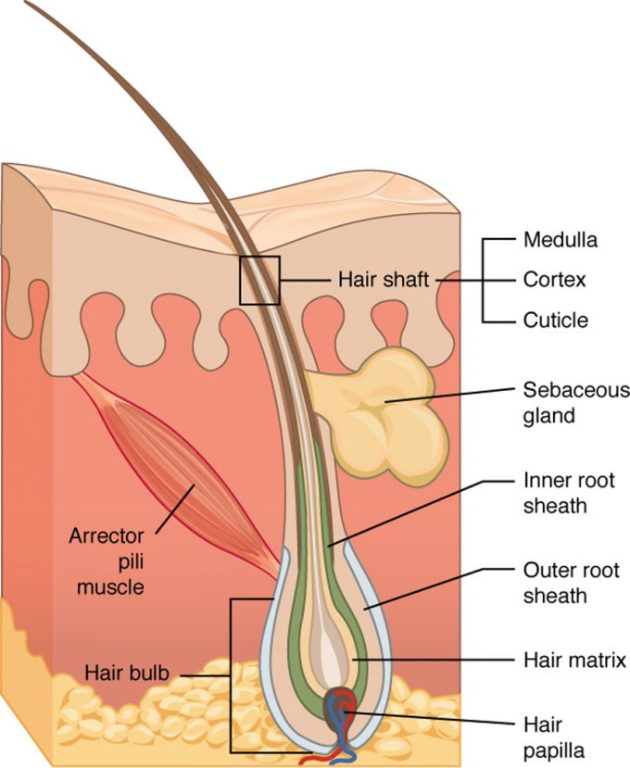

Figure 5.21: Hair. Hair follicles originate in the epidermis and have many different parts.
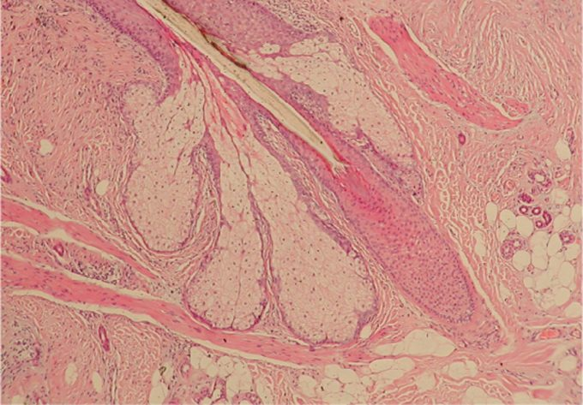

Figure 5.22: Hair Follicle. The slide shows a cross-section of a hair follicle. Basal cells of the hair matrix in the center differentiate into cells of the inner root sheath. Basal cells at the base of the hair root form the outer root sheath. LM × 4. (credit: modification of work by “kilbad”/Wikimedia Commons)
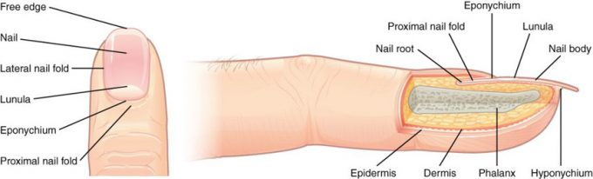

Figure 5.23: Nails. The nail is an accessory structure of the integumentary system.
Skin Glands

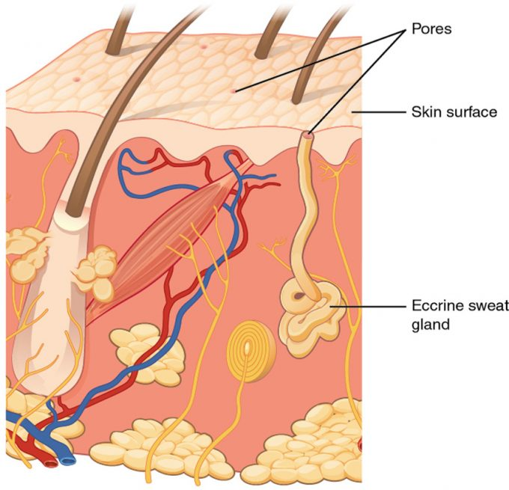
Figure 5.24: Eccrine Gland. Eccrine glands are coiled glands in the dermis that release sweat that is mostly water.

Burns

