Function of Skeleton

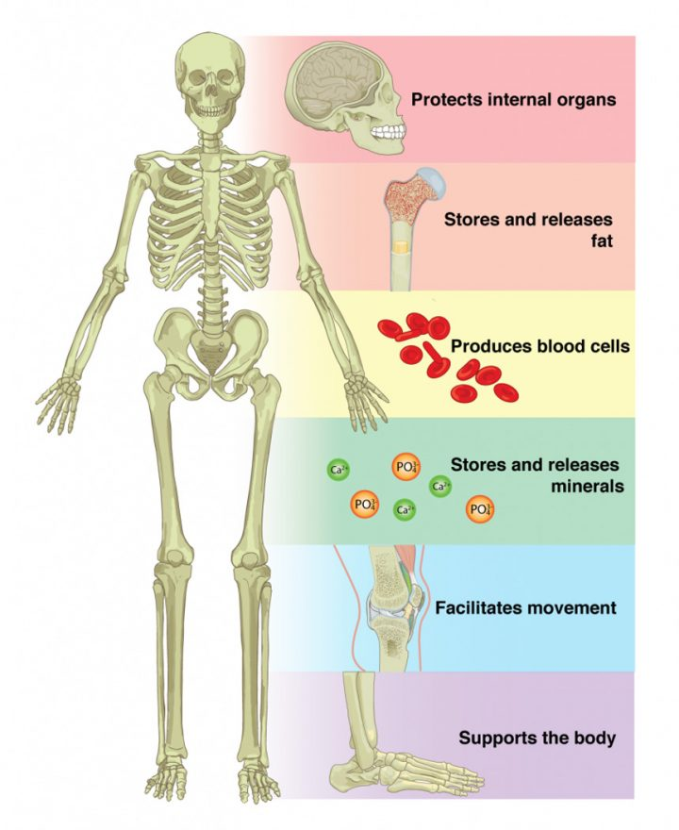
Figure 6.11: Functions of the skeletal system.

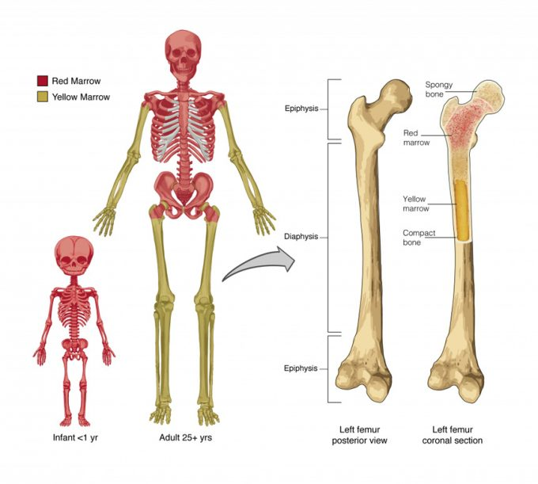
Figure 6.12: Bones contain variable amounts of yellow and/or red bone marrow. Yellow bone marrow stores fat and red bone marrow is responsible for producing blood cells (hematopoiesis).

Classification of Bones

Figure 6.21: Classifications of Bones. Bones are classified according to their shape.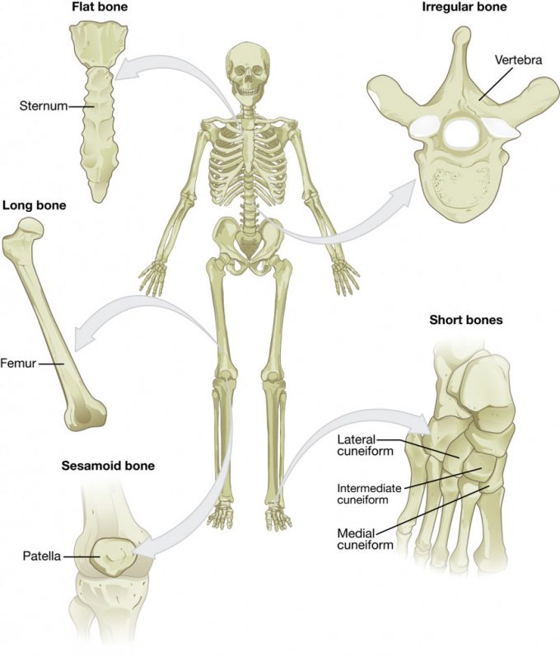

Bone Classifications (Table 1)
Bone classification | Features | Function(s) | Examples
Long | Cylinder-like shape, longer than it is wide | Movement, support | Femur, tibia, fibula, metatarsals, humerus, ulna, radius, metacarpals, phalanges
Short | Cube-like shape, approximately equal in length, width, and thickness | Provide stability, support, while allowing for some motion | Carpals, tarsals
Flat | Thin and curved | Points of attachment for muscles; protectors of internal organs | Sternum, ribs, scapulae, cranial bones
Irregular | Complex shape | Protect internal organs, movement, support | Vertebrae, facial bones
Sesamoid | Small and round; embedded in tendons | Protect tendons from excessive forces, allow effective muscle action | Patellae

Bone Structure

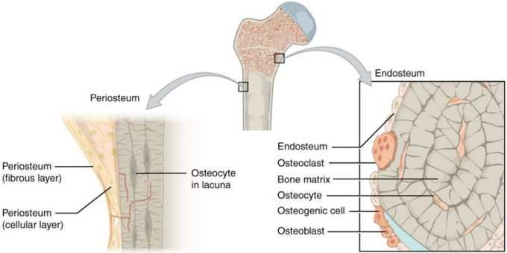

Figure 6.32 – Periosteum and Endosteum: The periosteum forms the outer surface of bone, and the endosteum lines the medullary cavity.

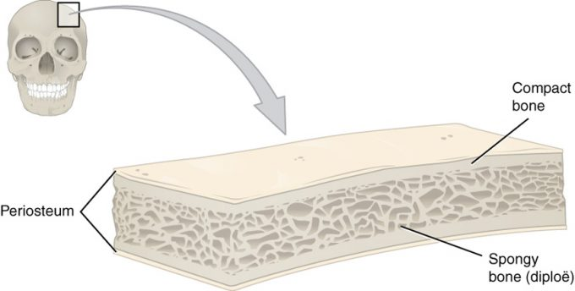

Figure 6.33 – Anatomy of a Flat Bone: This cross-section of a flat bone shows the spongy bone (diploë) covered on either side by a layer of compact bone.
Structure of Long Bone

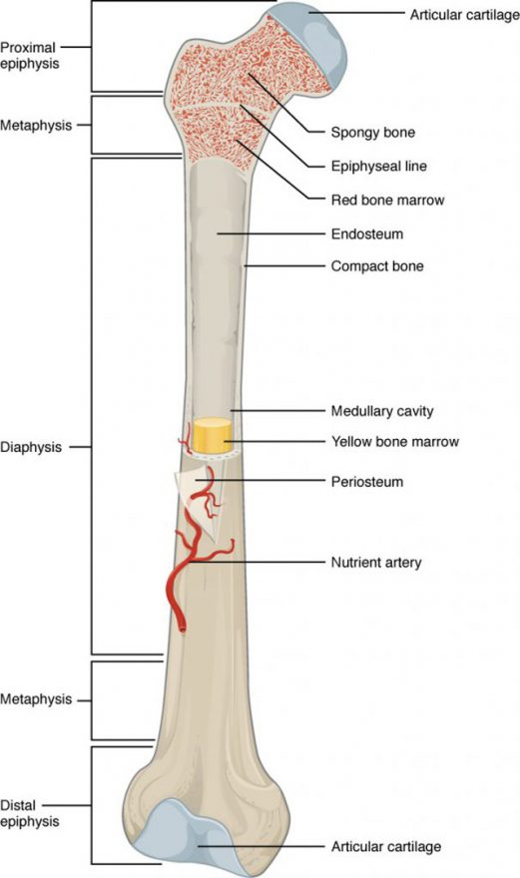
Figure 6.31 – Anatomy of a Long Bone: A typical long bone showing gross anatomical features.
Bone Cells

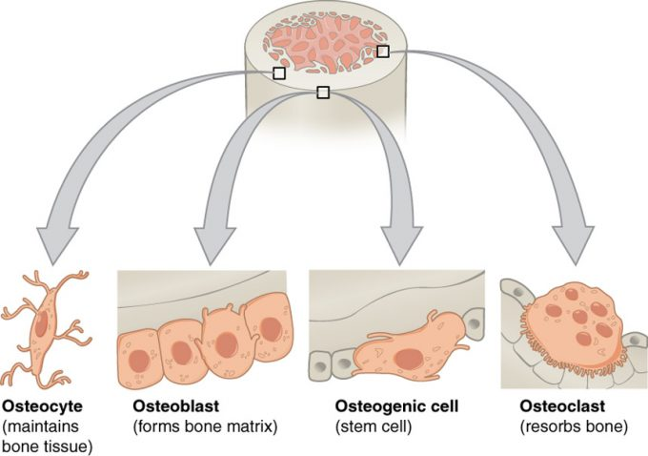

Figure 6.35 – Bone Cells: Four types of cells are found within bone tissue. Osteogenic cells are undifferentiated and develop into osteoblasts. Osteoblasts deposit bone matrix. When osteoblasts get trapped within the calcified matrix, they become osteocytes. Osteoclasts develop from a different cell lineage and act to resorb bone.

Compact and Spongy Bone

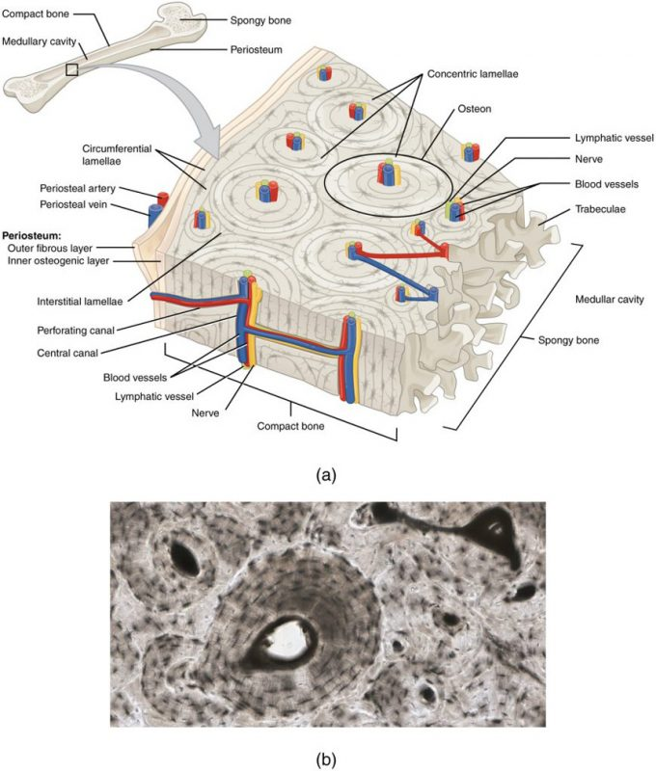Figure 6.36 – Diagram of Compact Bone: (a) This cross-sectional view of compact bone shows several osteons, the basic structural unit of compact bone. (b) In this micrograph of the osteon, you can see the concentric lamellae around the central canals. LM × 40. (Micrograph provided by the Regents of University of Michigan Medical School © 2012)

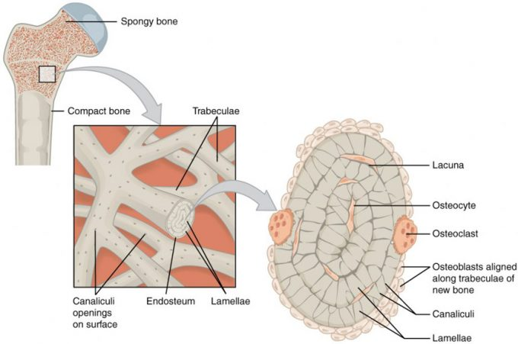
Figure 6.38 – Diagram of Spongy Bone: Spongy bone is composed of trabeculae that contain the osteocytes. Red marrow fills the spaces in some bones.

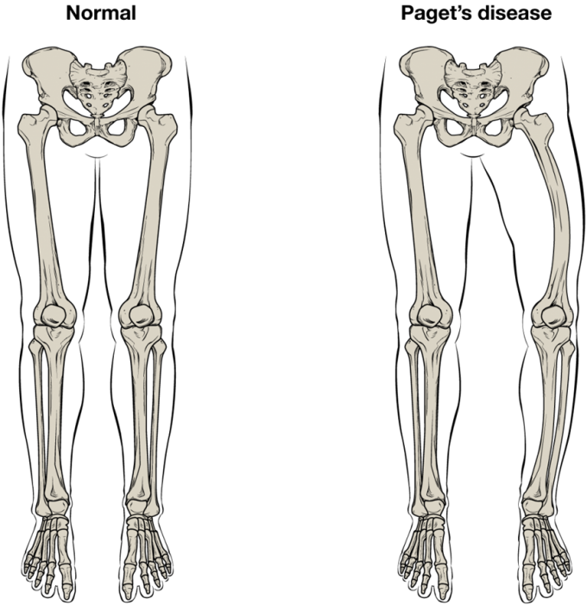Figure 6.39 – Paget’s Disease: Normal leg bones are relatively straight, but those affected by Paget’s disease are porous and curved.

Blood and Nerve Supply

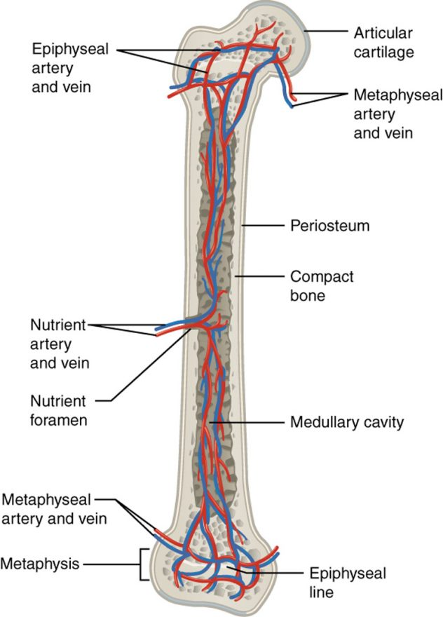

Figure 6.310 – Diagram of Blood and Nerve Supply to Bone: Blood vessels and nerves enter the bone through the nutrient foramen.
Bone Formation and Development
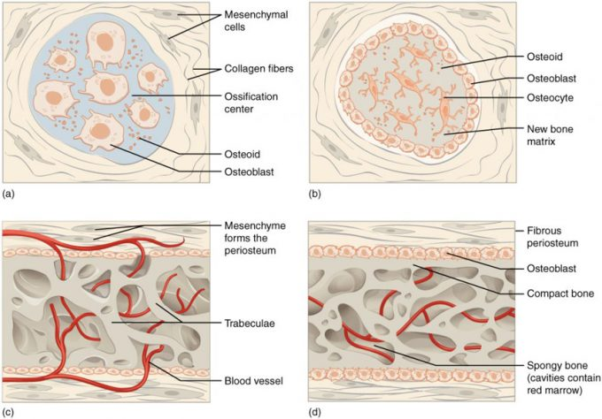

Figure 6.41 – Intramembranous Ossification: Intramembranous ossification follows four steps. (a) Mesenchymal cells group into clusters, differentiate into osteoblasts, and ossification centers form. (b) Secreted osteoid traps osteoblasts, which then become osteocytes. (c) Trabecular matrix and periosteum form. (d) Compact bone develops superficial to the trabecular bone, and crowded blood vessels condense into red bone marrow.
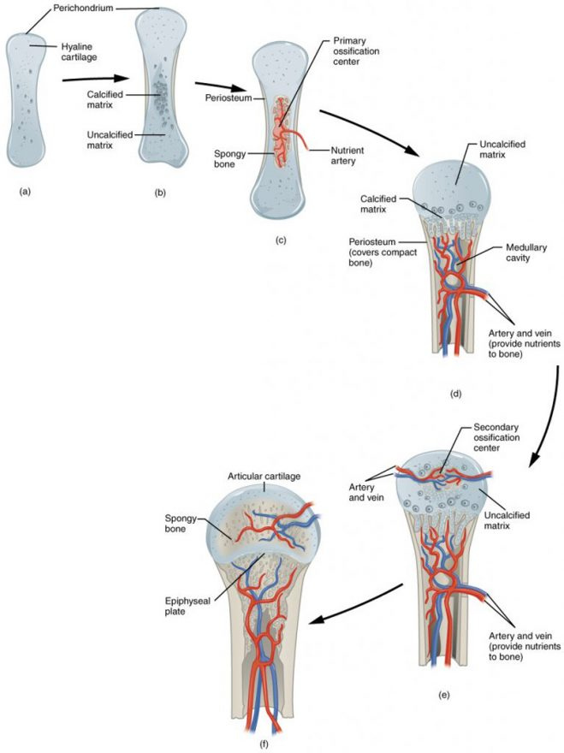
Figure 6.42. Endochondral Ossification. Endochondral ossification follows five steps. (a) Mesenchymal cells differentiate into chondrocytes that produce a cartilage model of the future bony skeleton. (b) Blood vessels on the edge of the cartilage model bring osteoblasts that deposit a bony collar. (c) Capillaries penetrate cartilage and deposit bone inside cartilage model, forming primary ossification center. (d) Cartilage and chondrocytes continue to grow at ends of the bone while medullary cavity expands and remodels. (e) Secondary ossification centers develop after birth. (f) Hyaline cartilage remains at epiphyseal (growth) plate and at joint surface as articular cartilage.
How Bones Grow in Length

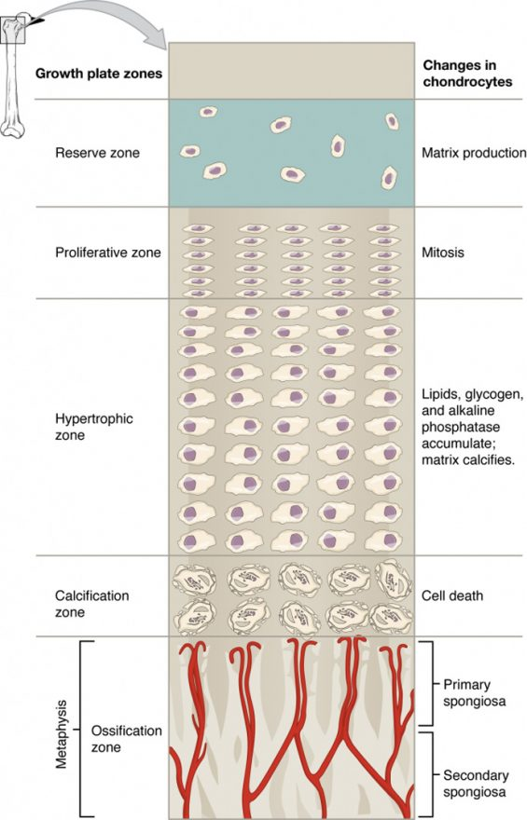

Figure 6.43 – Longitudinal Bone Growth: The epiphyseal plate is responsible for longitudinal bone growth.
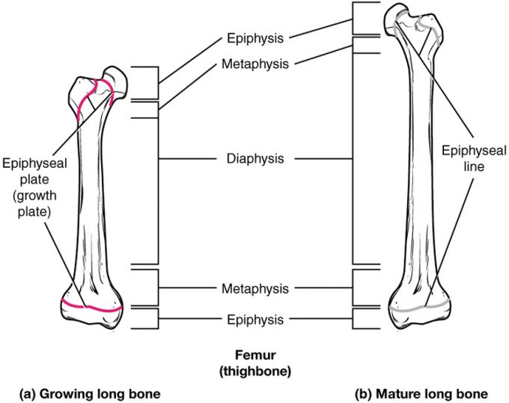

Figure 6.44 – Progression from Epiphyseal Plate to Epiphyseal Line: As a bone matures, the epiphyseal plate progresses to an epiphyseal line. (a) Epiphyseal plates are visible in a growing bone. (b) Epiphyseal lines are the remnants of epiphyseal plates in a mature bone.

Fractures and Repair

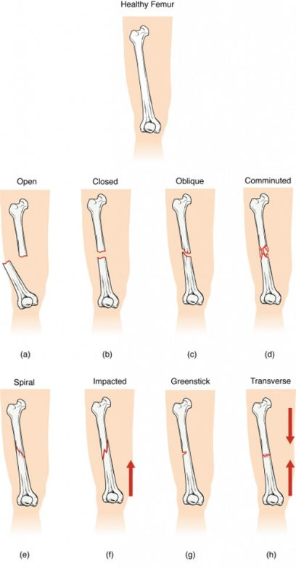
Figure 6.51 – Types of Fractures: Compare healthy bone with different types of fractures: (a) open fracture, (b) closed fracture, (c) oblique fracture, (d) comminuted fracture, (e) spiral fracture , (f) impacted fracture, (g) greenstick fracture, and (h) transverse fracture.

Types of Fractures (Table 4)
Type of fracture | Description
Transverse | Occurs straight across the long axis of the bone
Oblique | Occurs at an angle that is not 90 degrees
Spiral | Bone segments are pulled apart as a result of a twisting motion
Comminuted | Several breaks result in many small pieces between two large segments
Impacted | One fragment is driven into the other, usually as a result of compression
Greenstick | A partial fracture in which only one side of the bone is broken, often occurs in the young

Type of Fracture | Description
Open (or compound) | A fracture in which at least one end of the broken bone tears through the skin; carries a high risk of infection
Closed (or simple) | A fracture in which the skin remains intact

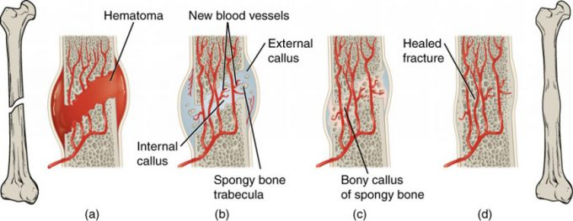

Figure 6.52 – Stages in Fracture Repair: The healing of a bone fracture follows a series of progressive steps: (a) Broken blood vessels leak blood that clots into a fracture hematoma. (b) Internal and external calluses form made of cartilage and bone. (c) Cartilage of the calluses is gradually eroded and replaced by trabecular bone, forming the hard callus. (d) Remodeling occurs to replace immature bone with mature bone.
Healthy Bones

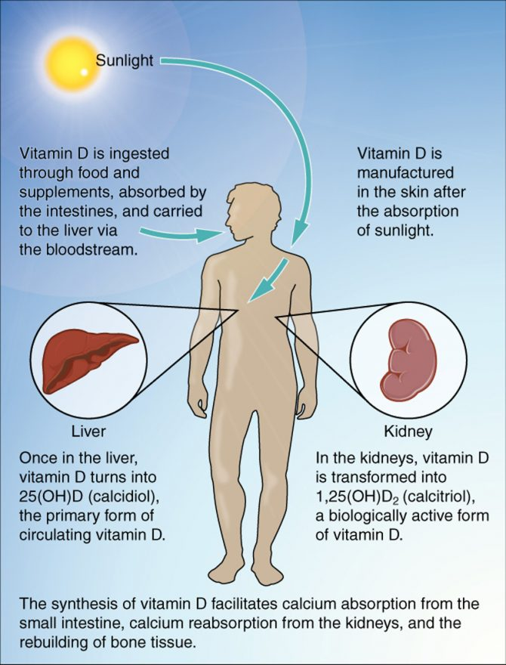

Nutrients and Bone Health (Table 5)
Nutrient | Role in bone health
Calcium | Needed to make calcium phosphate and calcium carbonate, which form the hydroxyapatite crystals that give bone its hardness
Vitamin D | Needed for calcium absorption
Vitamin K | Supports bone mineralization; may have synergistic effect with vitamin D
Magnesium | Structural component of bone
Fluoride | Structural component of bone
Omega-3 fatty acids | Reduces inflammation that may interfere with osteoblast function

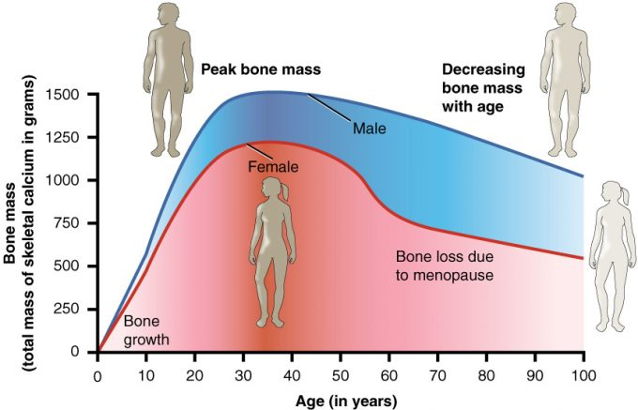

Figure 6.62 – Graph Showing Relationship Between Age and Bone Mass: Bone density peaks at about 30 years of age. Women lose bone mass more rapidly than men.

Hormones

Hormones That Affect the Skeletal System (Table 6)
Hormone | Role
Growth hormone | Increases length of long bones, enhances mineralization, and improves bone density
Thyroxine | Stimulates bone growth and promotes synthesis of bone matrix
Sex hormones | Promote osteoblastic activity and production of bone matrix; responsible for adolescent growth spurt; promote conversion of epiphyseal plate to epiphyseal line
Calcitriol | Stimulates absorption of calcium and phosphate from digestive tract
Parathyroid hormone | Stimulates osteoclast proliferation and resorption of bone by osteoclasts; promotes reabsorption of calcium by kidney tubules; indirectly increases calcium absorption by small intestine
Calcitonin | Inhibits osteoclast activity and stimulates calcium uptake by bones

Calcium Homeostasis

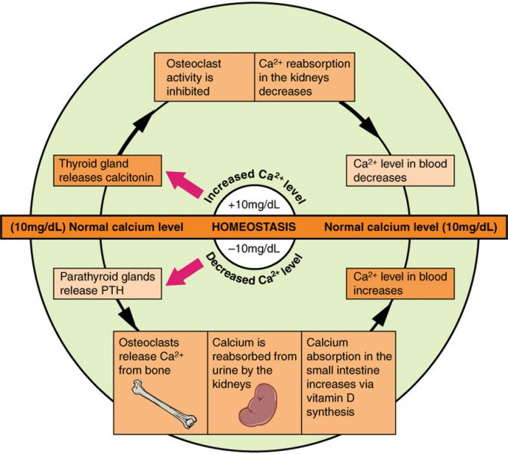

Figure 6.71 – Pathways in Calcium Homeostasis: The body regulates calcium homeostasis with two pathways; one is signaled to turn on when blood calcium levels drop below normal and one is the pathway that is signaled to turn on when blood calcium levels are elevated.
Hematopoietic Tissue

