Axial Skeleton

Bone Markings

Bone Markings (Table 2)
Marking | Description | Example
Articulations | Where two bones meet | Knee joint
Head | Prominent rounded surface | Head of femur
Facet | Flat surface | Vertebrae
Condyle | Rounded surface | Occipital condyles
Projections | Raised markings | Spinous process of the vertebrae
Protuberance | Protruding | Chin
Process | Prominence feature | Transverse process of vertebra
Spine | Sharp process | Ischial spine
Tubercle | Small, rounded process | Tubercle of humerus
Tuberosity | Rough surface | Deltoid tuberosity
Line | Slight, elongated ridge | Temporal lines of the parietal bones
Crest | Ridge | Iliac crest
Holes | Holes and depressions | Foramen (holes through which blood vessels can pass through)
Fossa | Elongated basin | Mandibular fossa
Fovea | Small pit | Fovea capitis on the head of the femur
Sulcus | Groove | Sigmoid sulcus of the temporal bones
Canal | Passage in bone | Auditory canal
Fissure | Slit through bone | Auricular fissure
Foramen | Hole through bone | Foramen magnum in the occipital bone
Meatus | Opening into canal | External auditory meatus
Sinus | Air-filled space in bone | Nasal sinus
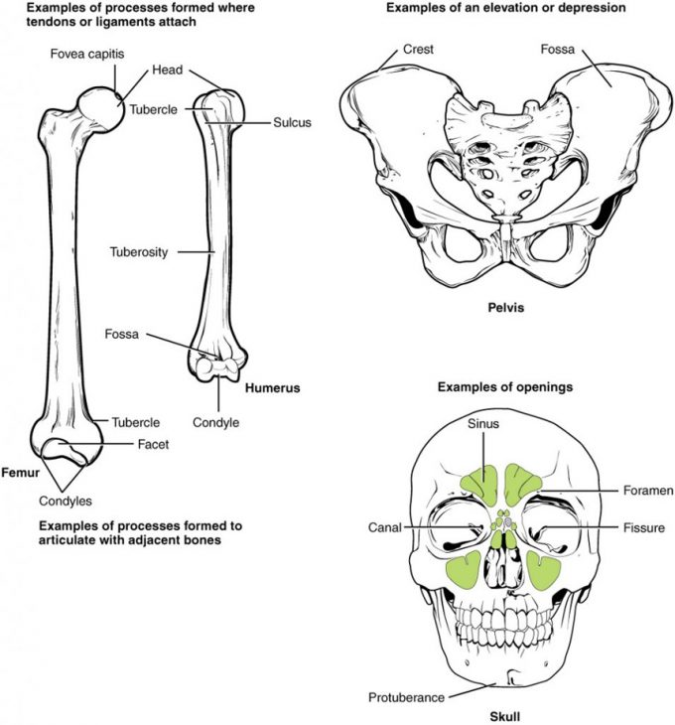
Figure 7.21 – Bone Features: The surface features of bones depend on their function, location, attachment of ligaments and tendons, or the penetration of blood vessels and nerves.

Skull
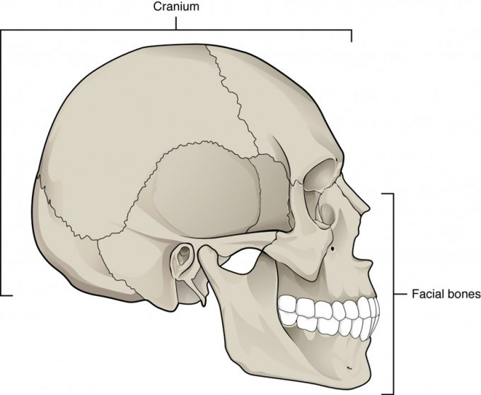

Figure 7.31 – Parts of the Skull: The skull consists of the rounded cranium that houses the brain and the facial bones that form the upper and lower jaws, nose, orbits, and other facial structures.

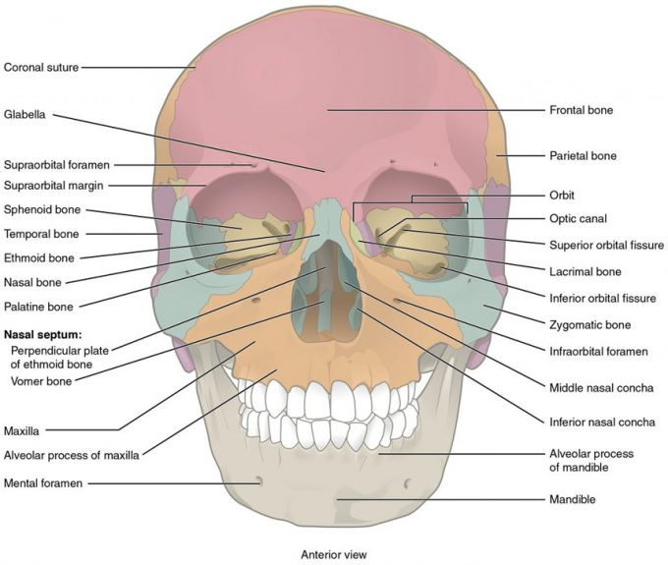
Figure 7.32 – Anterior View of Skull: An anterior view of the skull shows the bones that form the forehead, orbits (eye sockets), nasal cavity, nasal septum, and upper and lower jaws.

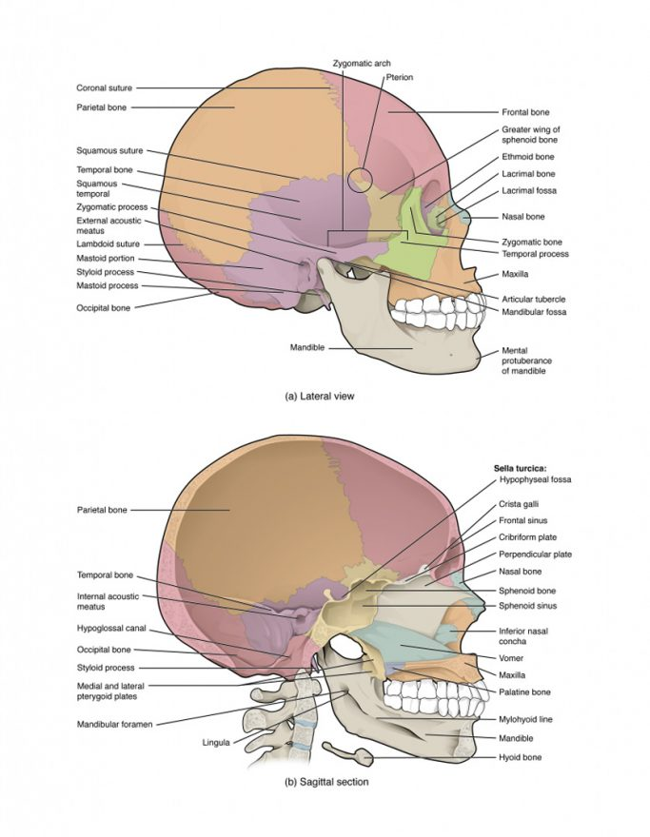
Figure 7.33: (a) Lateral View of Skull. The lateral skull shows the large rounded brain case, zygomatic arch, and the upper and lower jaws. The zygomatic arch is formed jointly by the zygomatic process of the temporal bone and the temporal process of the zygomatic bone. The shallow space above the zygomatic arch is the temporal fossa. (b) Sagittal Section of Skull. This midline view of the sagittally sectioned skull shows the nasal septum.

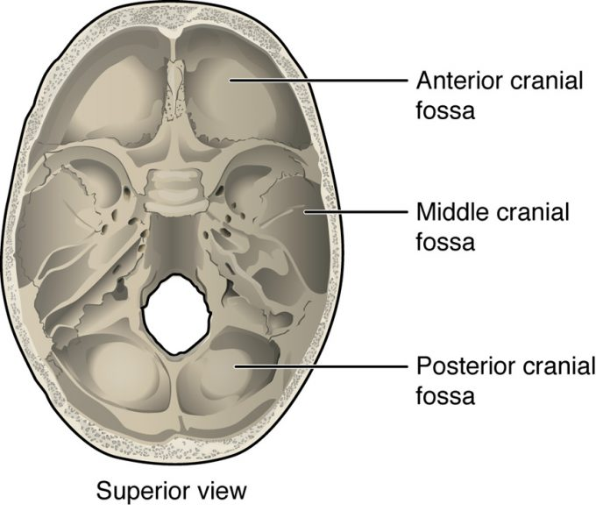

Figure 7.34 – Cranial Fossae: The bones of the brain case surround and protect the brain, which occupies the cranial cavity. The base of the brain case, which forms the floor of cranial cavity, is subdivided into the shallow anterior cranial fossa, the middle cranial fossa, and the deep posterior cranial fossa.
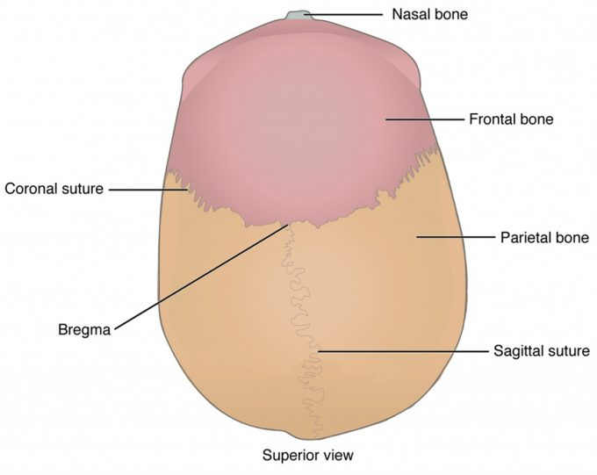

Figure 7.35. Superior view of the skull.

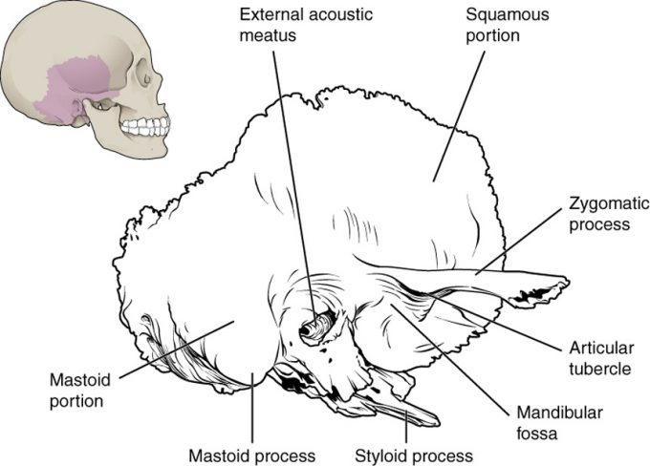

Figure 7.36 – Temporal Bone: A lateral view of the isolated temporal bone shows the squamous, mastoid, and zygomatic portions of the temporal bone.
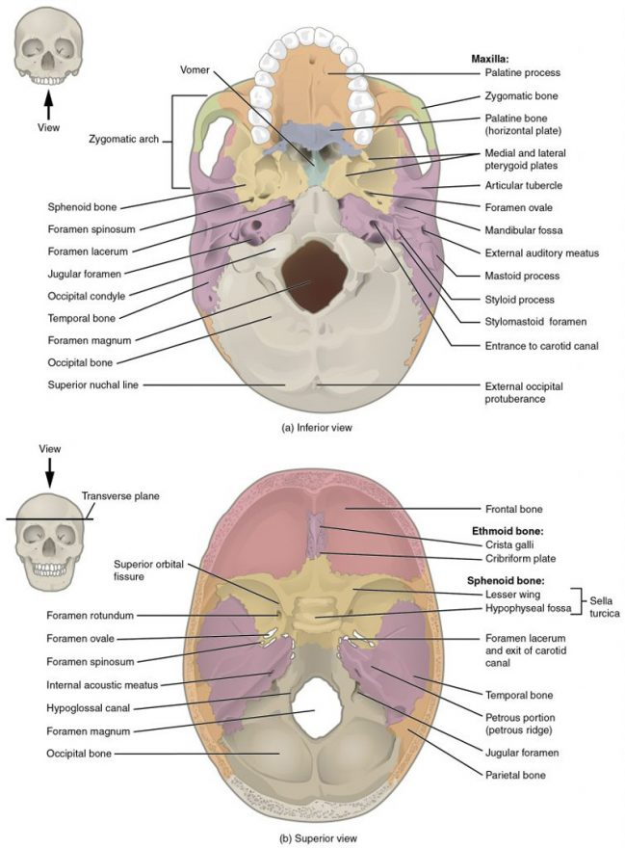

Figure 7.37 – External and Internal Views of Base of Skull: (a) The hard palate is formed anteriorly by the palatine processes of the maxilla bones and posteriorly by the horizontal plate of the palatine bones. (b) The complex floor of the cranial cavity is formed by the frontal, ethmoid, sphenoid, temporal, and occipital bones. The lesser wing of the sphenoid bone separates the anterior and middle cranial fossae. The petrous ridge (petrous portion of temporal bone) separates the middle and posterior cranial fossae.
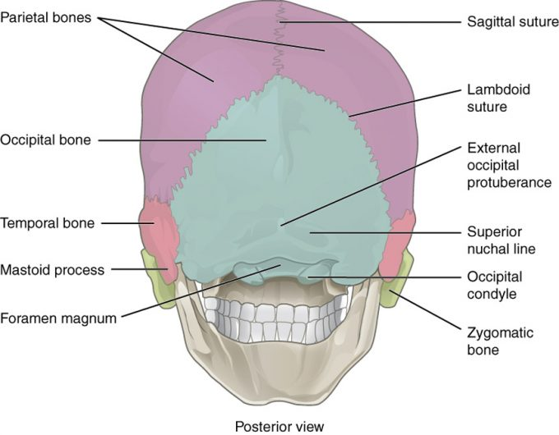

Figure 7.38 – Posterior View of Skull: This view of the posterior skull shows attachment sites for muscles and joints that support the skull.
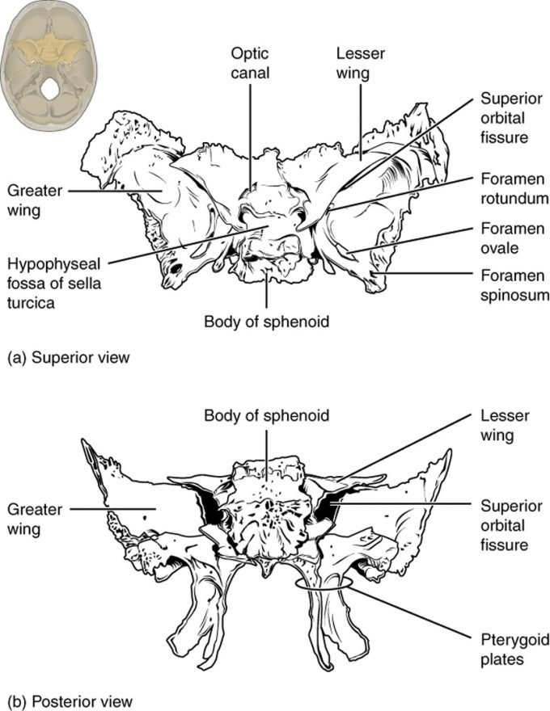

Figure 7.39 – Sphenoid Bone: Shown in isolation in (a) superior and (b) posterior views, the sphenoid bone is a single midline bone that forms the anterior walls and floor of the middle cranial fossa. It has a pair of lesser wings and a pair of greater wings. The sella turcica surrounds the hypophyseal fossa. Projecting downward are the medial and lateral pterygoid plates. The sphenoid has multiple openings for the passage of nerves and blood vessels, including the optic canal, superior orbital fissure, foramen rotundum, foramen ovale, and foramen spinosum.
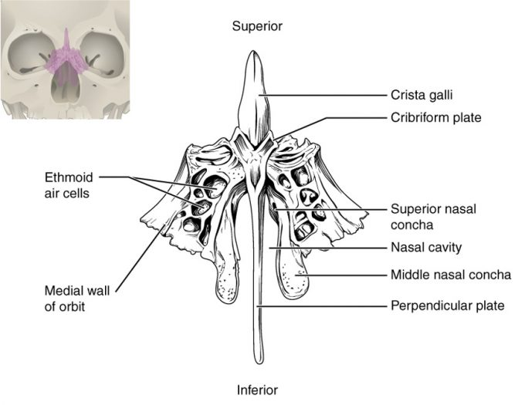Figure 7.311 – Ethmoid Bone: The unpaired ethmoid bone is located at the midline within the central skull. It has an upward projection, the crista galli, and a downward projection, the perpendicular plate, which forms the upper nasal septum. The cribriform plates form both the roof of the nasal cavity and a portion of the anterior cranial fossa floor. The lateral sides of the ethmoid bone form the lateral walls of the upper nasal cavity, part of the medial orbit wall, and give rise to the superior and middle nasal conchae. The ethmoid bone also contains the ethmoid air cells.

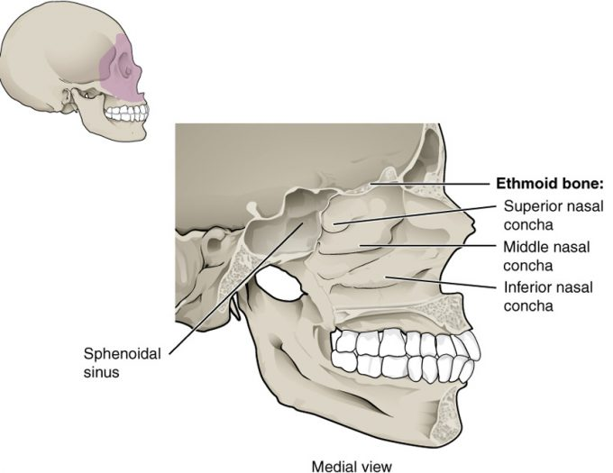

Figure 7.312 – Lateral Wall of Nasal Cavity: The three nasal conchae are curved bones that project from the lateral walls of the nasal cavity. The superior nasal concha and middle nasal concha are parts of the ethmoid bone. The inferior nasal concha is an independent bone of the skull.

Sutures

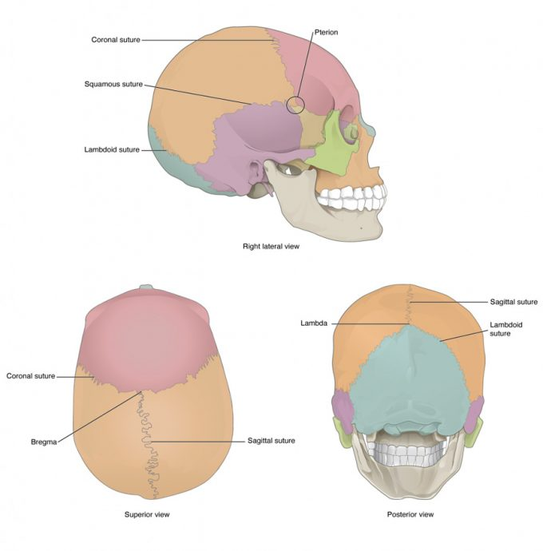Figure 7.313 – Sutures of the skull

Facial Bones

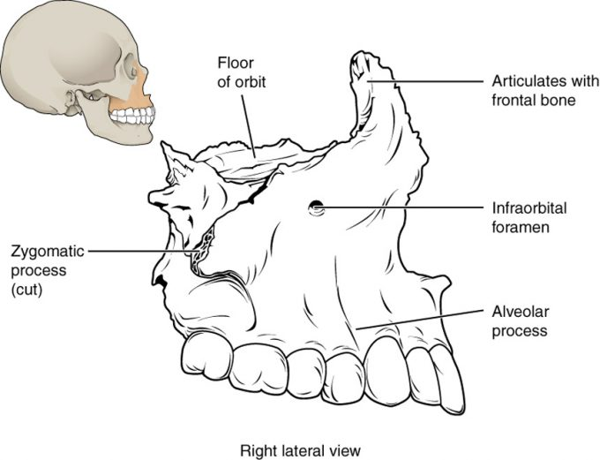

Figure 7.312 – Maxillary Bone: The maxillary bone forms the upper jaw and supports the upper teeth. Each maxilla also forms the lateral floor of each orbit and the majority of the hard palate.
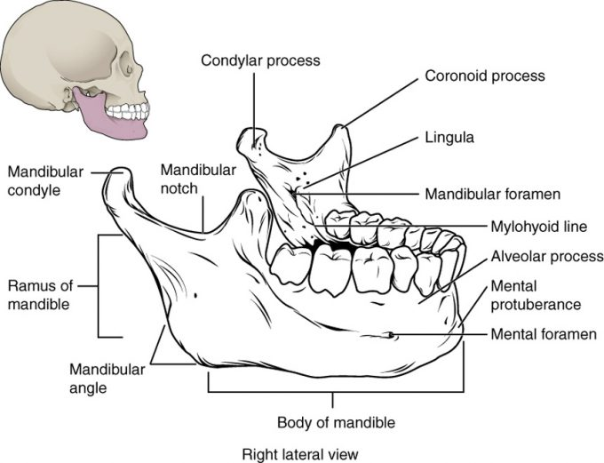

Figure 7.314 – Isolated Mandible: The mandible is the only moveable bone of the skull.

The Orbit

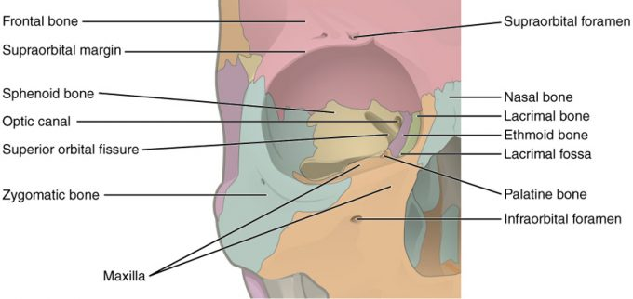

Nasal Septum and Sinuses

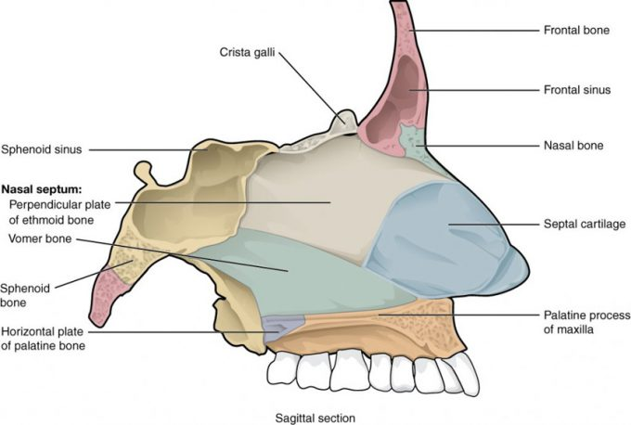
Figure 7.316 – Nasal Septum: The nasal septum is formed by the perpendicular plate of the ethmoid bone and the vomer bone. The septal cartilage fills the gap between these bones and extends into the nose.

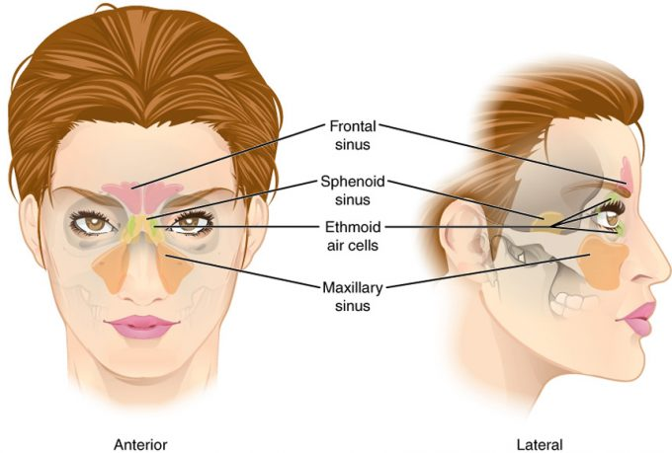

Figure 7.317 – Paranasal Sinuses: The air-filled paranasal sinuses, each named for the bone in which it is found, drain into the nasal cavity.
Hyoid Bone

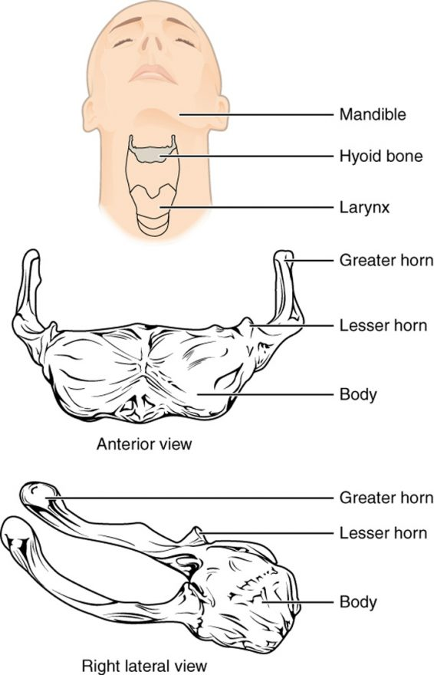
Vertebral Column

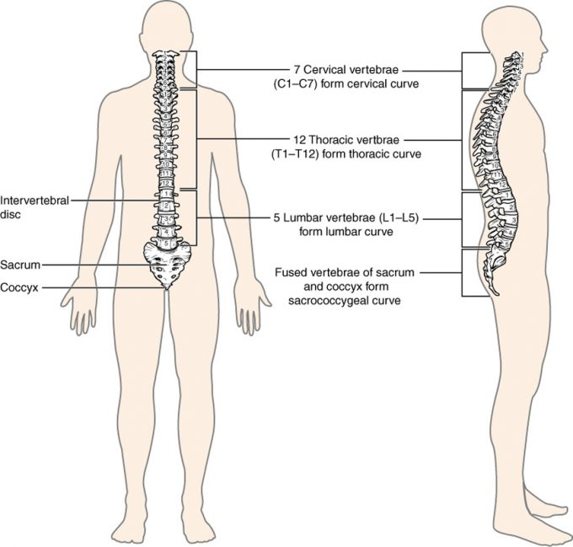

Figure 7.41 – Vertebral Column: The adult vertebral column consists of 24 vertebrae, plus the fused vertebrae of the sacrum and coccyx. The vertebrae are divided into three regions: cervical C1–C7 vertebrae, thoracic T1–T12 vertebrae, and lumbar L1–L5 vertebrae. The vertebral column is curved, with two primary curvatures (thoracic and sacrococcygeal curves) and two secondary curvatures (cervical and lumbar curves).
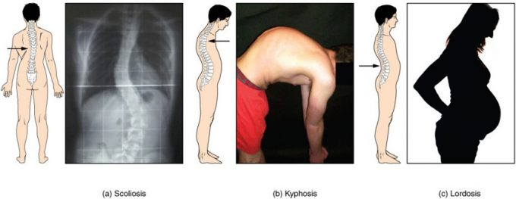
igure 7.42 – Abnormal Curvatures of the Vertebral Column: (a) Scoliosis is an abnormal lateral bending of the vertebral column. (b) An excessive curvature of the upper thoracic vertebral column is called kyphosis. (c) Lordosis is an excessive curvature in the lumbar region of the vertebral column.

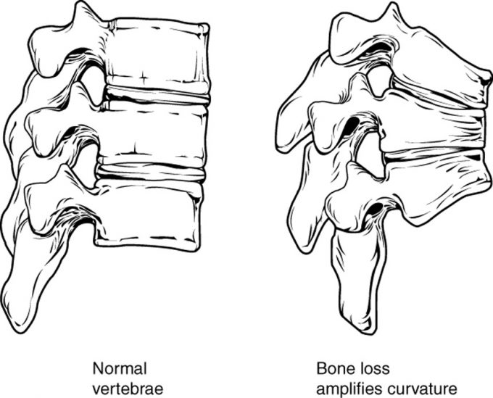

Figure 7.43 – Osteoporosis: Osteoporosis is an age-related disorder that causes the gradual loss of bone density and strength. When the thoracic vertebrae are affected, there can be a gradual collapse of the vertebrae. This results in kyphosis, an excessive curvature of the thoracic region.
General Structure of Vertebrae

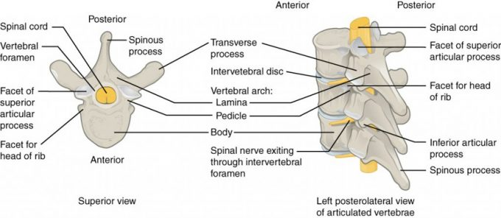
Figure 7.44 – Parts of a Typical Vertebra: A typical vertebra consists of a body and a vertebral arch. The arch is formed by the paired pedicles and paired laminae. Arising from the vertebral arch are the transverse, spinous, superior articular, and inferior articular processes. The vertebral foramen provides for passage of the spinal cord. Each spinal nerve exits through an intervertebral foramen, located between adjacent vertebrae. Intervertebral discs unite the bodies of adjacent vertebrae.

Intervertebral Disc

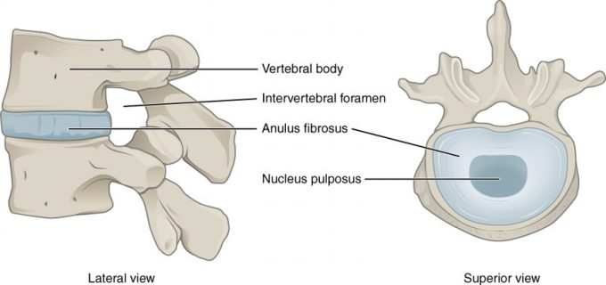

Figure 7.45 – Intervertebral Disc: The bodies of adjacent vertebrae are separated and united by an intervertebral disc, which provides padding and allows for movements between adjacent vertebrae. The disc consists of a fibrous outer layer called the anulus fibrosus and a gel-like center called the nucleus pulposus. The intervertebral foramen is the opening formed between adjacent vertebrae for the exit of a spinal nerve.

Cervical Vertebrae

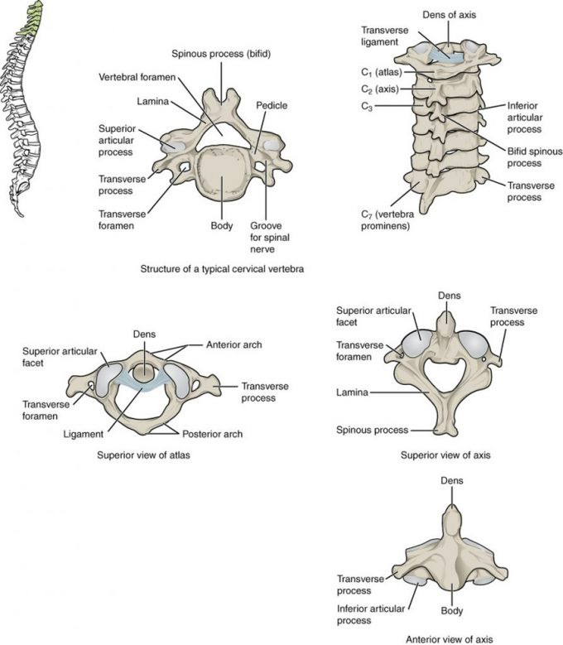

Figure 7.46 – Cervical Vertebrae: A typical cervical vertebra has a small body, a bifid spinous process, transverse processes that have a transverse foramen and are curved for spinal nerve passage. The atlas (C1 vertebra) does not have a body or spinous process. It consists of an anterior and a posterior arch and elongated transverse processes. The axis (C2 vertebra) has the upward projecting
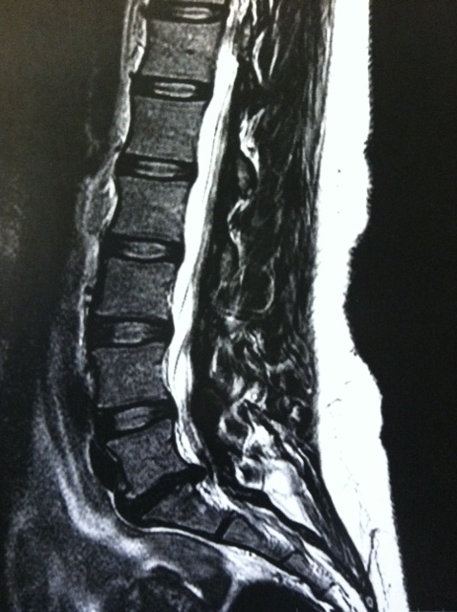

Thoracic Vertebrae

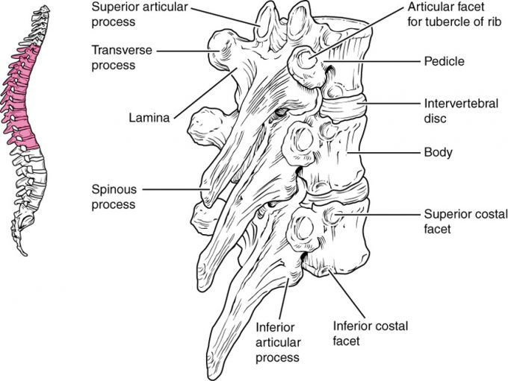

Figure 7.47 – Thoracic Vertebrae: A typical thoracic vertebra is distinguished by the spinous process, which is long and projects downward to overlap the next inferior vertebra. It also has articulation sites (facets) on the vertebral body and a transverse process for rib attachment. A posterior view of a midthoracic vertebra resembles a giraffe.

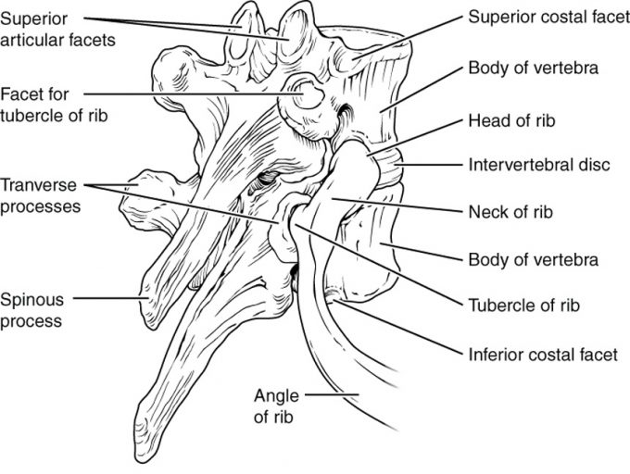
Figure 7.48 – Rib Articulation in Thoracic Vertebrae: Thoracic vertebrae have superior and inferior articular facets on the vertebral body for articulation with the head of a rib, and a transverse process facet for articulation with the rib tubercle.

Lumbar Vertebrae

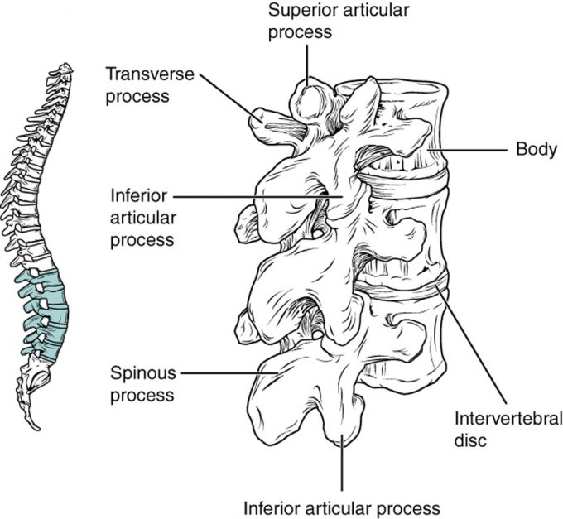

Figure 7.49 – Lumbar Vertebrae: Lumbar vertebrae are characterized by having a large, thick body and a short, rounded spinous process. A posterior view of a lumbar vertebra resembles a moose.
Sacrum and Coccyx

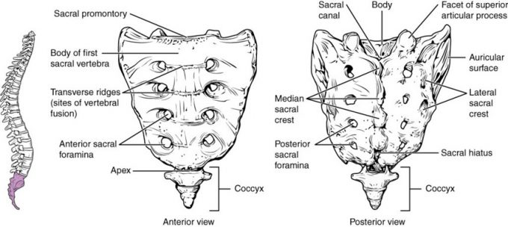

Figure 7.410 – Sacrum and Coccyx: The sacrum is formed from the fusion of five sacral vertebrae, whose lines of fusion are indicated by the transverse ridges. The fused spinous processes form the median sacral crest, while the lateral sacral crest arises from the fused transverse processes. The coccyx is formed by the fusion of four small coccygeal vertebrae.

Disc Herniation

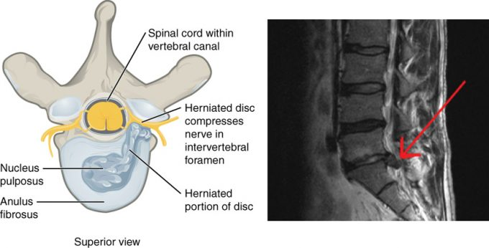

Figure 7.411 – Herniated Intervertebral Disc: Weakening of the anulus fibrosus can result in herniation (protrusion) of the nucleus pulposus and compression of a spinal nerve, resulting in pain and/or muscle weakness in the body regions supplied by that nerve.

Ligaments of Vertebral Column

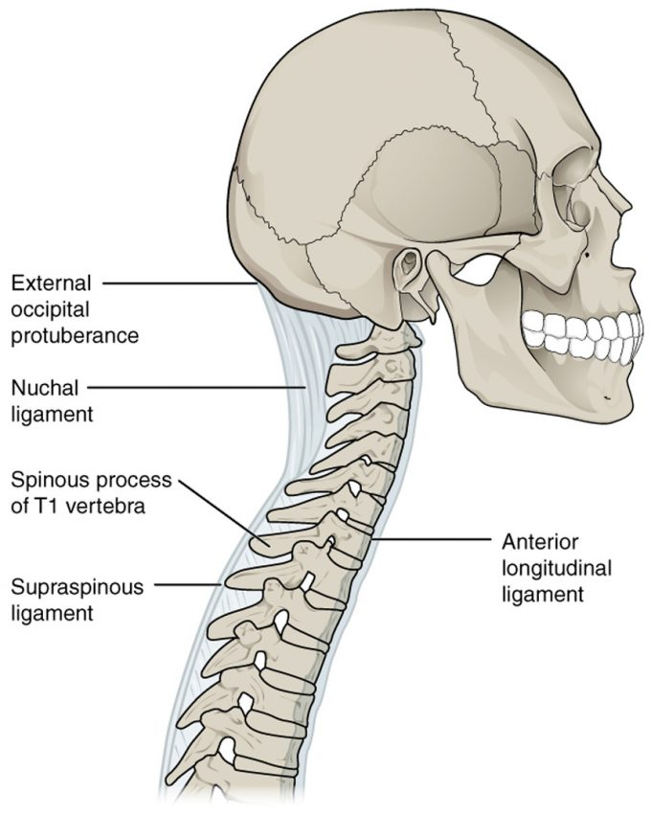
Figure 7.412 – Ligaments of Vertebral Column: The anterior longitudinal ligament runs the length of the vertebral column, uniting the anterior sides of the vertebral bodies. The supraspinous ligament connects the spinous processes of the thoracic and lumbar vertebrae. In the posterior neck, the supraspinous ligament enlarges to form the nuchal ligament, which attaches to the cervical spinous processes and to the base of the skull.

Thoracic Cage

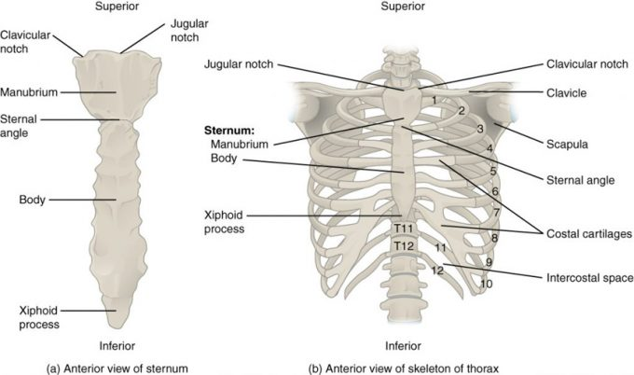

Figure 7.51 – Thoracic Cage: The thoracic cage is formed by the (a) sternum and (b) 12 pairs of ribs with their costal cartilages. The ribs are anchored posteriorly to the 12 thoracic vertebrae. The sternum consists of the manubrium, body, and xiphoid process. The ribs are classified as true ribs (1–7) and false ribs (8–12). The last two pairs of false ribs are also known as floating ribs (11–12).

Embryonic Development

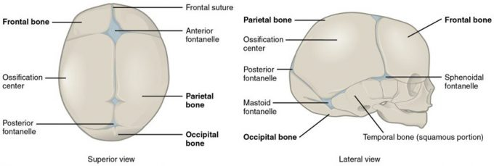

Figure 7.61 – Newborn Skull: The bones of the newborn skull are not fully ossified and are separated by large areas called fontanelles, which are filled with fibrous connective tissue. The fontanelles allow for continued growth of the brain and skull after birth. At the time of birth, the facial bones are small and underdeveloped, and the mastoid process has not yet formed.

