Pregnancy & Gestation

Accomplishing Fertilization

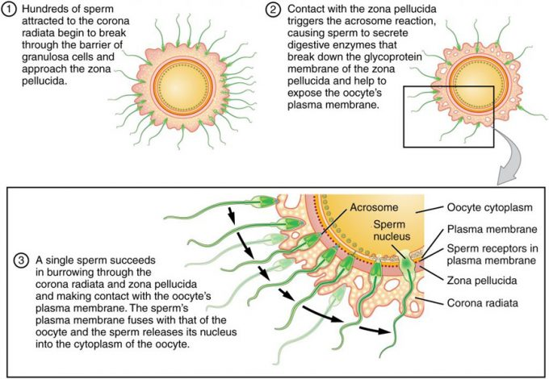

Figure 1. Sperm and the Process of Fertilization. Before fertilization, hundreds of capacitated sperm must break through the surrounding corona radiata and zona pellucida so that one can contact and fuse with the oocyte plasma membrane.
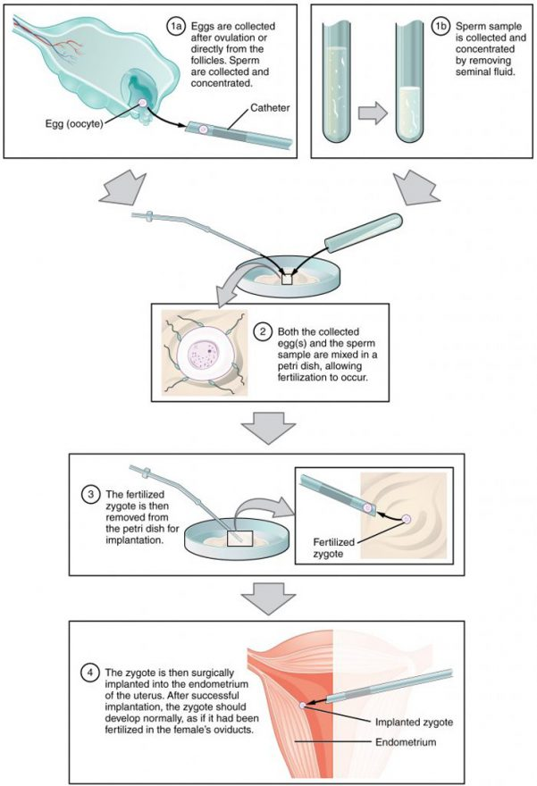

Figure 2. IVF. In vitro fertilization involves egg collection from the ovaries, fertilization in a petri dish, and the transfer of embryos into the uterus

Blocks to Polyspermy

Early Embryonic Development

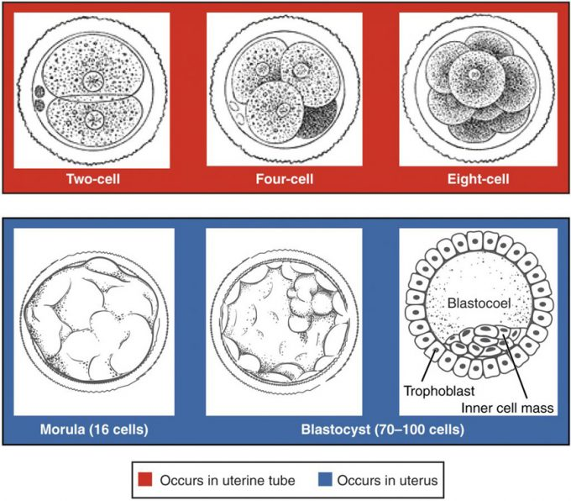
Figure 1. Pre-Embryonic Cleavages. Pre-embryonic cleavages make use of the abundant cytoplasm of the conceptus as the cells rapidly divide without changing the total volume.
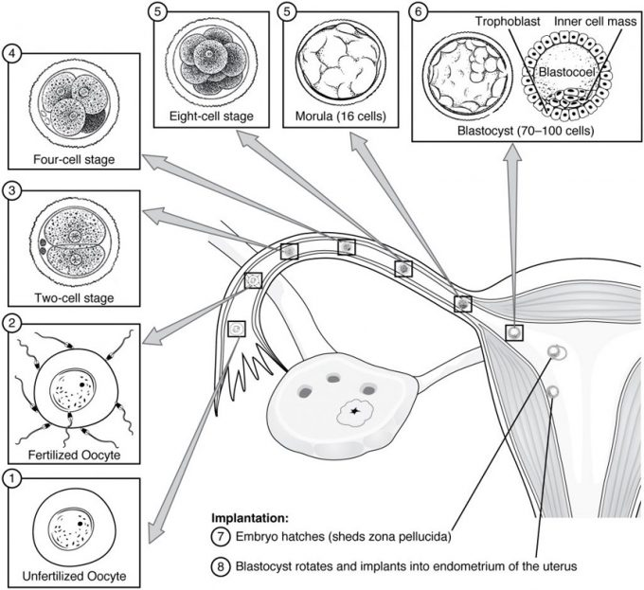
Figure 2. Pre-Embryonic Development. Ovulation, fertilization, pre-embryonic development, and implantation occur at specific locations within the female reproductive system in a time span of approximately 1 week.
Twins
Implantation

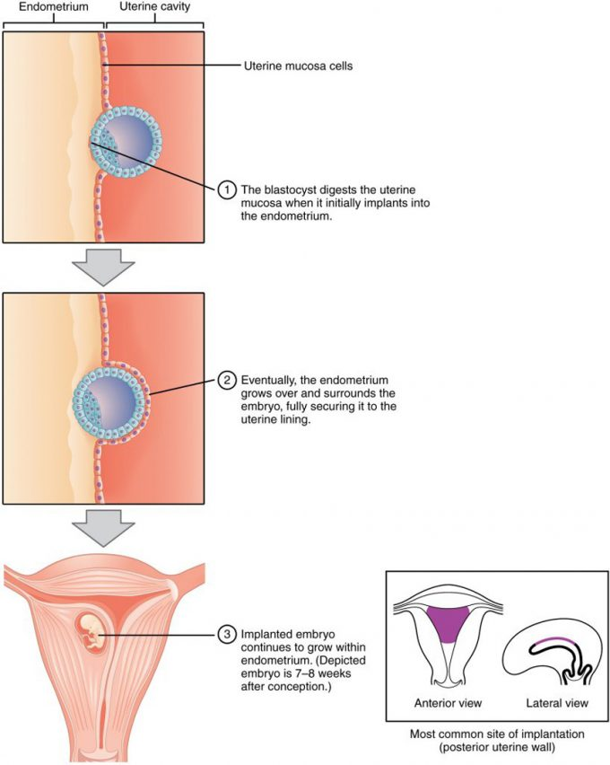
Figure 3. Implantation. During implantation, the trophoblast cells of the blastocyst adhere to the endometrium and digest endometrial cells until it is attached securely.
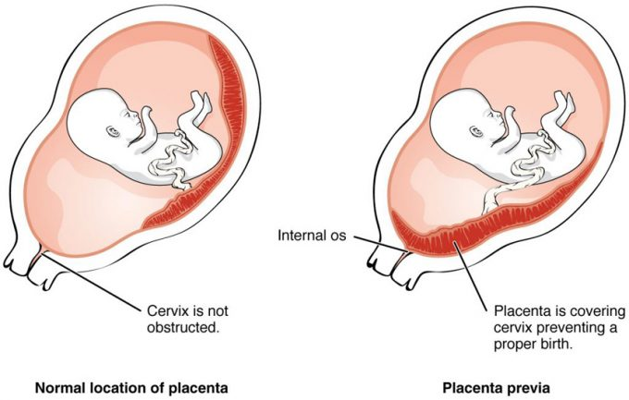

Figure 4. Placenta Previa. An embryo that implants too close to the opening of the cervix can lead to placenta previa, a condition in which the placenta partially or completely covers the cervix.

Extraembryonic Membranes

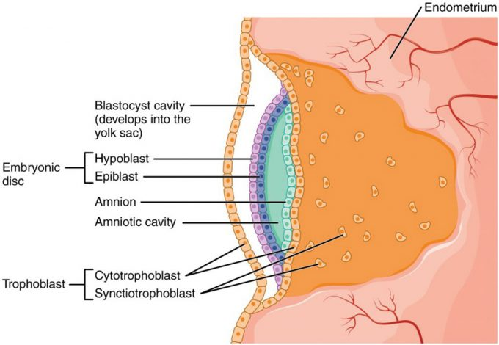
Figure 5. Development of the Embryonic Disc. Formation of the embryonic disc leaves spaces on either side that develop into the amniotic cavity and the yolk sac.

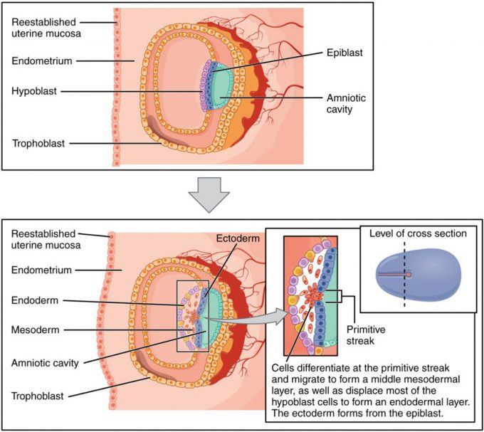
Figure 6. Germ Layers. Formation of the three primary germ layers occurs during the first 2 weeks of development. The embryo at this stage is only a few millimeters in length.
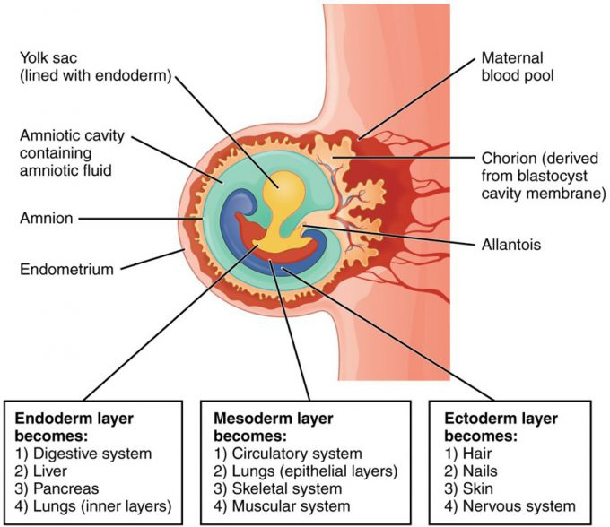Figure 7. Fates of Germ Layers in Embryo. Following gastrulation of the embryo in the third week, embryonic cells of the ectoderm, mesoderm, and endoderm begin to migrate and differentiate into the cell lineages that will give rise to mature organs and organ systems in the infant.

Placentation

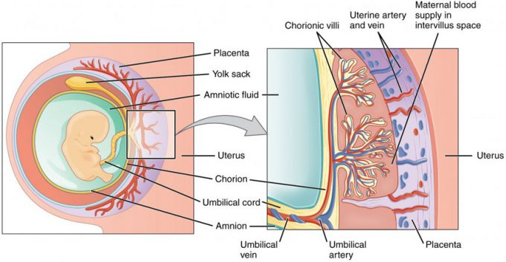
Figure 8. Cross-Section of the Placenta. In the placenta, maternal and fetal blood components are conducted through the surface of the chorionic villi, but maternal and fetal bloodstreams never mix directly.

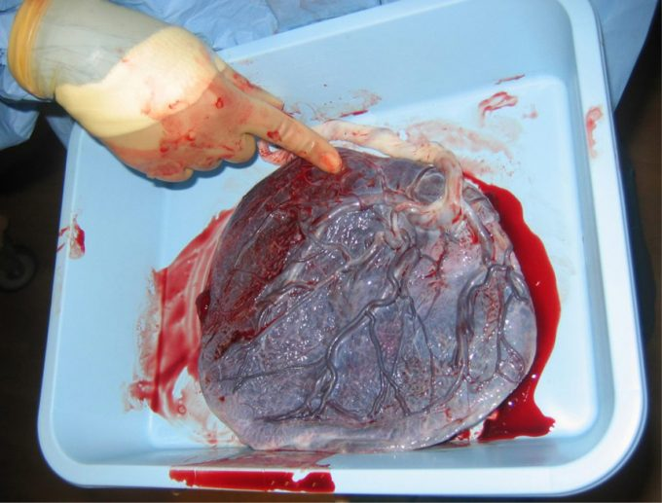
Figure 9. Placenta. This post-expulsion placenta and umbilical cord (white) are viewed from the fetal side.
Cell Differentiation

Organogenesis

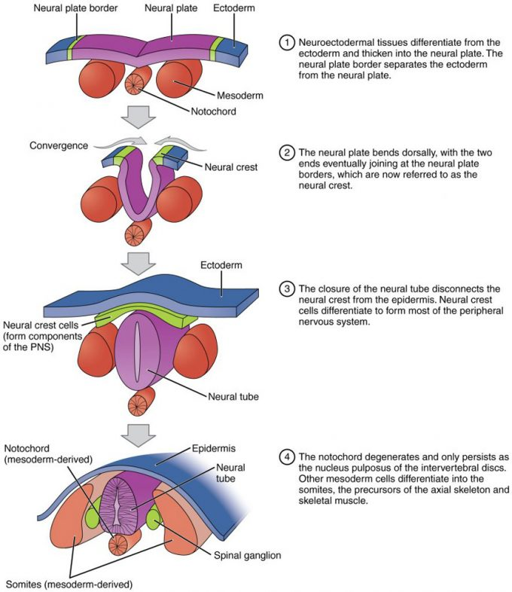
Figure 10. Neurulation. The embryonic process of neurulation establishes the rudiments of the future central nervous system and skeleton.
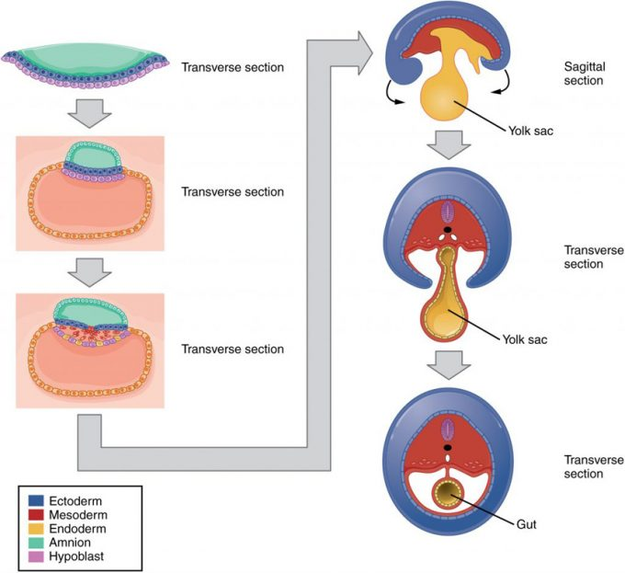Figure 11. Embryonic Folding. Embryonic folding converts a flat sheet of cells into a hollow, tube-like structure.

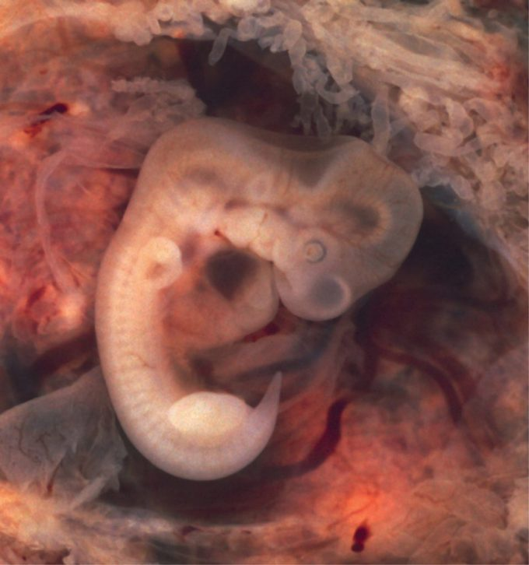
Figure 12. Embryo at 7 Weeks. An embryo at the end of 7 weeks of development is only 10 mm in length, but its developing eyes, limb buds, and tail are already visible. (This embryo was derived from an ectopic pregnancy.) (credit: Ed Uthman)
Fetal Circulation

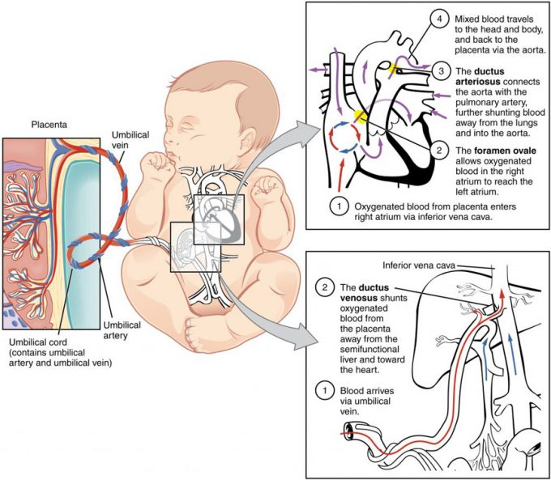
Figure 2. Fetal Circulatory System. The fetal circulatory system includes three shunts to divert blood from undeveloped and partially functioning organs, as well as blood supply to and from the placenta.
Effects of Pregnancy

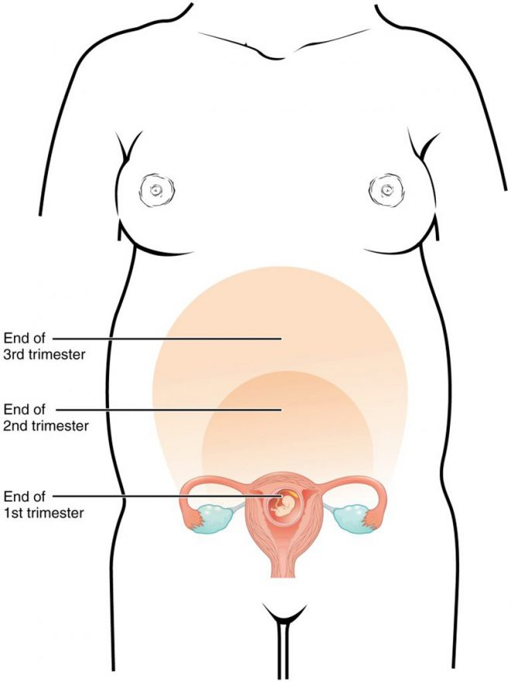
Figure 1. Size of Uterus throughout Pregnancy. The uterus grows throughout pregnancy to accommodate the fetus.

Contributors to Weight Gain During Pregnancy (Table 2)
Component | Weight (kg) | Weight (lb)
Fetus | 3.2–3.6 | 7–8
Placenta and fetal membranes | 0.9–1.8 | 2–4
Amniotic fluid | 0.9–1.4 | 2–3
Breast tissue | 0.9–1.4 | 2–3
Blood | 1.4 | 4
Fat | 0.9–4.1 | 3–9
Uterus | 0.9–2.3 | 2–5
Total | 10–16.3 | 22–36

Initiation of Labor

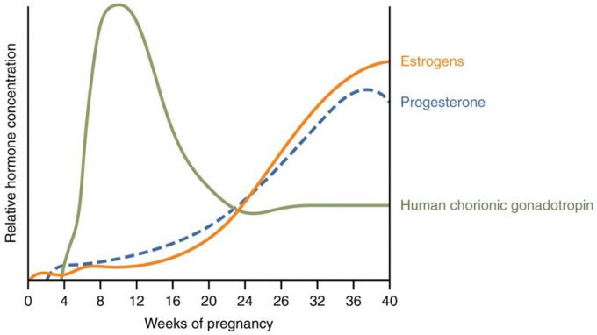
Figure 3. Hormones Initiating Labor. A positive feedback loop of hormones works to initiate labor.

Stages of Labor

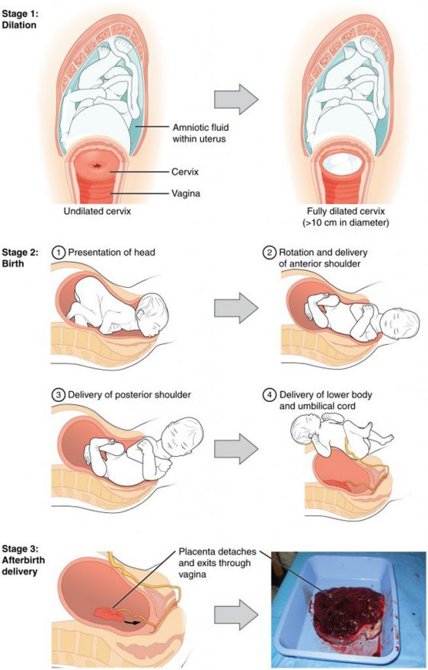
Figure 4. Stages of Childbirth. The stages of childbirth include Stage 1, early cervical dilation; Stage 2, full dilation and expulsion of the newborn; and Stage 3, delivery of the placenta and associated fetal membranes. (The position of the newborn’s shoulder is described relative to the mother.)

Adjustments of the Infant

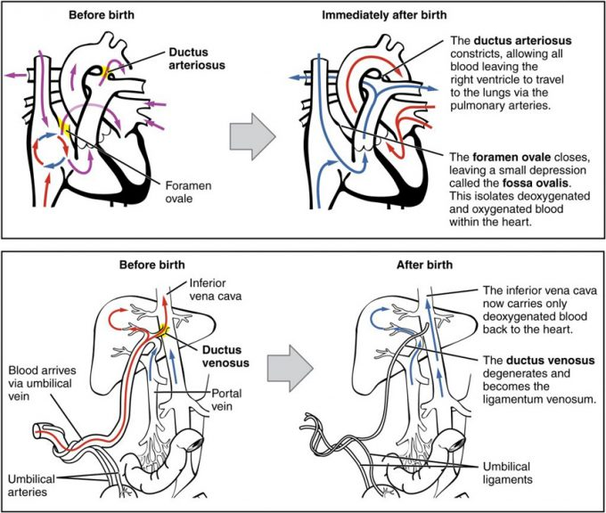 Figure 1. Neonatal Circulatory System. A newborn’s circulatory system reconfigures immediately after birth. The three fetal shunts have been closed permanently, facilitating blood flow to the liver and lungs.

Lactation

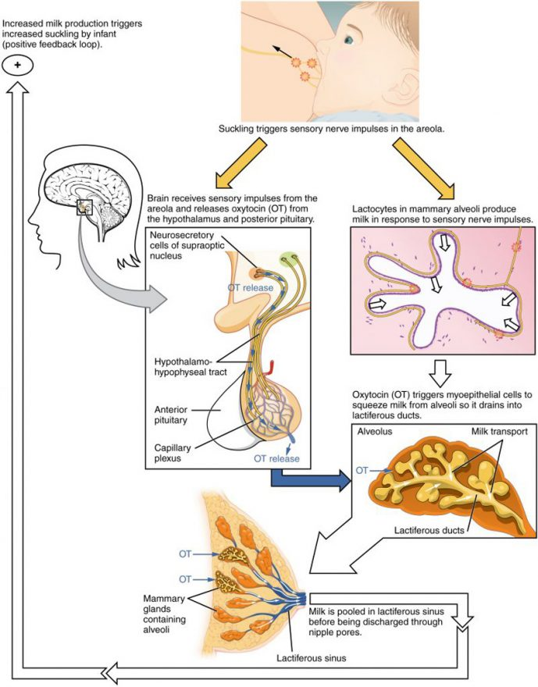
Figure 1. Let-Down Reflex. A positive feedback loop ensures continued milk production as long as the infant continues to breastfeed.
Human Genetics

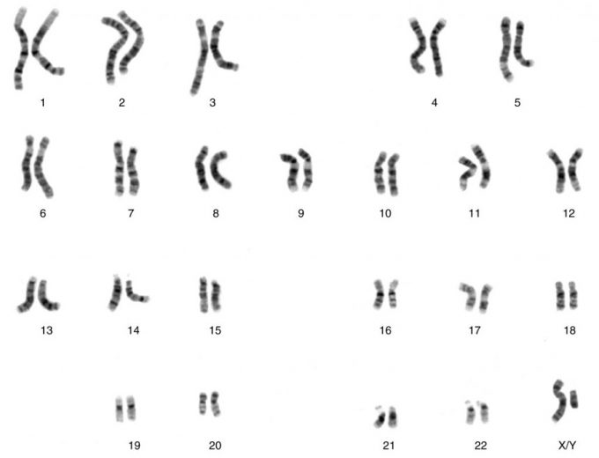
Figure 1. Chromosomal Complement of a Male. Each pair of chromosomes contains hundreds to thousands of genes. The banding patterns are nearly identical for the two chromosomes within each pair, indicating the same organization of genes. As is visible in this karyotype, the only exception to this is the XY sex chromosome pair in males. (credit: National Human Genome Research Institute)
Mendelian Patterns of Inheritance

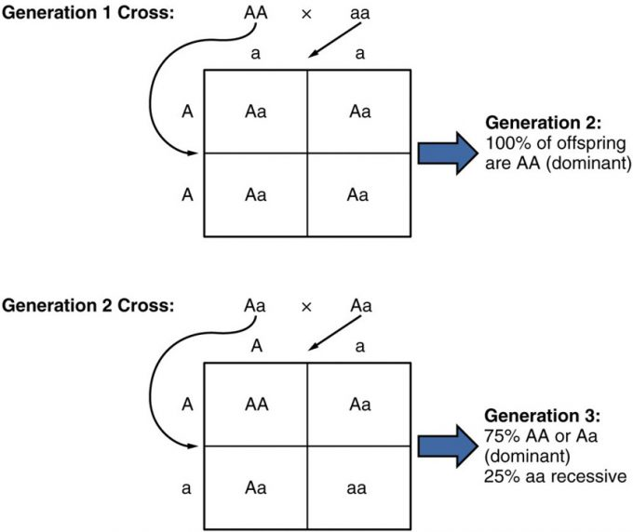

Figure 2. Random Segregation. In the formation of gametes, it is equally likely that either one of a pair alleles from one parent will be passed on to the offspring. This figure follows the possible combinations of alleles through two generations following a first-generation cross of homozygous dominant and homozygous recessive parents. The recessive phenotype, which is masked in the second generation, has a 1 in 4, or 25 percent, chance of reappearing in the third generation.

Patterns of Inheritance

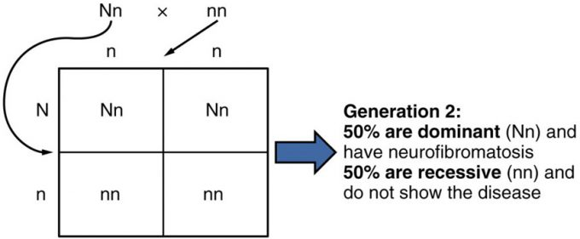

Figure 3. Autosomal Dominant Inheritance. Inheritance pattern of an autosomal dominant disorder, such as neurofibromatosis, is shown in a Punnett square.

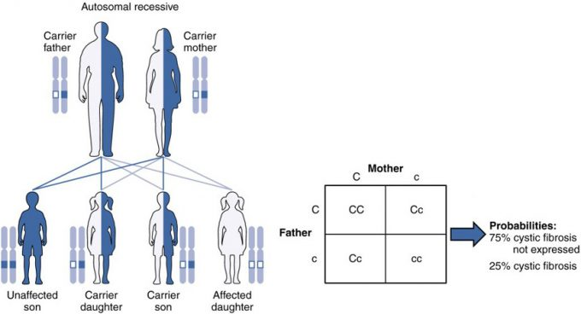

Figure 4. Autosomal Recessive Inheritance. The inheritance pattern of an autosomal recessive disorder with two carrier parents reflects a 3:1 probability of expression among offspring. (credit: U.S. National Library of Medicine)

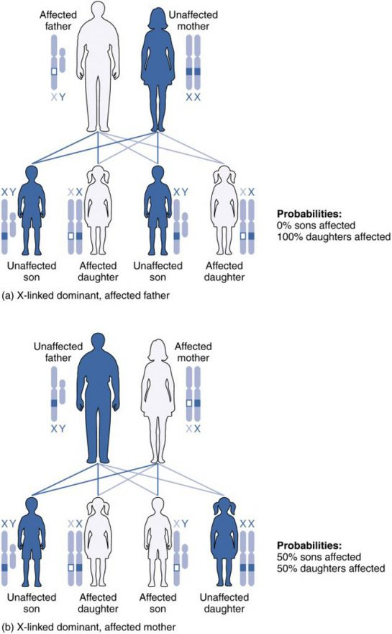

Figure 5. X-Linked Patterns of Inheritance. A chart of X-linked dominant inheritance patterns differs depending on whether (a) the father or (b) the mother is affected with the disease. (credit: U.S. National Library of Medicine)

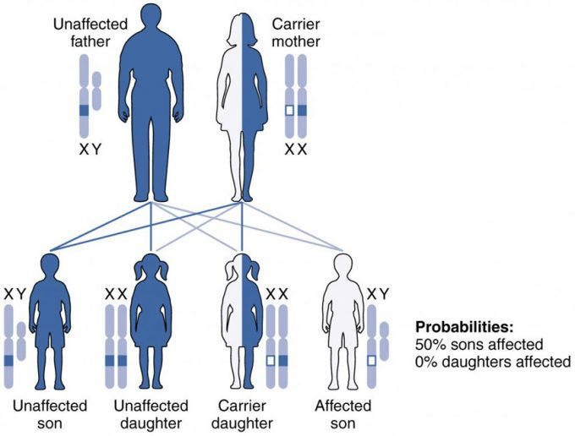

Figure 6. X-Linked Recessive Inheritance. Given two parents in which the father is normal and the mother is a carrier of an X-linked recessive disorder, a son would have a 50 percent probability of being affected with the disorder, whereas daughters would either be carriers or entirely unaffected. (credit: U.S. National Library of Medicine)

Other Inheritance Patterns

Expression of Blood Types (Table 4)
Blood type | Genotype | Pattern of inheritance
A | I^{A}I^{A} or I^{A}i | I^{A}is dominant to i
B | I^{B}I^{B} or^{IB}i | I^{B} is dominant to i
AB | I^{A}I^{B} | I^{A} is co-dominant to I^{B}
O | ii | Two recessive alleles

