Urinary System

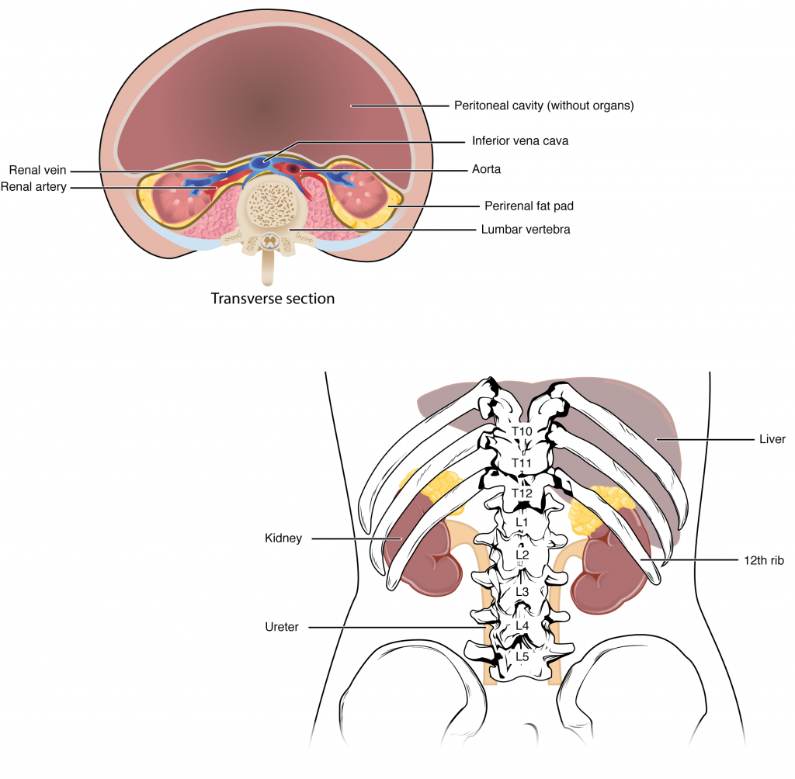
Figure 1. Kidneys. The kidneys are slightly protected by the ribs and are surrounded by fat for protection. On the superior aspect of each kidney is an adrenal gland.

Kidney Anatomy

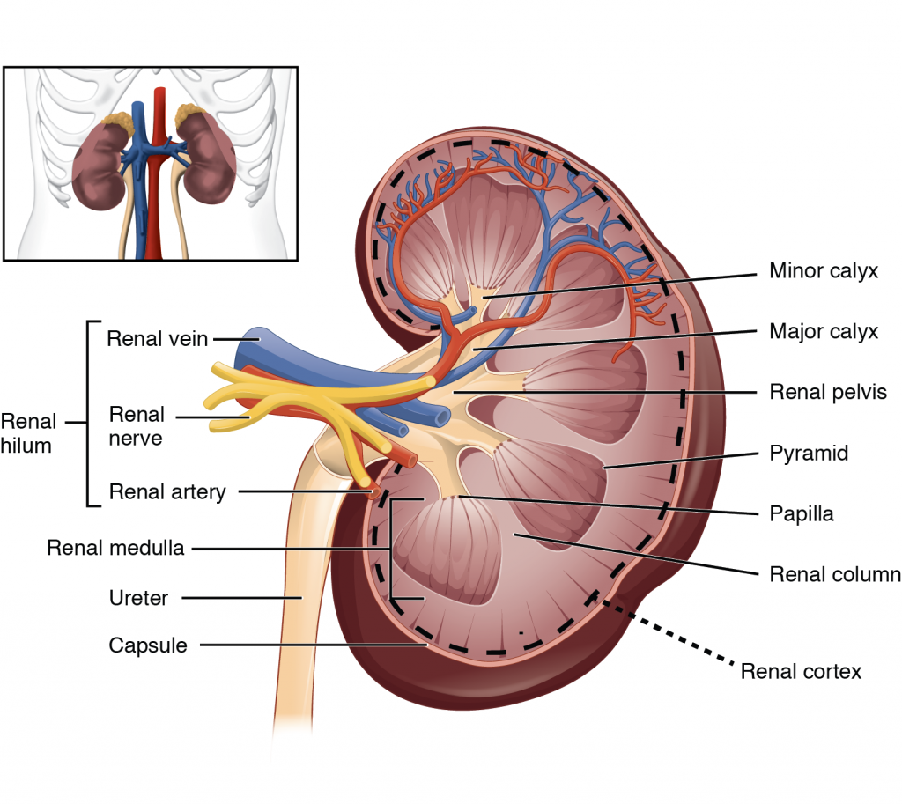
Figure 2. Left Kidney.

Blood Supply to Kidney

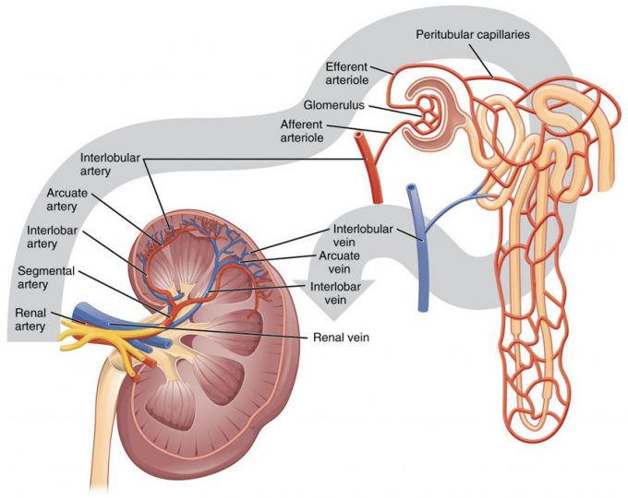

Figure 3. Blood Flow in the Kidney.
Nephrons

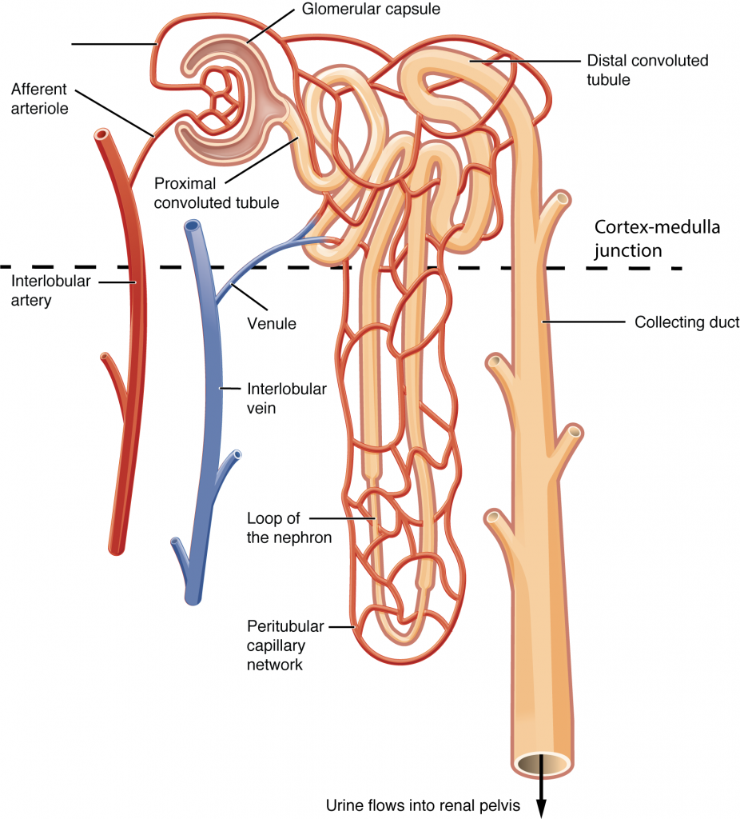

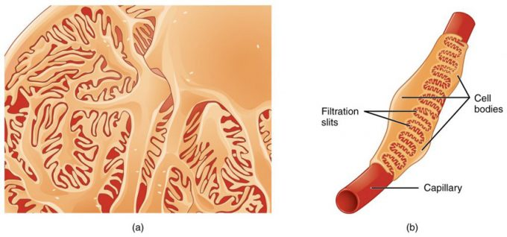

Figure 1. Podocytes. Podocytes interdigitate with structures called pedicels and filter substances into the glomerular capsule. In (a), the large cell body can be seen at the top right corner, with branches extending from the cell body. The smallest finger-like extensions are the pedicels.

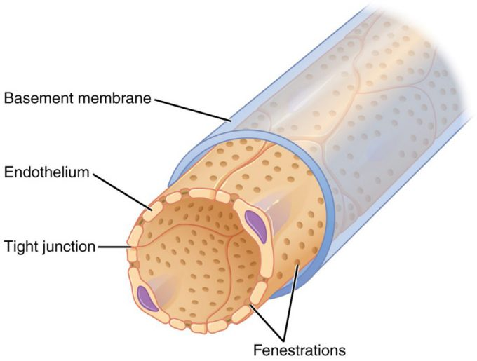

Figure 2. Fenestrated Capillary. Fenestrations allow many substances to leave the blood based primarily on size.

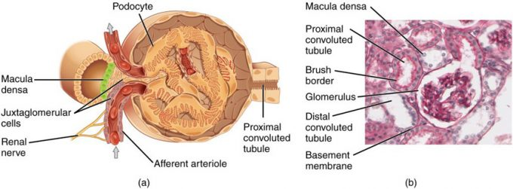

Figure 3. Juxtaglomerular Apparatus and Glomerulus. (a) The JGA allows specialized cells to monitor the composition of the fluid in the DCT and adjust the glomerular filtration rate. (b) This micrograph shows the glomerulus and surrounding structures. LM × 1540. (Micrograph provided by the Regents of University of Michigan Medical School © 2012)

Urine Formation

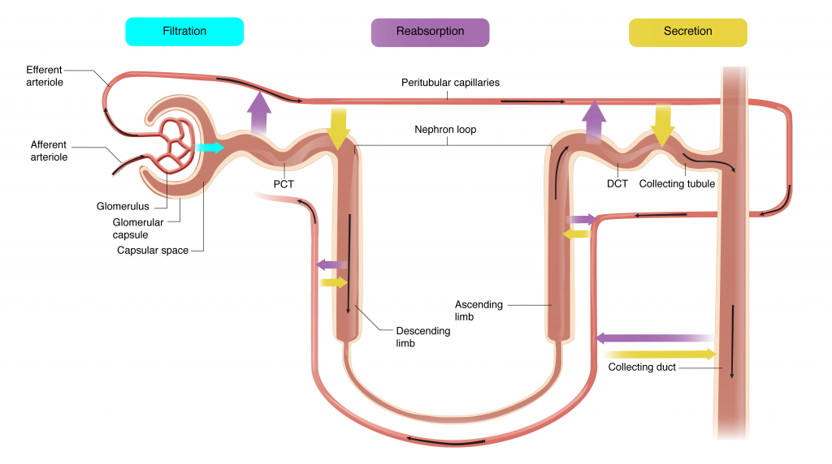
Figure 1. Urine formation

Substances Secreted or Reabsorbed in the Nephron and Their Locations (Table 5)
Substance | PCT | Loop of Henle | DCT | Collecting ducts
Glucose | Almost 100 percent reabsorbed; secondary active transport with Na⁺
Oligopeptides, proteins, amino acids | Almost 100 percent reabsorbed; symport with Na⁺
Vitamins | Reabsorbed
Lactate | Reabsorbed
Creatinine | Secreted
Urea | 50 percent reabsorbed by diffusion; also secreted | Secretion, diffusion in descending limb
Sodium | 65 percent actively reabsorbed | 25 percent reabsorbed in thick ascending limb; active transport | 5 percent reabsorbed; active | 5 percent reabsorbed, stimulated by aldosterone; active
Chloride | Reabsorbed, symport with Na⁺, diffusion | Reabsorbed in thin and thick ascending limb; diffusion in ascending limb | Reabsorbed; diffusion | Reabsorbed; symport
Water | 67 percent reabsorbed osmotically with solutes | 15 percent reabsorbed in descending limb; osmosis | 8 percent reabsorbed if ADH; osmosis | Variable amounts reabsorbed, controlled by ADH, osmosis
Bicarbonate | 80–90 percent symport reabsorption with Na⁺ | Reabsorbed, symport with Na⁺ and antiport with Cl–; in ascending limb
H⁺ | Secreted; diffusion
NH₄⁺ | Secreted; diffusion
HCO₃– | Reabsorbed; diffusion | Reabsorbed; diffusion in ascending limb | Reabsorbed; diffusion | Reabsorbed; antiport with Na⁺
Some drugs | Secreted
Potassium | 65 percent reabsorbed; diffusion | 20 percent reabsorbed in thick ascending limb; symport | Secreted; active | Secretion controlled by aldosterone; active
Calcium | Reabsorbed; diffusion | Reabsorbed in thick ascending limb; diffusion
Magnesium | Reabsorbed; diffusion | Reabsorbed in thick ascending limb; diffusion | Reabsorbed
Phosphate | 85 percent reabsorbed, inhibited by parathyroid hormone, diffusion

Glomerular Filtration

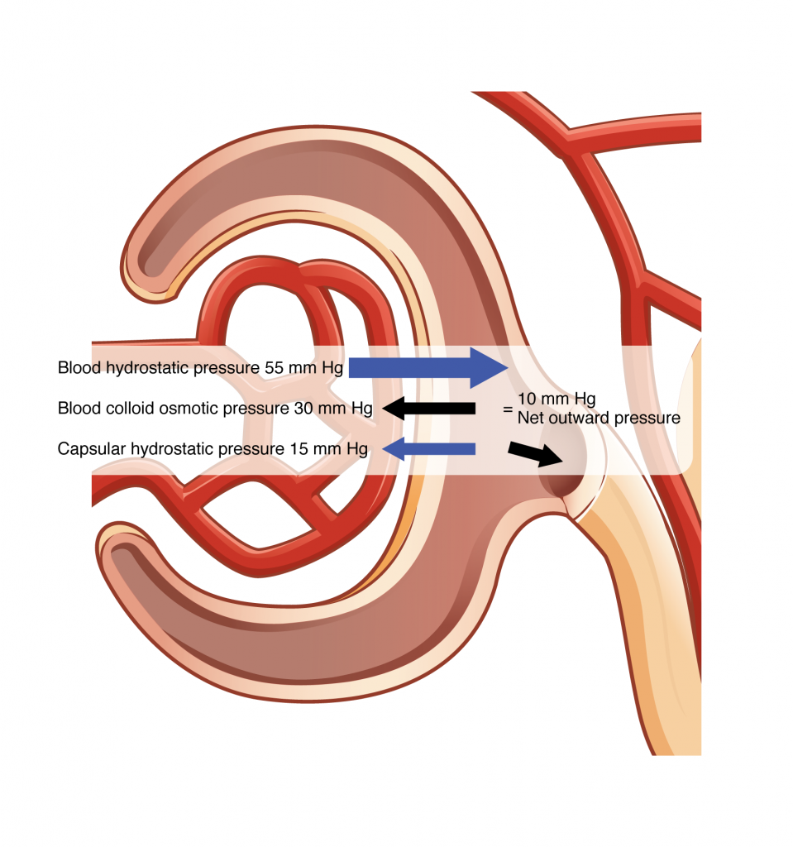
Figure 1. Net Filtration Pressure. The NFP is the sum of osmotic and hydrostatic pressures.

Paracrine Mechanisms Controlling Glomerular Filtration Rate (Table 8)
Change in GFR | NaCl Absorption | Role of ATP and adenosine/Role of NO | Effect on GFR
Increased GFR | Tubular NaCl increases | ATP and adenosine increase, causing vasoconstriction | Vasoconstriction slows GFR
Decreased GFR | Tubular NaCl decreases | ATP and adenosine decrease, causing vasodilation | Vasodilation increases GFR

.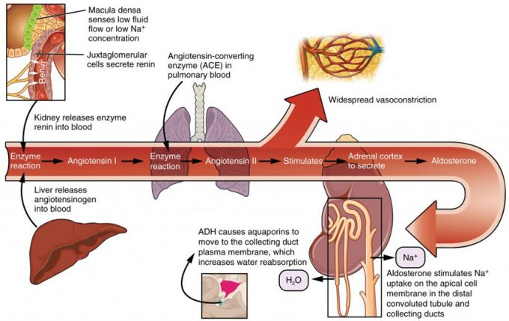

Figure 4. Conversion of Angiotensin I to Angiotensin II. The enzyme renin converts the pro-enzyme angiotensin I; the lung-derived enzyme ACE converts angiotensin I into active angiotensin II

Physiology of Urine Formation

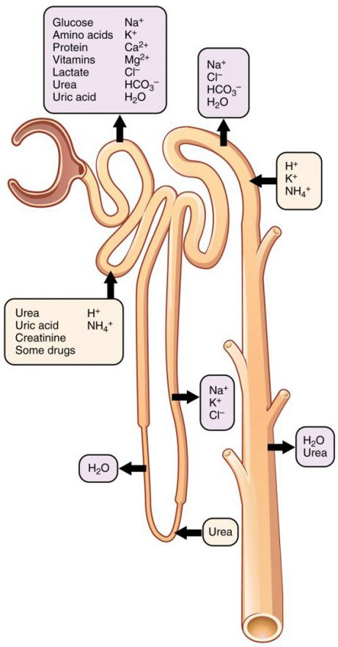

Figure 1. Locations of Secretion and Reabsorption in the Nephron.

PCT

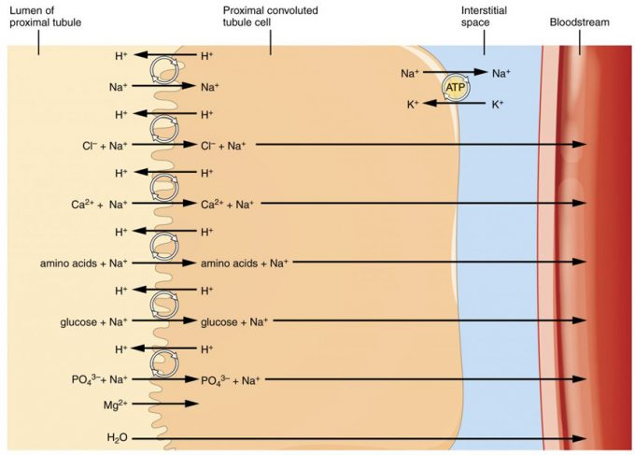 Figure 2. Substances Reabsorbed and Secreted by the PCT.
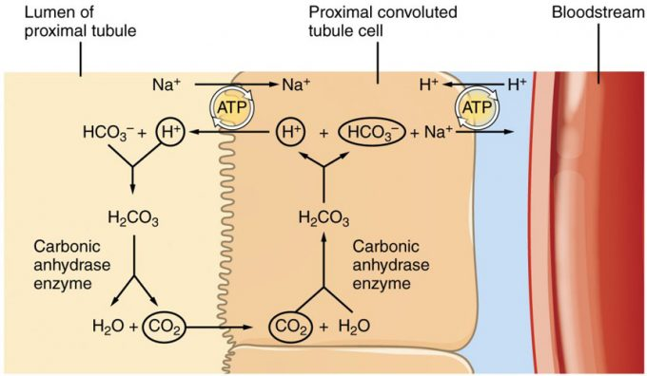 Figure 3. Reabsorption of Bicarbonate from the PCT.
Loop of Henle

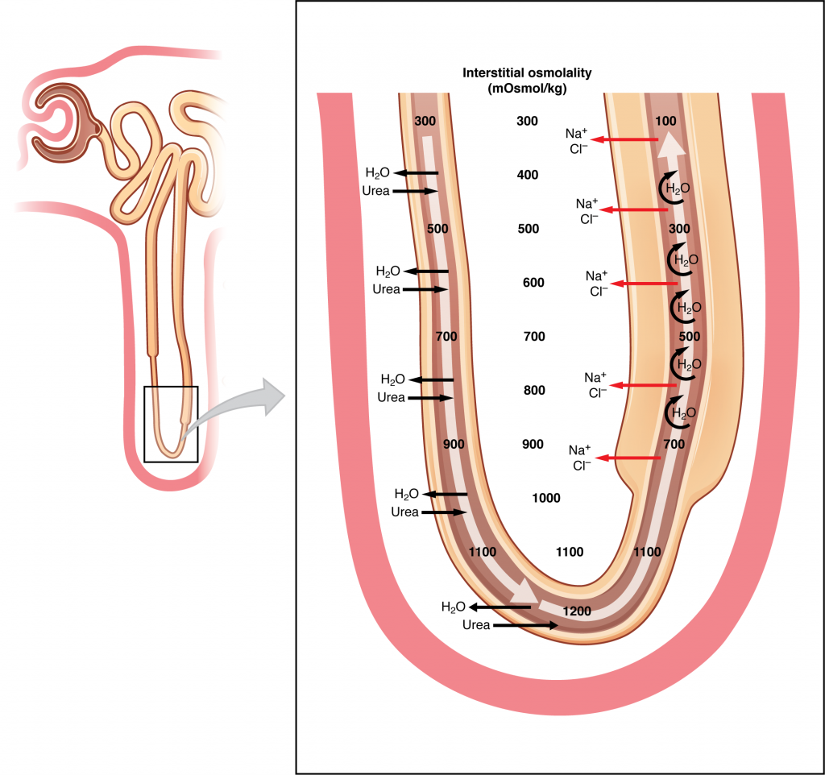
Figure 4. Countercurrent Multiplier System.
Regulation of Urine Concentration

Urine

Normal Urine Characteristics (Table 1)
Characteristic | Normal values
Color | Pale yellow to deep amber
Odor | Odorless
Volume | 750–2000 mL/24 hour
pH | 4.5–8.0
Specific gravity | 1.003–1.032
Osmolarity | 40–1350 mOsmol/kg
Urobilinogen | 0.2–1.0 mg/100 mL
White blood cells | 0–2 HPF (per high-power field of microscope)
Leukocyte esterase | None
Protein | None or trace
Bilirubin | <0.3 mg/100 mL
Ketones | None
Nitrites | None
Blood | None
Glucose | None

Urine Transport

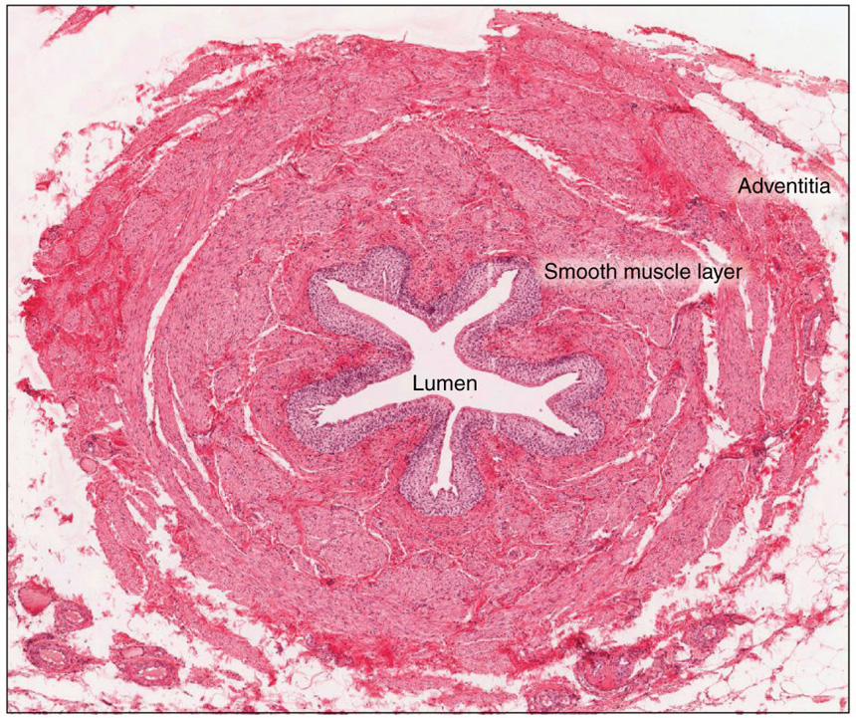
Figure 4. Ureter. Peristaltic contractions help to move urine through the lumen with contributions from fluid pressure and gravity. LM × 128. (Micrograph provided by the Regents of the University of Michigan Medical School © 2012)

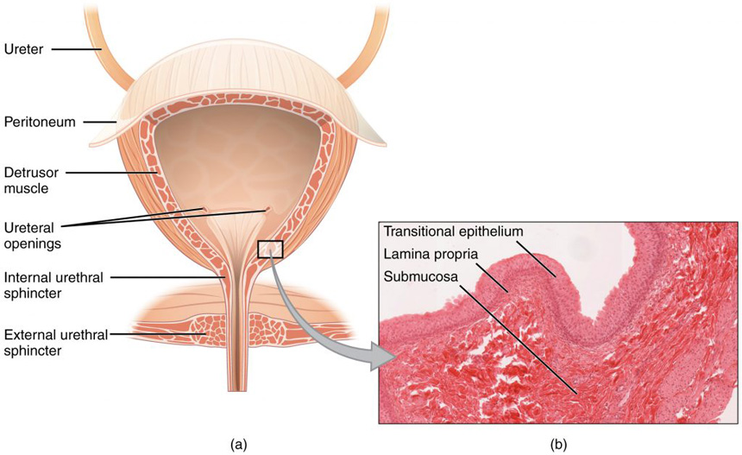
Figure 2. Bladder. (a) Anterior cross section of the bladder. (b) The detrusor muscle of the bladder (source: monkey tissue) LM × 448. (Micrograph provided by the Regents of the University of Michigan Medical School © 2012)
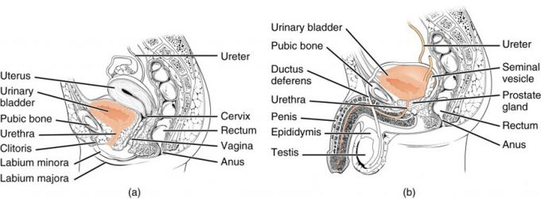
Figure 1. Female and Male Urethras. The urethra transports urine from the bladder to the outside of the body. This image shows (a) a female urethra and (b) a male urethra.
Micturition

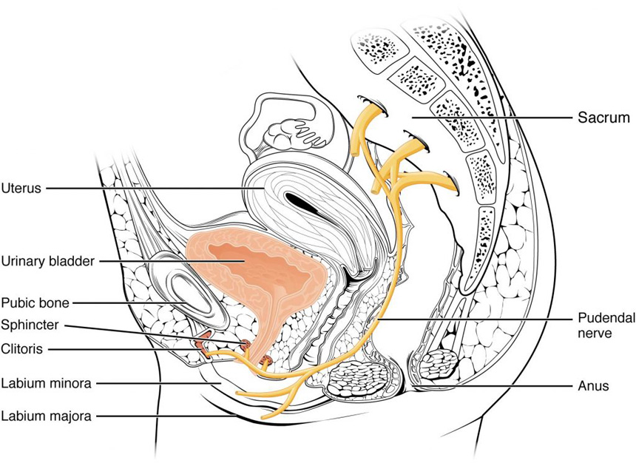
Figure 3. Nerves Innervating the Urinary System.

