Fluid and Electrolyte Balance

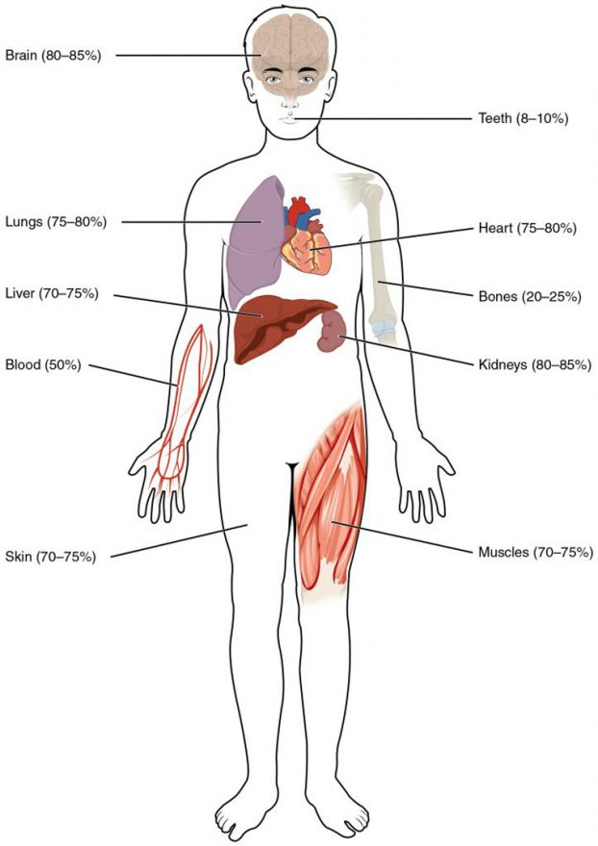
Water Content of the Body’s Organs and Tissues. Water content varies in different body organs and tissues, from as little as 8 percent in the teeth to as much as 85 percent in the brain.

Fluid Compartments

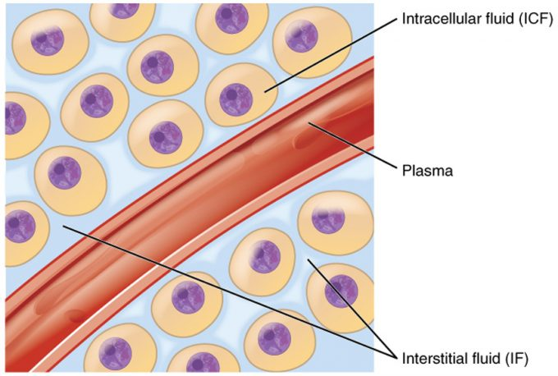

Figure 2. Fluid Compartments in the Human Body. The intracellular fluid (ICF) is the fluid within cells. The interstitial fluid (IF) is part of the extracellular fluid (ECF) between the cells. Blood plasma is the second part of the ECF. Materials travel between cells and the plasma in capillaries through the IF.

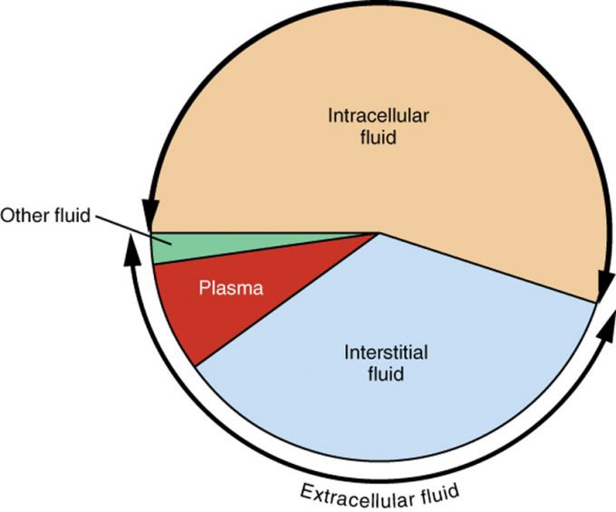

Figure 3. A Pie Graph Showing the Proportion of Total Body Fluid in Each of the Body’s Fluid Compartments. Most of the water in the body is intracellular fluid. The second largest volume is the interstitial fluid, which surrounds cells that are not blood cells.

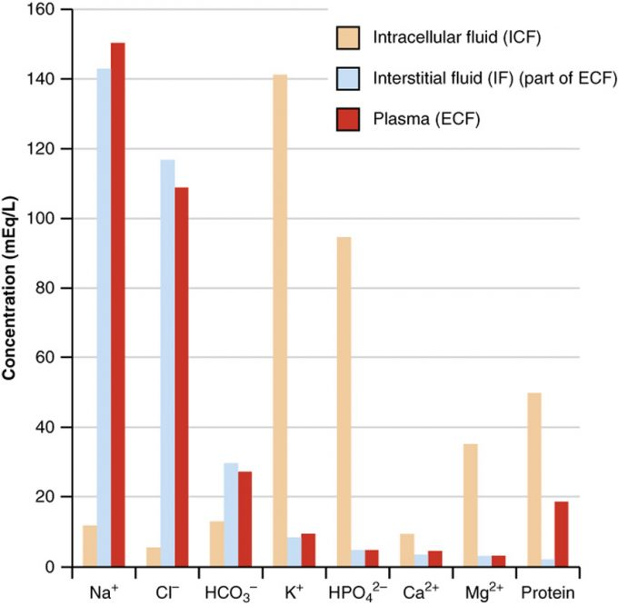
Figure 4. The Concentrations of Different Elements in Key Bodily Fluids. The graph shows the composition of the ICF, IF, and plasma. The compositions of plasma and IF are similar to one another but are quite different from the composition of the ICF.

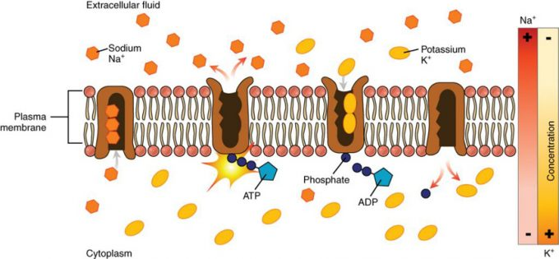

Figure 5. The Sodium-Potassium Pump. The sodium-potassium pump is powered by ATP to transfer sodium out of the cytoplasm and into the ECF. The pump also transfers potassium out of the ECF and into the cytoplasm. (credit: modification of work by Mariana Ruiz Villarreal)
Fluid Movements

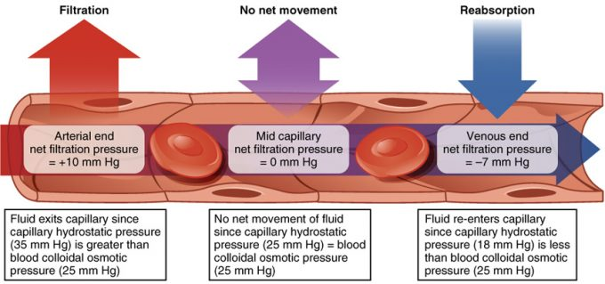

Figure 6. Capillary Exchange. Net filtration occurs near the arterial end of the capillary since capillary hydrostatic pressure (CHP) is greater than blood colloidal osmotic pressure (BCOP). There is no net movement of fluid near the midpoint of the capillary since CHP = BCOP. Net reabsorption occurs near the venous end of the capillary since BCOP is greater than CHP.

Solute Movement

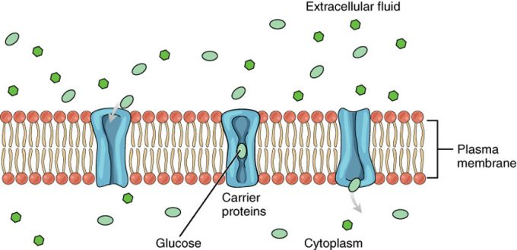

Figure 7. Facilitated Diffusion. Glucose molecules use facilitated diffusion to move down a concentration gradient through the carrier protein channels in the membrane. (credit: modification of work by Mariana Ruiz Villarreal)
Edema

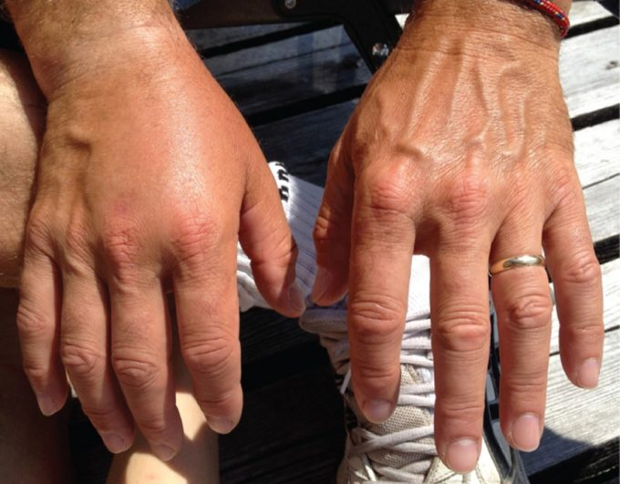

Figure 8. Edema. An allergic reaction can cause capillaries in the hand to leak excess fluid that accumulates in the tissues. (credit: Jane Whitney)
Water Balance

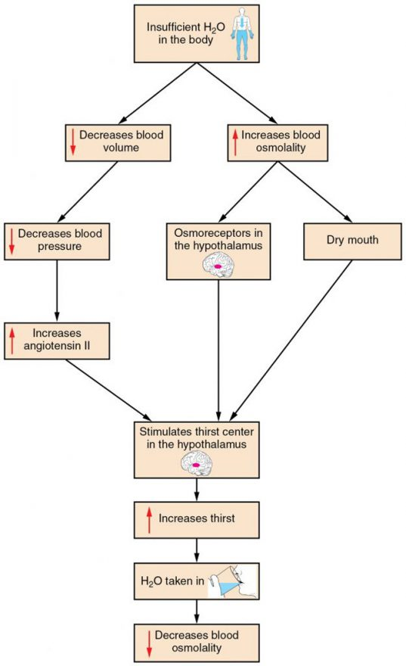

Figure 1. A Flowchart Showing the Thirst Response. The thirst response begins when osmoreceptors detect a decrease in water levels in the blood.
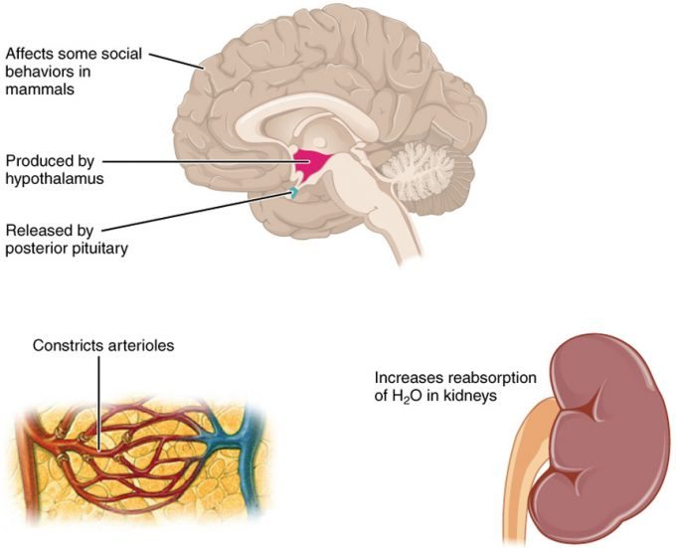

Figure 2. Antidiuretic Hormone (ADH). ADH is produced in the hypothalamus and released by the posterior pituitary gland. It causes the kidneys to retain water, constricts arterioles in the peripheral circulation, and affects some social behaviors in mammals.

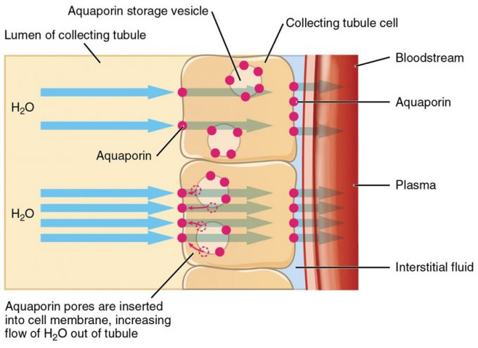

Figure 3. Aquaporins. The binding of ADH to receptors on the cells of the collecting tubule results in aquaporins being inserted into the plasma membrane, shown in the lower cell. This dramatically increases the flow of water out of the tubule and into the bloodstream.

Electrolyte Balance

Electrolyte and Ion Reference Values (Table 1)
Name | Chemical symbol | Plasma | CSF | Urine
Sodium | Na⁺ | 136.00–146.00 (mM) | 138.00–150.00 (mM) | 40.00–220.00 (mM)
Potassium | K⁺ | 3.50–5.00 (mM) | 0.35–3.5 (mM) | 25.00–125.00 (mM)
Chloride | Cl– | 98.00–107.00 (mM) | 118.00–132.00 (mM) | 110.00–250.00 (mM)
Bicarbonate | HCO₃– | 22.00–29.00 (mM) | —— | ——
Calcium | Ca⁺⁺ | 2.15–2.55 (mmol/day) | —— | Up to 7.49 (mmol/day)
Phosphate | HPO42−HPO42− | 0.81–1.45 (mmol/day) | —— | 12.90–42.00 (mmol/day)

Sodium Balance

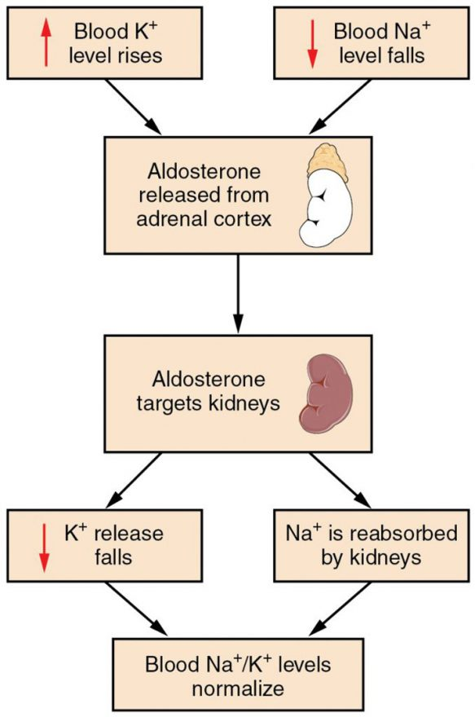
Figure 1. The Aldosterone Feedback Loop. Aldosterone, which is released by the adrenal gland, facilitates reabsorption of Na+ and thus the reabsorption of water.
Acid-Base Balance

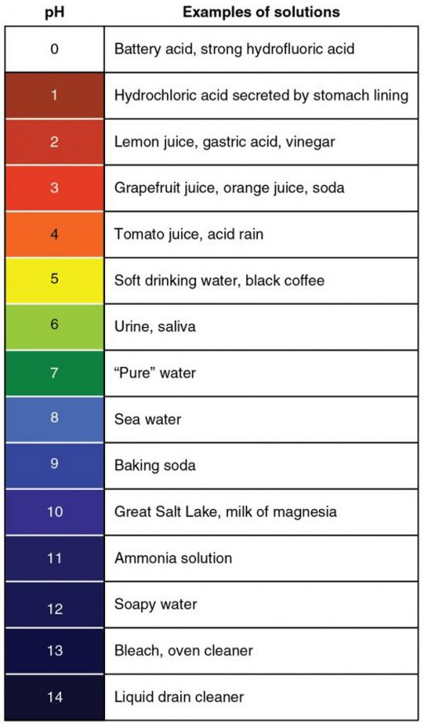
Figure 1. The pH Scale. This chart shows where many common substances fall on the pH scale.

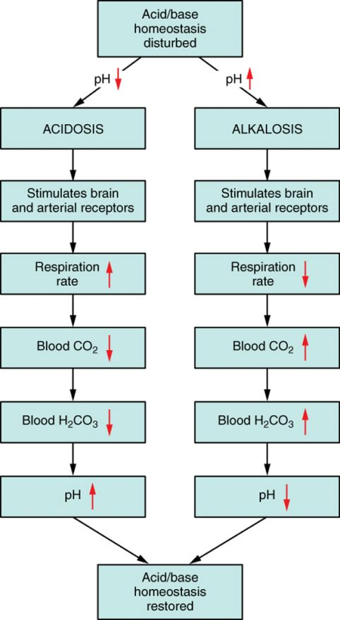

Figure 2. Respiratory Regulation of Blood pH. The respiratory system can reduce blood pH by removing CO2 from the blood.

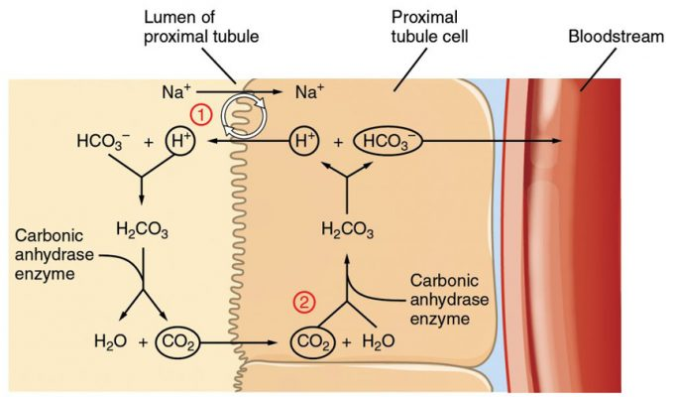
- Step 1: Sodium ions are reabsorbed from the filtrate in exchange for H⁺ by an antiport mechanism in the apical membranes of cells lining the renal tubule.
- Step 2: The cells produce bicarbonate ions that can be shunted to peritubular capillaries.
- Step 3: When CO₂ is available, the reaction is driven to the formation of carbonic acid, which dissociates to form a bicarbonate ion and a hydrogen ion.
- Step 4: The bicarbonate ion passes into the peritubular capillaries and returns to the blood. The hydrogen ion is secreted into the filtrate, where it can become part of new water molecules and be reabsorbed as such, or removed in the urine.

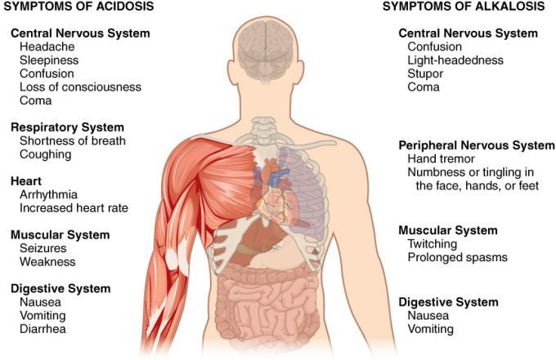

Metabolic Acidosis

Chloride Balance
Regulation of Calcium

