Which of the following structures functions to filter lymph of possible pathogens and diseased cells?
- spleen
- liver
- tonsils
- lymph nodes
- Peyer’s patches
Immune System

Innate Defenses

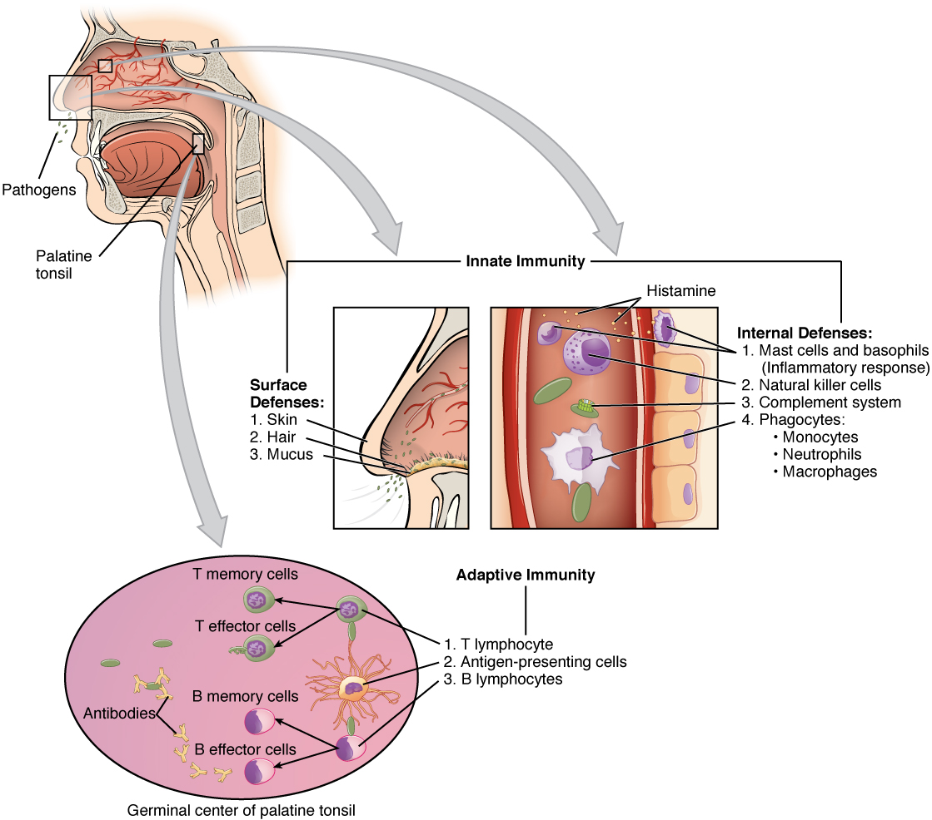Figure 1. Cooperation between Innate and Adaptive Immune Responses. The innate immune system enhances adaptive immune responses so they can be more effective

Barriers

Barrier Defenses (Table 2)
Site | Specific defense | Protective aspect
Skin | Epidermal surface | Keratinized cells of surface, Langerhans cells
Skin (sweat/secretions) | Sweat glands, sebaceous glands | Low pH, washing action
Oral cavity | Salivary glands | Lysozyme
Stomach | Gastrointestinal tract | Low pH
Mucosal surfaces | Mucosal epithelium | Nonkeratinized epithelial cells
Normal flora (nonpathogenic bacteria) | Mucosal tissues | Prevent pathogens from growing on mucosal surfaces

Phagocytes

Phagocytic Cells of the Innate Immune System (Table 3)
Cell | Cell type | Primary location | Function in the innate immune response
Macrophage | Agranulocyte | Body cavities/organs | Phagocytosis
Neutrophil | Granulocyte | Blood | Phagocytosis
Monocyte | Agranulocyte | Blood | Precursor of macrophage/dendritic cell

Natural Killer Cells

Chemical Signals

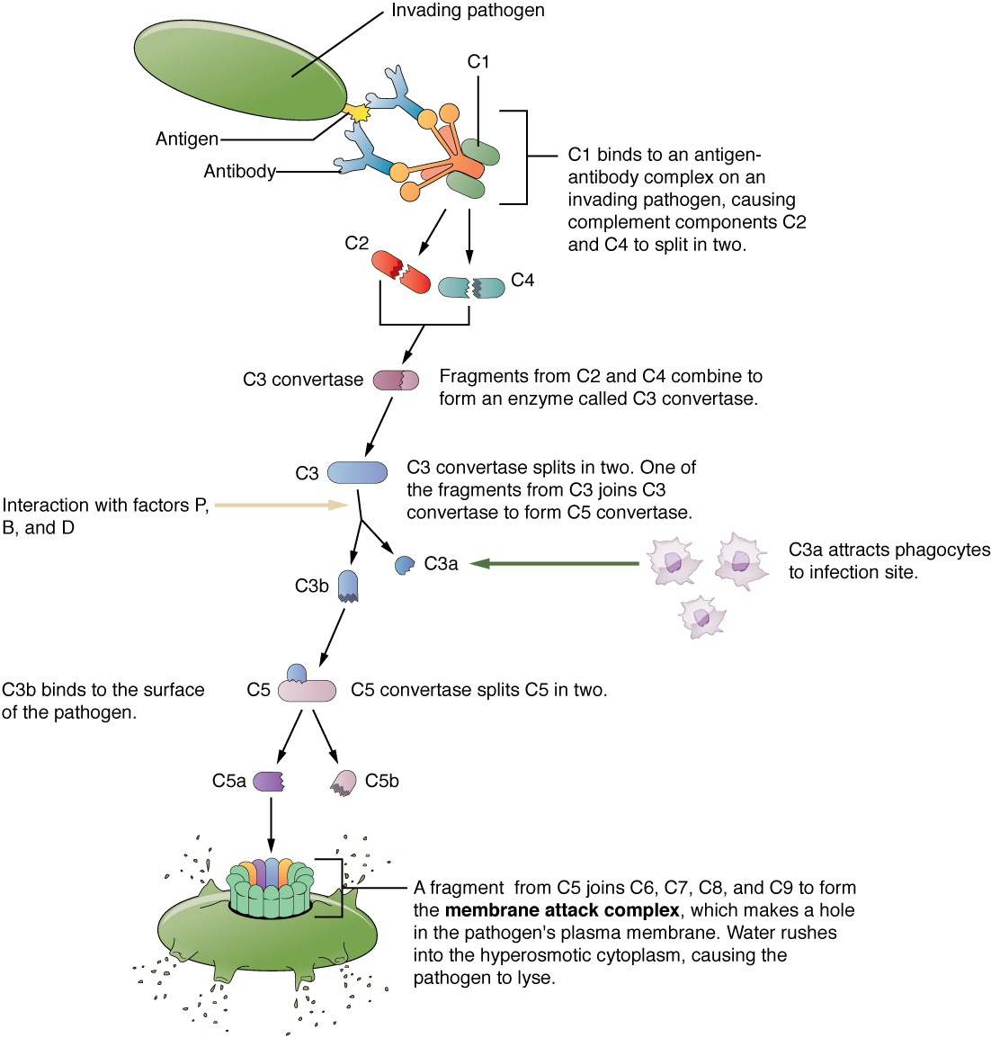Figure 2. Complement Cascade and Function. The classical pathway, used during adaptive immune responses, occurs when C1 reacts with antibodies that have bound an antigen.

Inflammation

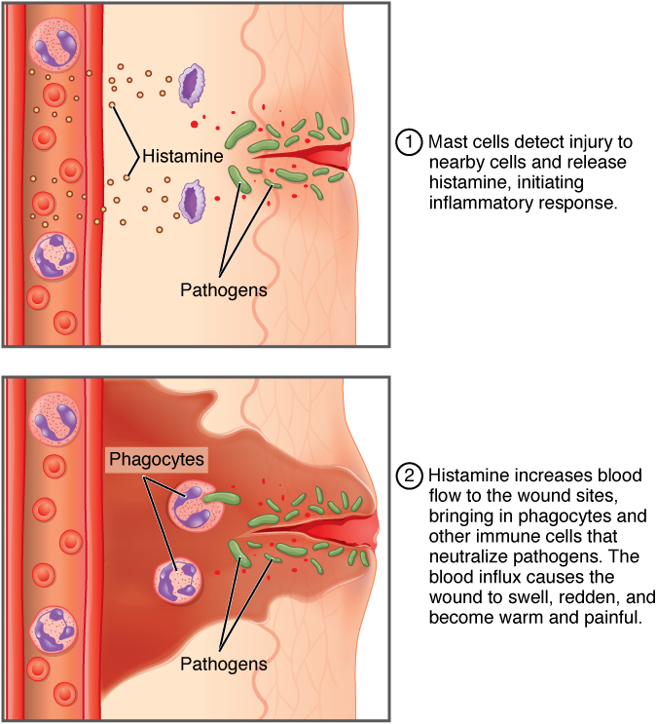

Fever

Adaptive Defenses

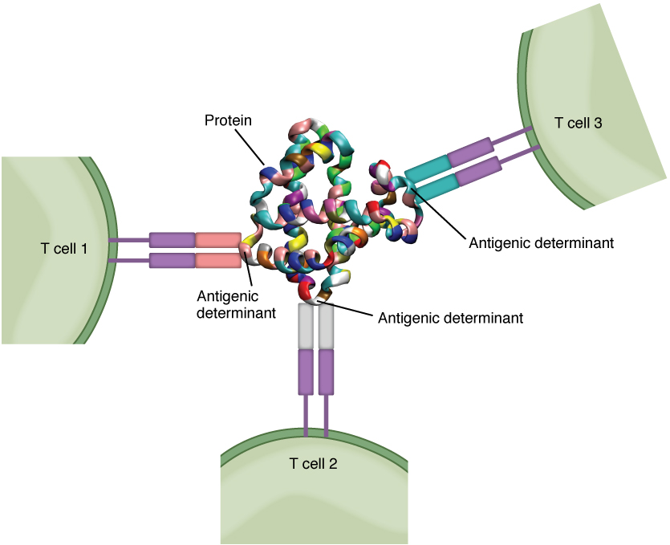
Figure 2. Antigenic Determinants. A typical protein antigen has multiple antigenic determinants, shown by the ability of T cells with three different specificities to bind to different parts of the same antigen.

T-Cells
MHC Proteins

Classes of Antigen-presenting Cells (Table 4)
MHC | Cell type | Phagocytic? | Function
Class I | Many | No | Stimulates cytotoxic T cell immune response
Class II | Macrophage | Yes | Stimulates phagocytosis and presentation at primary infection site
Class II | Dendritic | Yes, in tissues | Brings antigens to regional lymph nodes
Class II | B cell | Yes, internalizes surface Ig and antigen | Stimulates antibody secretion by B cells

Antigen Presentation
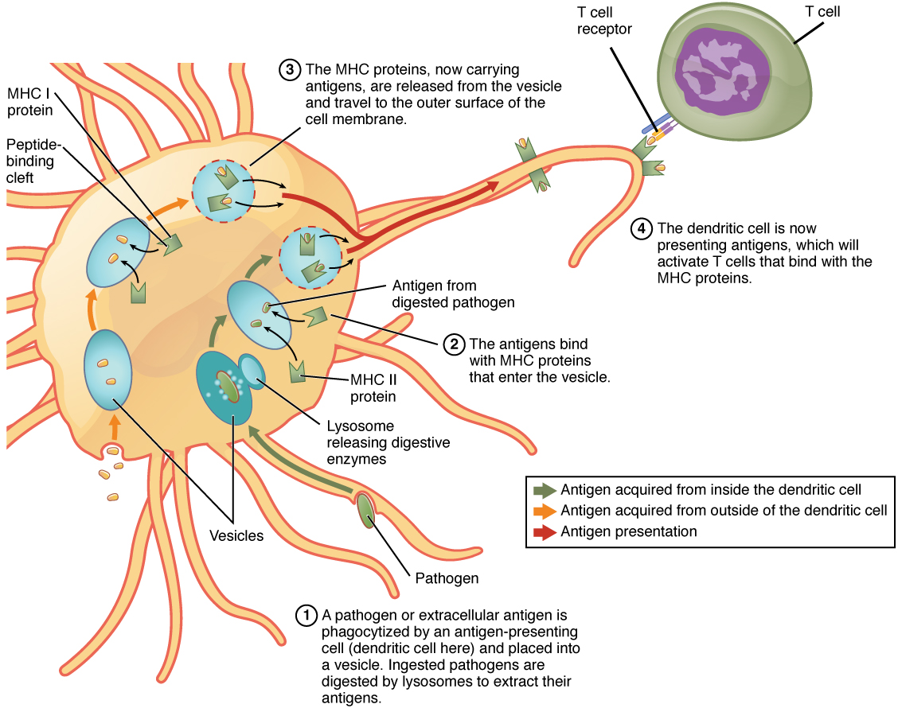

T-Cell Differentiation

Figure 4. Differentiation of T Cells within the Thymus. Thymocytes enter the thymus and go through a series of developmental stages that ensures both function and tolerance before they leave and become functional components of the adaptive immune response.

T-Cell Mediated Responses
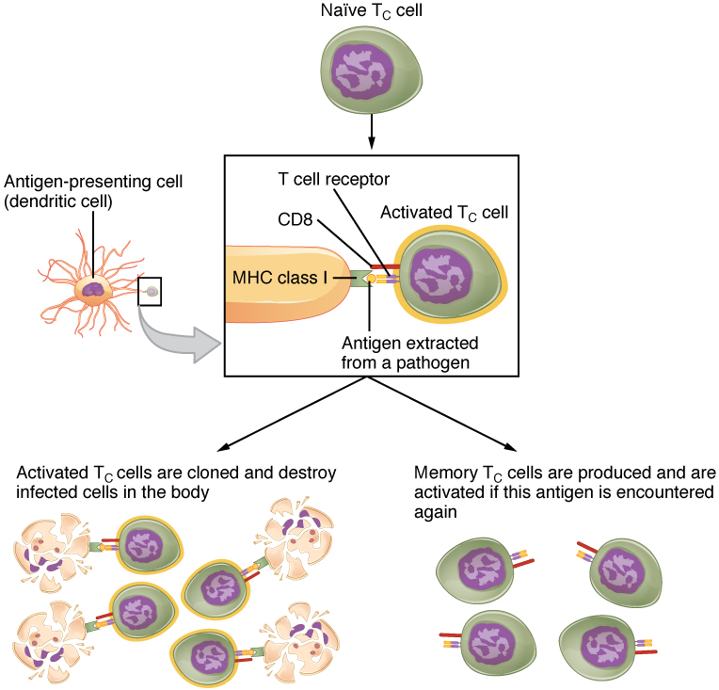Figure 5. Clonal Selection and Expansion of T Lymphocytes. Stem cells differentiate into T cells with specific receptors, called clones. The clones with receptors specific for antigens on the pathogen are selected for and expanded.
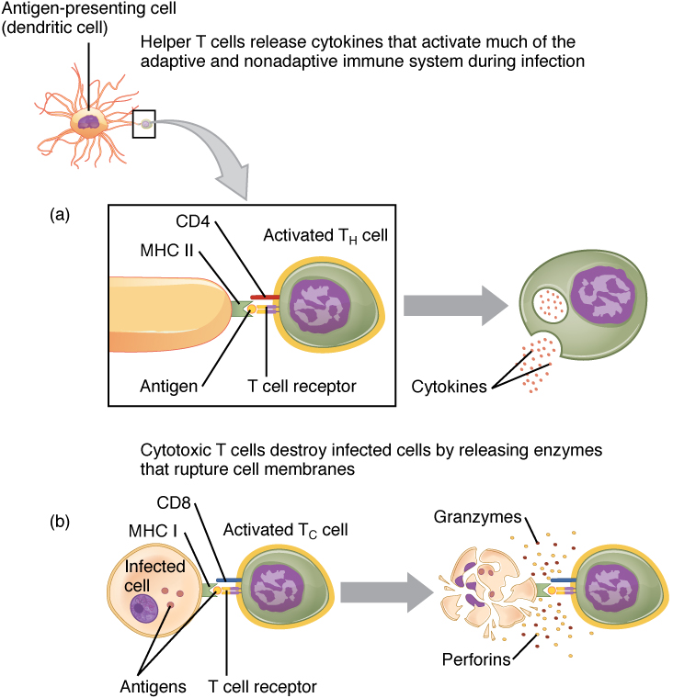Figure 6. Pathogen Presentation. (a) CD4 is associated with helper and regulatory T cells. An extracellular pathogen is processed and presented in the binding cleft of a class II MHC molecule, and this interaction is strengthened by the CD4 molecule. (b) CD8 is associated with cytotoxic T cells. An intracellular pathogen is presented by a class I MHC molecule, and CD8 interacts with it.

B-Cells and Antibodies

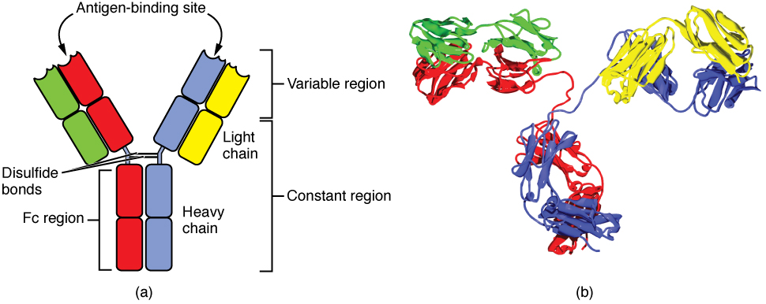Figure 1. Antibody and IgG2 Structures. The typical four chain structure of a generic antibody (a) and the corresponding three-dimensional structure of the antibody IgG2 (b). (credit b: modification of work by Tim Vickers)

Classes of Antibodies

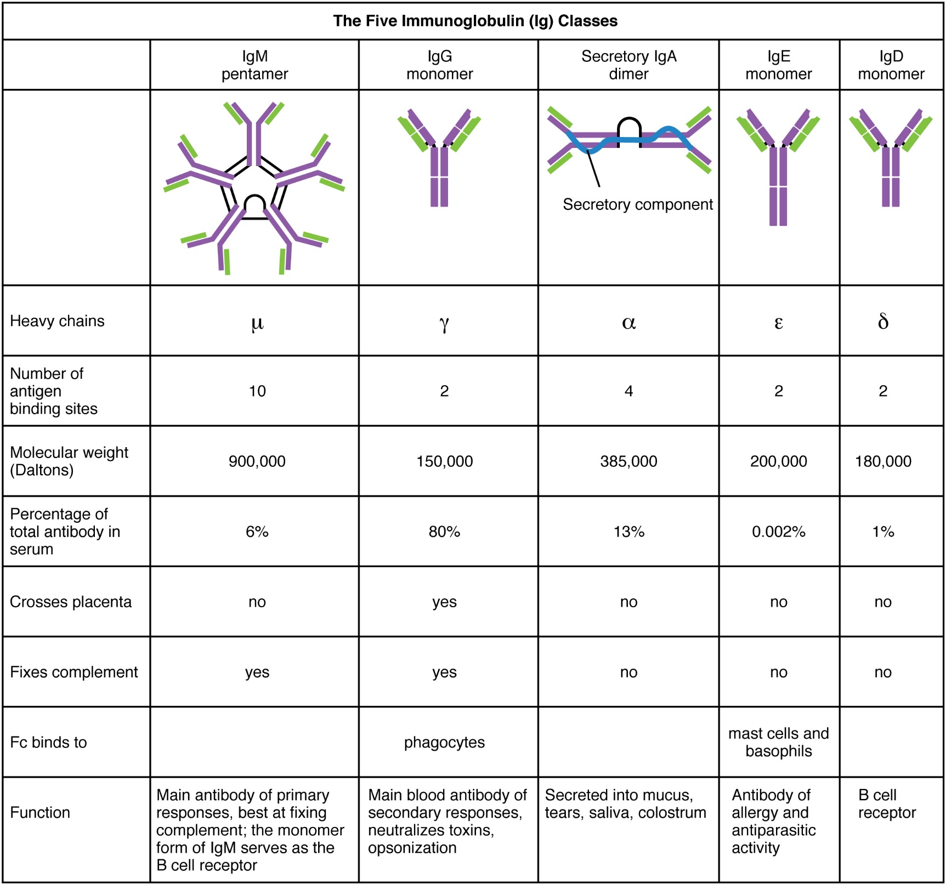

Mechanism of Antibody Action

Clonal Selection

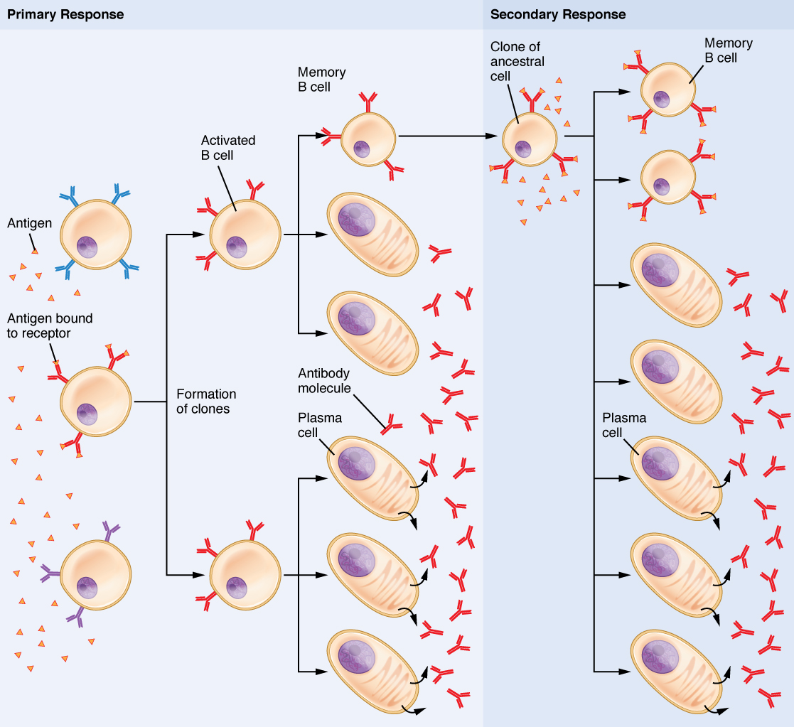Figure 3. Clonal Selection of B Cells. During a primary B cell immune response, both antibody-secreting plasma cells and memory B cells are produced. These memory cells lead to the differentiation of more plasma cells and memory B cells during secondary responses.

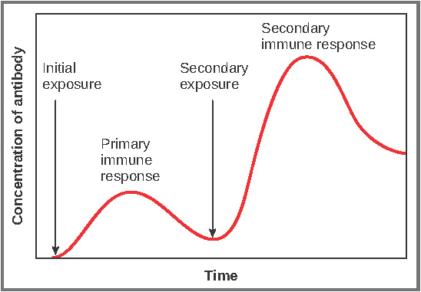
Figure 4. Primary and Secondary Antibody Responses. Antigen A is given once to generate a primary response and later to generate a secondary response. When a different antigen is given for the first time, a new primary response is made.

Vaccinations

Evolution of Virulence
Active vs. Passive Immunity

Interaction between B-Cells and T-Cells

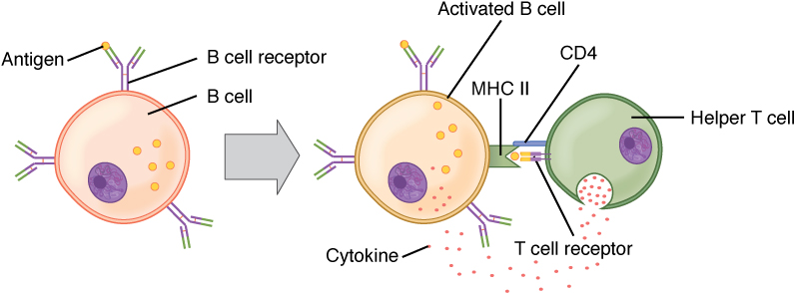Figure 5. T and B Cell Binding. To elicit a response to a T cell-dependent antigen, the B and T cells must come close together. To become fully activated, the B cell must receive two signals from the native antigen and the T cell’s cytokines.

AIDS

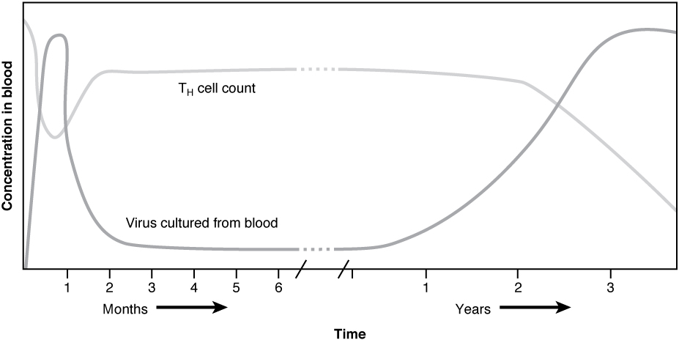

Other Immunodeficiencies

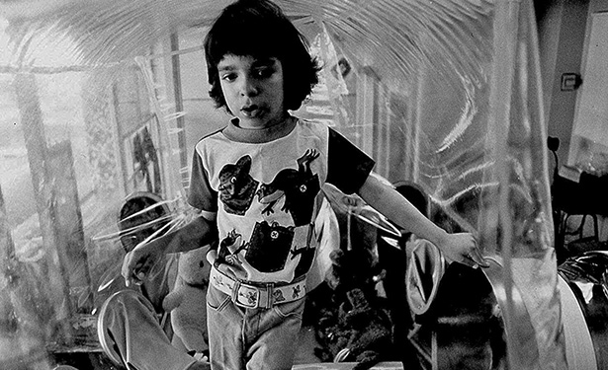
SCID
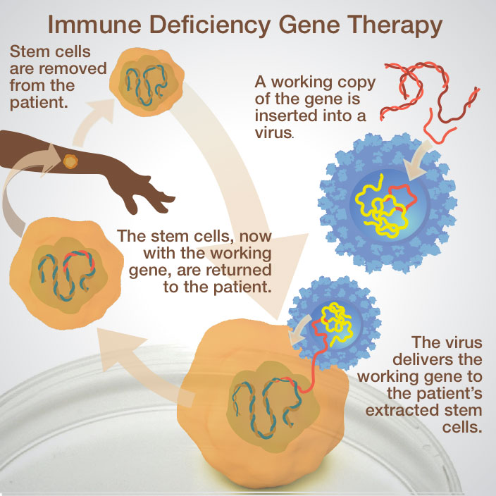

Hypersensitivities
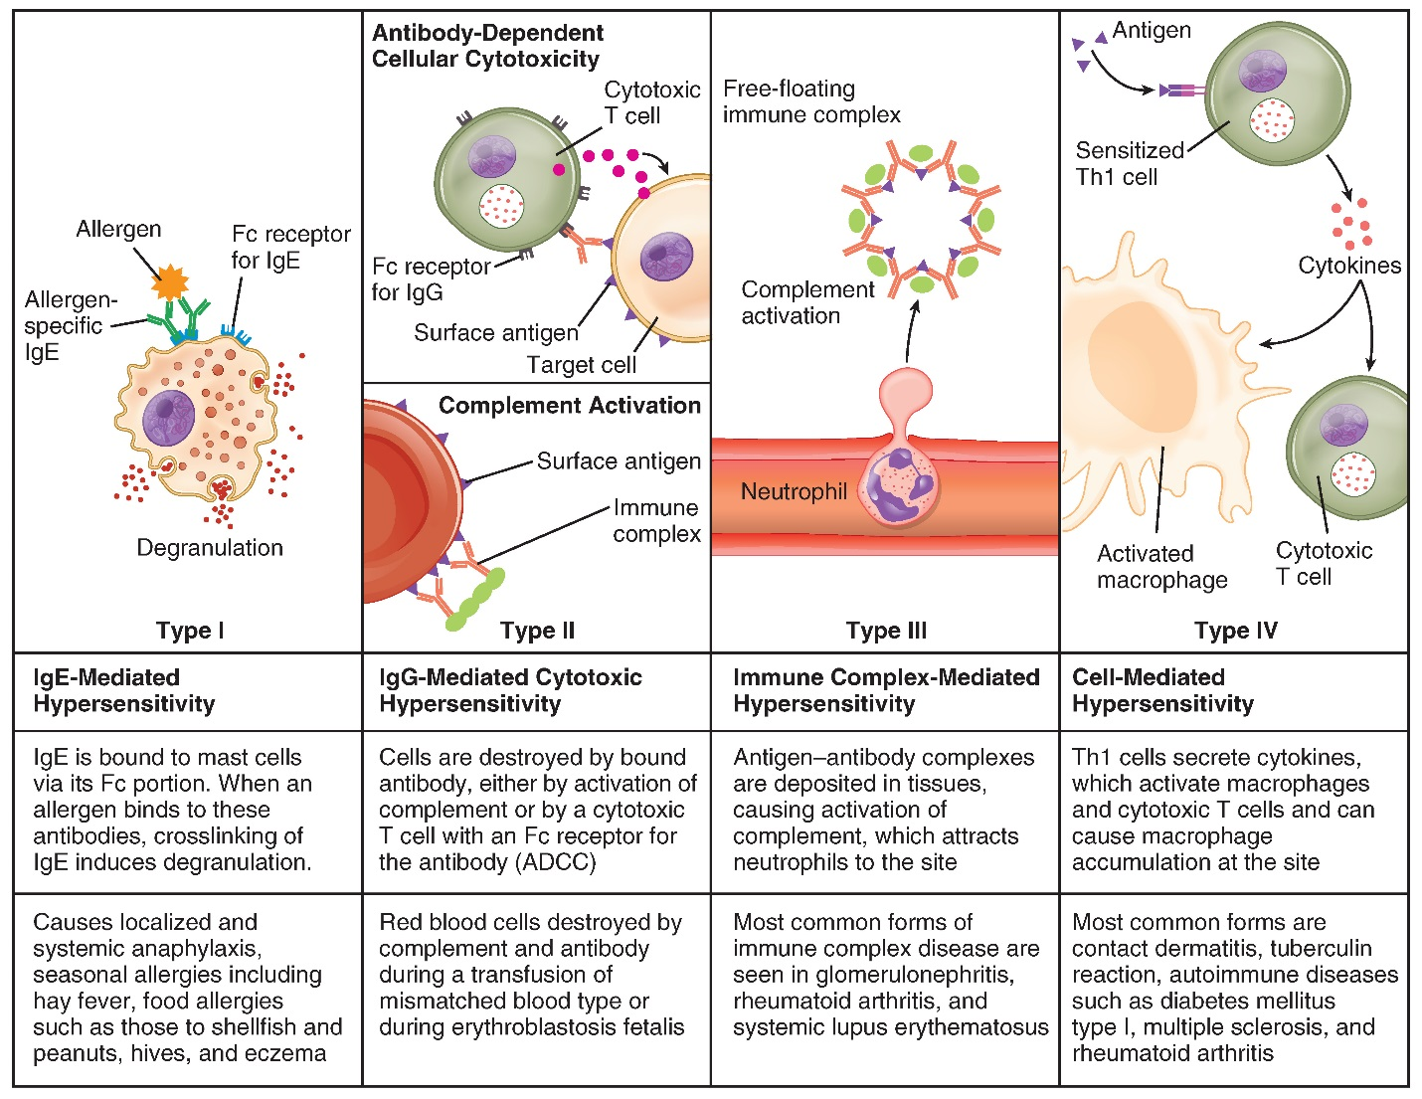

Autoimmunity

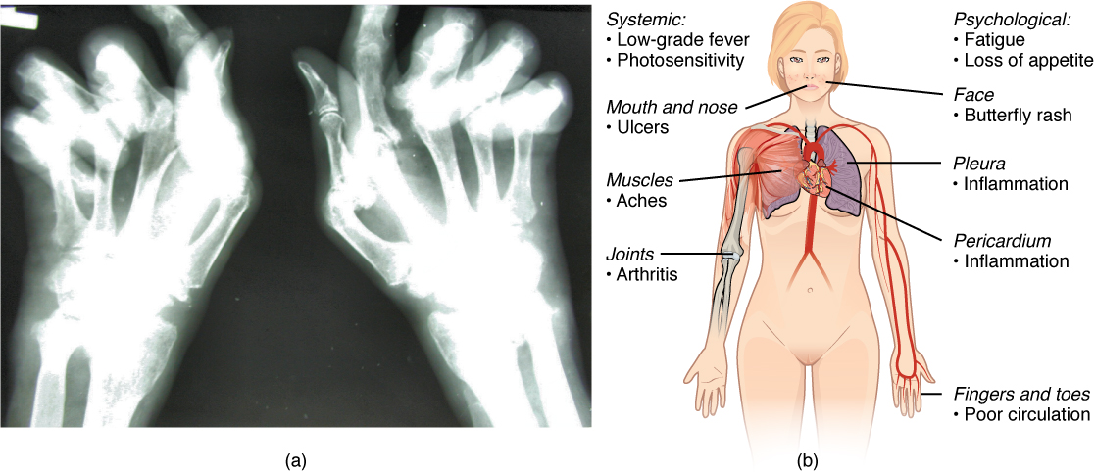
Figure 2. Autoimmune Disorders: Rheumatoid Arthritis and Lupus. (a) Extensive damage to the right hand of a rheumatoid arthritis sufferer is shown in the x-ray. (b) The diagram shows a variety of possible symptoms of systemic lupus erythematosus.
Autoimmune Diseases (Table 7)
Disease | Autoantigen | Symptoms
Celiac disease | Tissue transglutaminase | Damage to small intestine
Diabetes mellitus type I | Beta cells of pancreas | Low insulin production; inability to regulate serum glucose
Graves’ disease | Thyroid-stimulating hormone receptor (antibody blocks receptor) | Hyperthyroidism
Hashimoto’s thyroiditis | Thyroid-stimulating hormone receptor (antibody mimics hormone and stimulates receptor) | Hypothyroidism
Lupus erythematosus | Nuclear DNA and proteins | Damage of many body systems
Myasthenia gravis | Acetylcholine receptor in neuromuscular junctions | Debilitating muscle weakness
Rheumatoid arthritis | Joint capsule antigens | Chronic inflammation of joints

