Identification of Human Chromosomes

Cytologists had begun trying to determine the exact number of chromosomes in human cells in the 1980s.Under a light microscope, chromosomes show only a few morphological characteristics by which they can be differentiated: (1) their length, (2) the position of their centromere and the relative lengths of the chromosome arms, (3) the presence of absence of satellites¹, and (4) banding patterns resulting from the application of stains.

Four positions of Centromere:
Metacentric – the centromere is centrally placed so that the chromosome arms are of equal or nearly equal length.
Submetacentric – the centromere is nearer one end than another, resulting in one longer arm and one shorter arm.
Acrocentric – the centromere is very near one end of the chromosome, resulting in arms that are very unequal in length.
Telocentric – the centromere is at the extreme end of the chromosome so that there is only one arm.
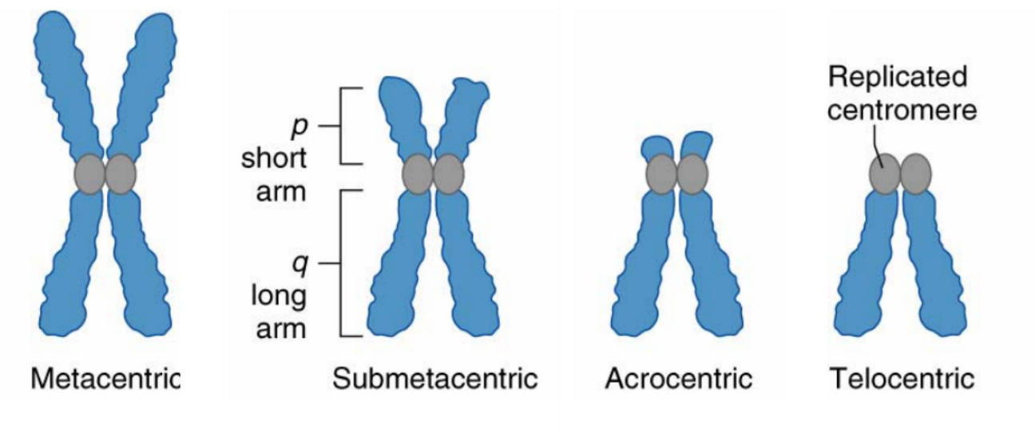
Chromosome abnormalities (inversions, translocations, aneupolidy², etc.) can be diagnosed by examining a karyotype, the entire chromosome complement of the cell. This involved the staining of the chromosomes at the metaphase stage of mitosis (when they are at their most condensed form). The stained chromosomes are then photographed under the microscope, the images cut out and grouped into homologous pairs based on size, centromere position, and banding pattern. The pairs are then arranged by size from largest to smallest.

Banding patterns of the human chromosomes:
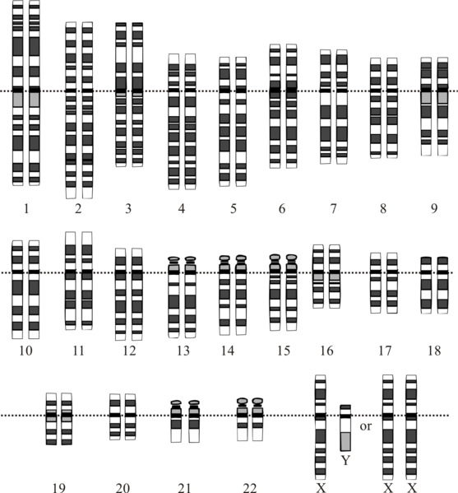

Changes in chromosome number are more common in humans than is generally appreciated. About 15% of all pregnancies end in miscarriage, and about a third of these involve aneuploidy. In addition, roughly 1 in every 300 live births has a chromosomal anomaly, usually aneuploidy of chromosomes 13, 18, 21 or of a sex chromosome.
Even without aneuploidy, human chromosomes (more specifically the genes they carry) may result in human disease or the inheritance of a genetic disorder. Each student will be assigned a random chromosome and tasked with the identification of that chromosome, its characteristics and a genetic disorder associated with this chromosome.
Part One – Identification of Human Chromosomes
- You will be provided with a scan of a metaphase spread and one chromosome will be randomly assigned to you.
- Identify your chromosome in the metaphase spread (it may be useful to find both copies). Make the identification based on the G-banding pattern, centromere position and the guidelines for identifying human chromosomes.
- Either highlight your chromosome in the scan or cut your chromosome out of the scan. This will be used as the “title graphic” in your lab report.
Part Two – Internet Search for Genes on Your Chromosome
- Start at the Online Mendelian Inheritance in Man site at www.ncbi.nlm.nih.gov/omim
- On the left side of the page click on “Search OMIM”.
- In the box that says “Only records with:” select clinical synopsis and gene map locus.
- In the box to the left of that, select your chromosome, then lick on the “Go” button towards the top of the page (or simply hit enter).
- The page that now appears will list up to 200 syndromes associated with genes on your chromosome. Select a syndrome that interests you by clicking on its six-digit OMIM number. This will take you to the page on this condition.
- Print out the “TEXT” section, or, better yet, copy it to a Word file and save it.
- Under “phenotype Gene Relationships” click on the location of the gene. On the page that comes up, click again on the location of the gene in the first column. This will take you to the UCSC Genome Browser. Immediately under he “position/search” box there will be a diagram of your chromosome with a red bad indicating the position of your gene. Right click on the far left end of the diagram and save it.
- Find at least one additional source of information about your gene and the condition it is responsible for. You may do an internet search or find the information in the library.
Part Three – The Lab Report
- Start the report with the heading “Chromosome Number X”, where “X” is the chromosome number. Below that put your name.
- Below the heading, paste your title graphic. Remember this is either the cut out chromosome from the metaphase spread (which may be enlarged) or a copy of the metaphase spread with your chromosome highlighted (circled, colored, starred) in some fashion and indicate the location of your gene on the title graphic with an arrow.
- Below the title graphic, list the following information about the chromosome:
  - Its group, size and type (see Table), and
  - Below this, calculate the centromeric index of your chromosome

The centromeric index is the ratio of the length of the short arm of a chromosome (p) to the total length of the chromosome (p + q):
Centromeric Index = p × 100
p + q
- One the next page, describe the characteristics of your gene. Include whatever information you find interesting and think the rest of the class might enjoy learning about. At a minimum, you must include the following:
  - The condition associated with the gene, when it was first identified, its frequency, clinical features, and treatment,
  - The mode of inheritance of the condition, and
  - The protein the gene encodes and its function.
- Include a reference for all the information in the report, either an Internet address or a conventional reference. If you use a direct quote, indicate them with quotation marks.
- The report must be double spaced and in 12 point font. Reports should be two to three pages long (no more than 4).

Table of Chromosome Groups
Group | Chromosomes | Size | Type
A | 1, 2, 3 | Large | Metacentric or submetacentric
B | 4, 5 | Large | Submetacentric
C | 6 – 12, and X | Medium | Submetacentric
D | 13, 14, 15 | Medium | Acrocentric
E | 16, 17, 18 | Small | Metacentric or submetacentric
F | 19, 20 | Small | Metacentric
G | 21, 22, 23, and Y | Smallest | Acrocentric

